# Data Engineering

[Introduction to Data Engineering - What is Data Engineering? - Week 1 | Coursera](https://www.coursera.org/learn/introduction-to-data-engineering/home/module/1)

## Module 1

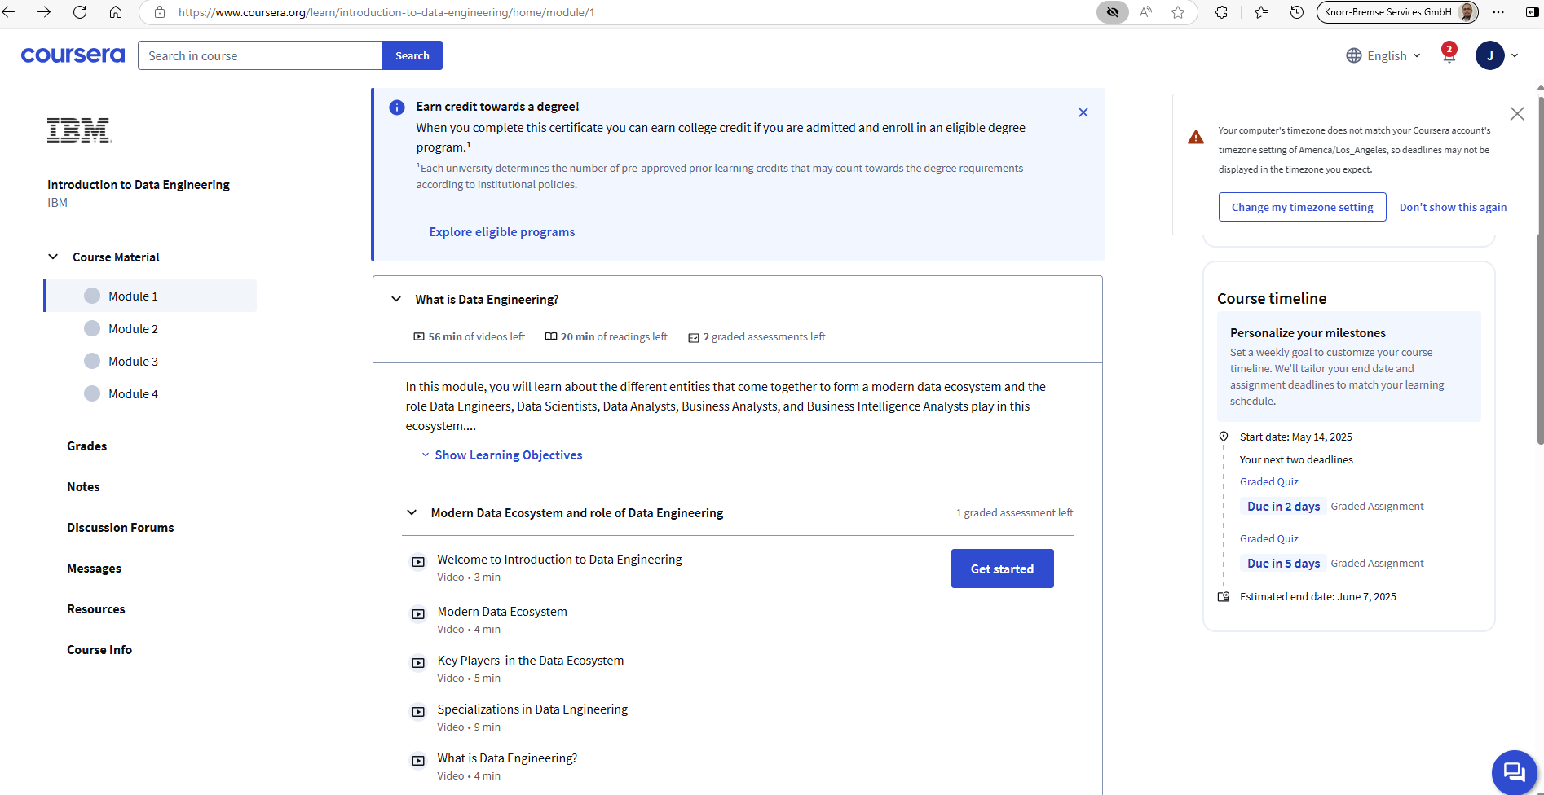

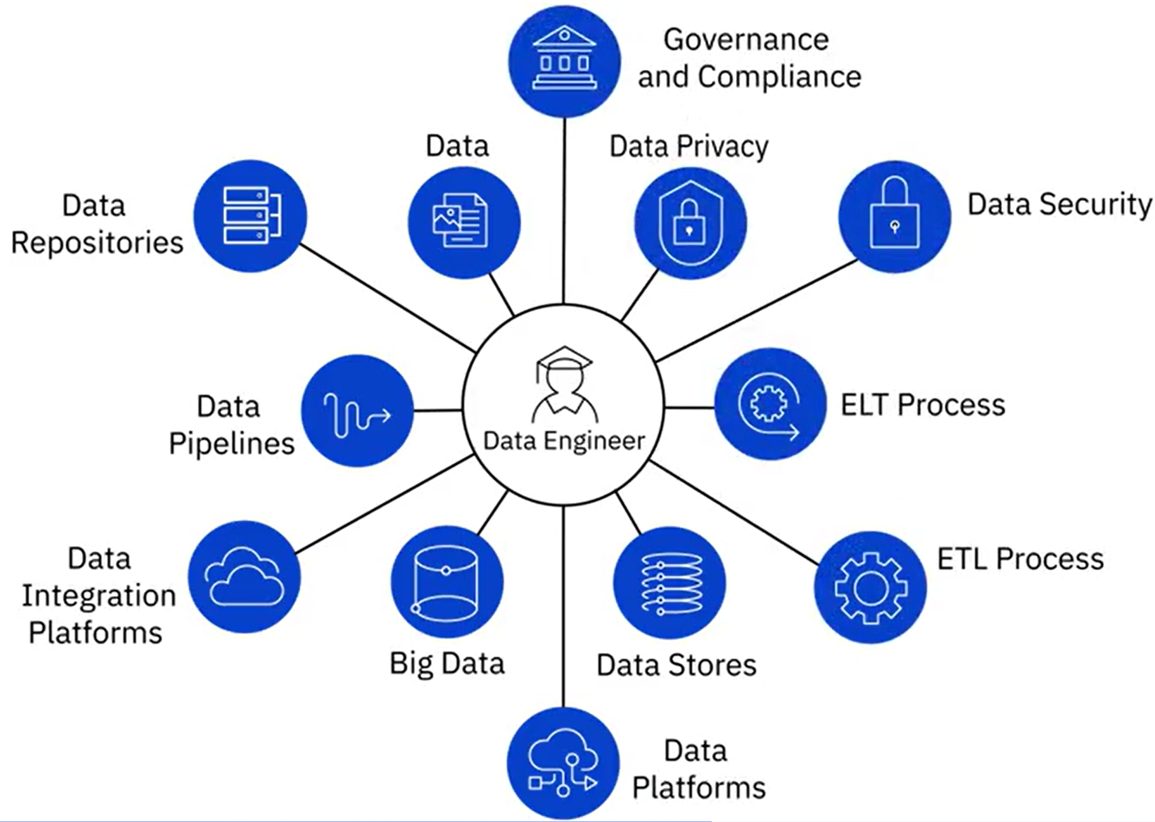

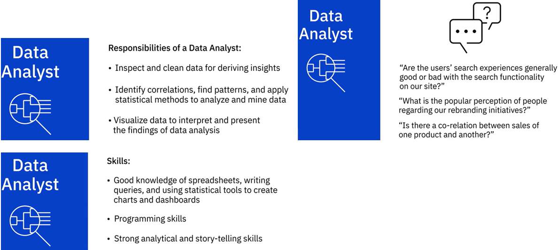

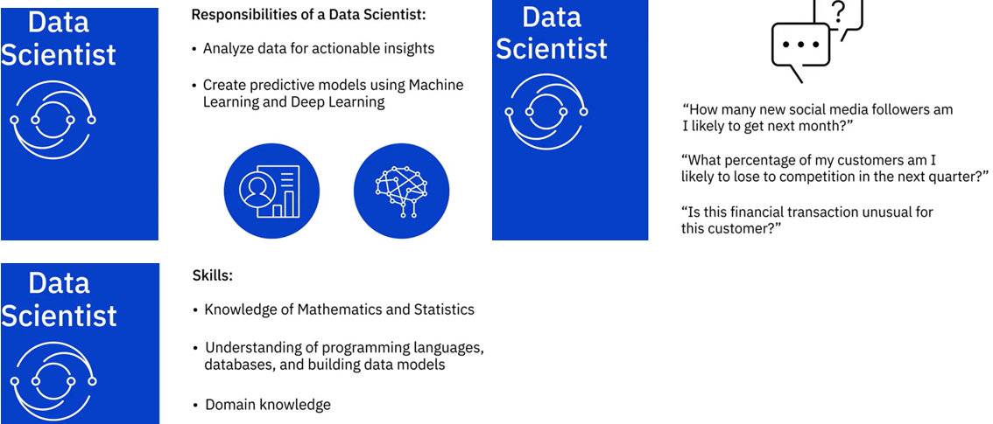

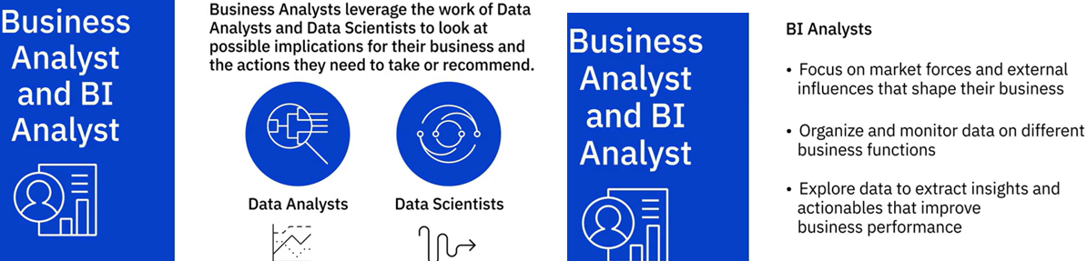

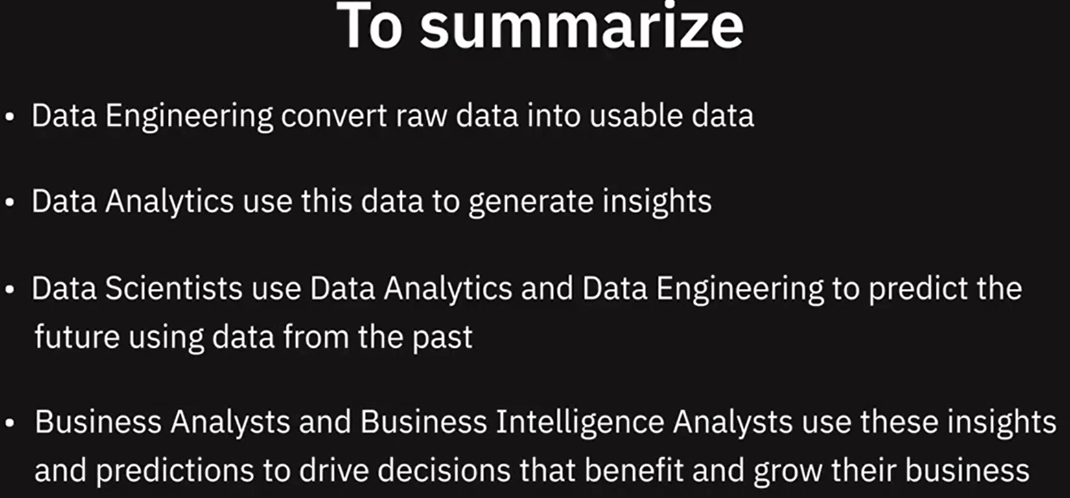

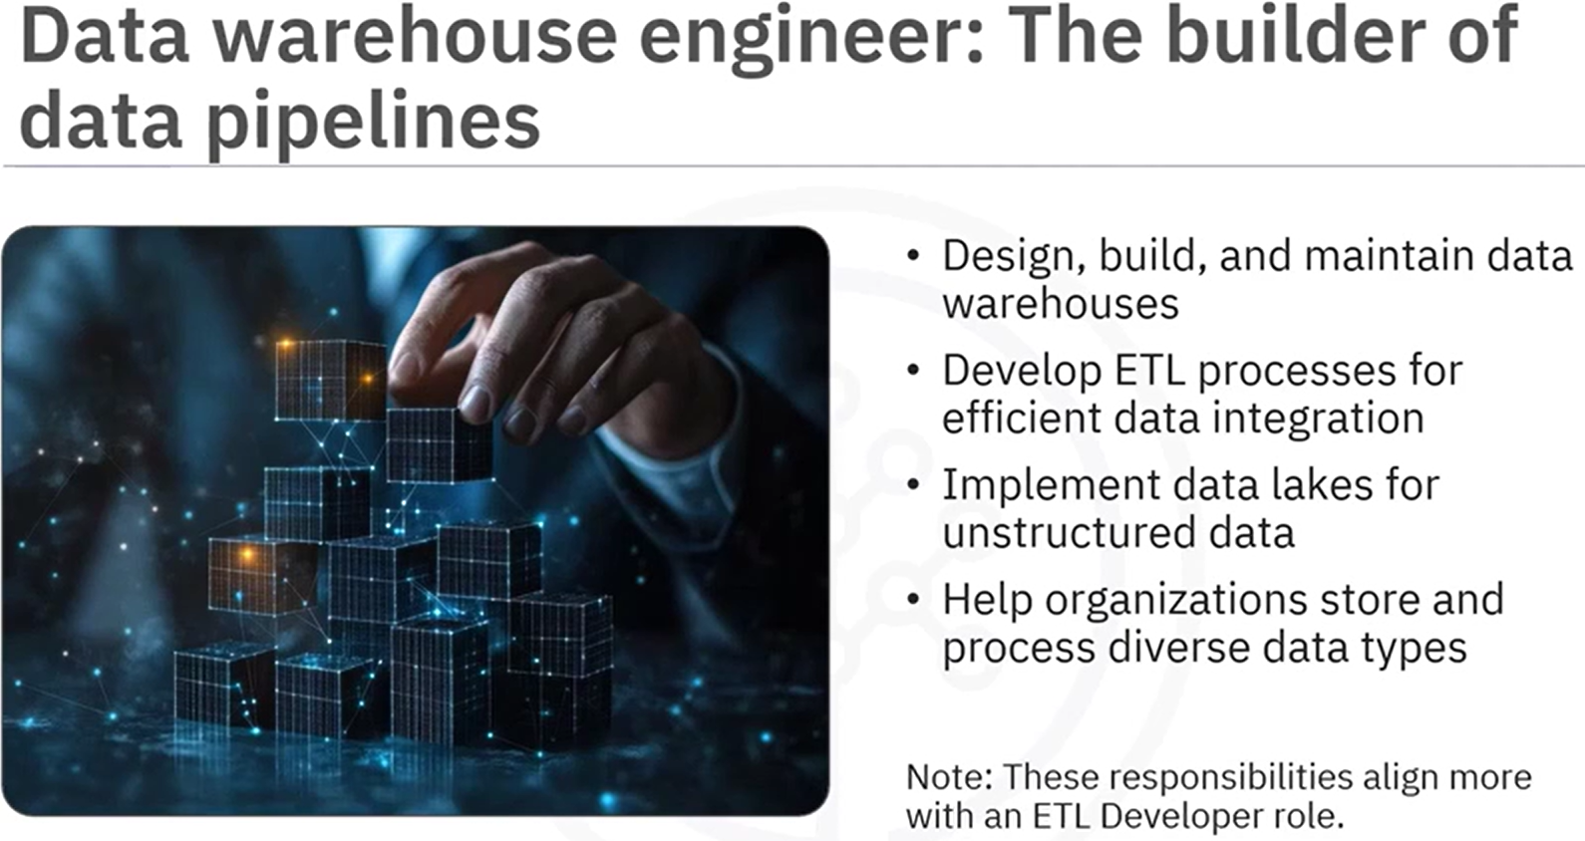

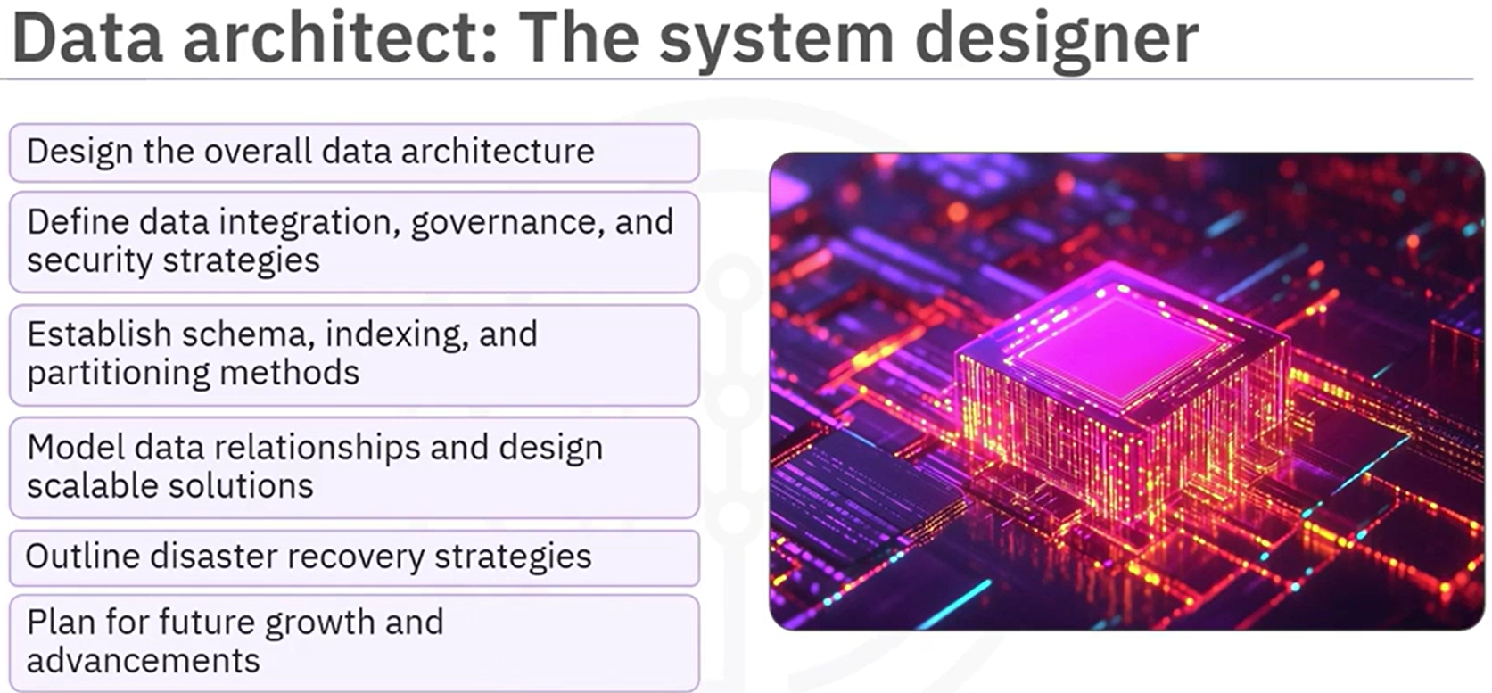

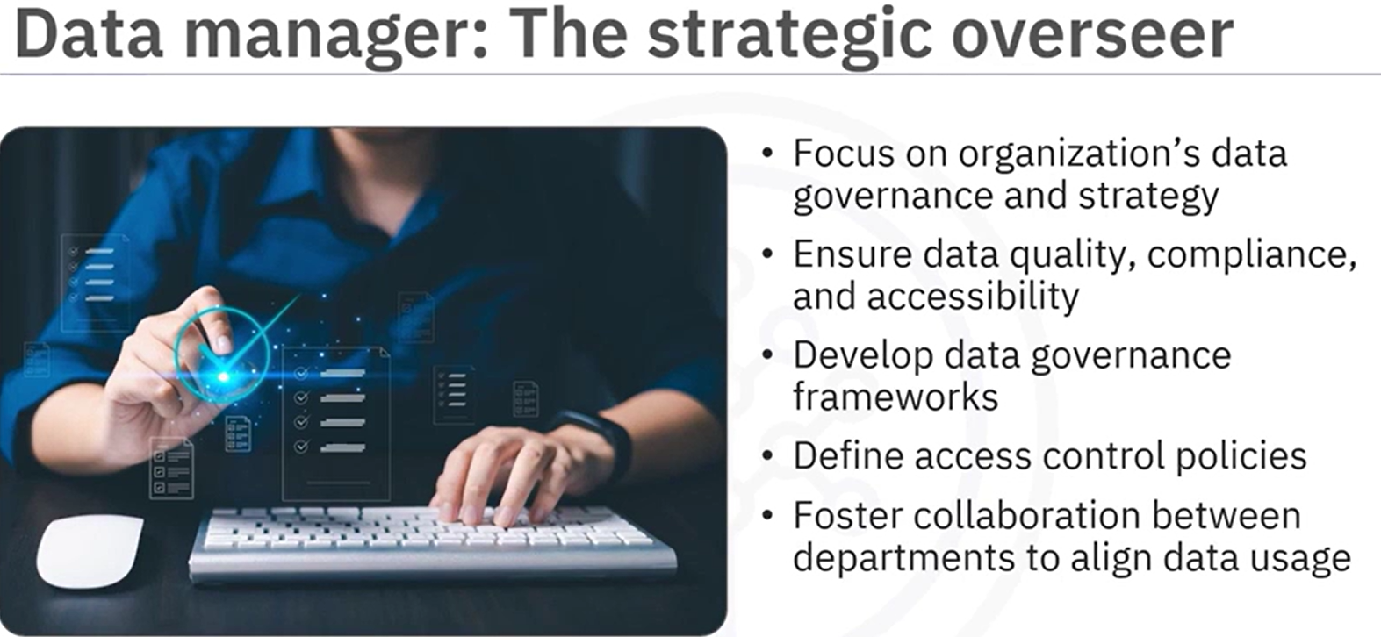

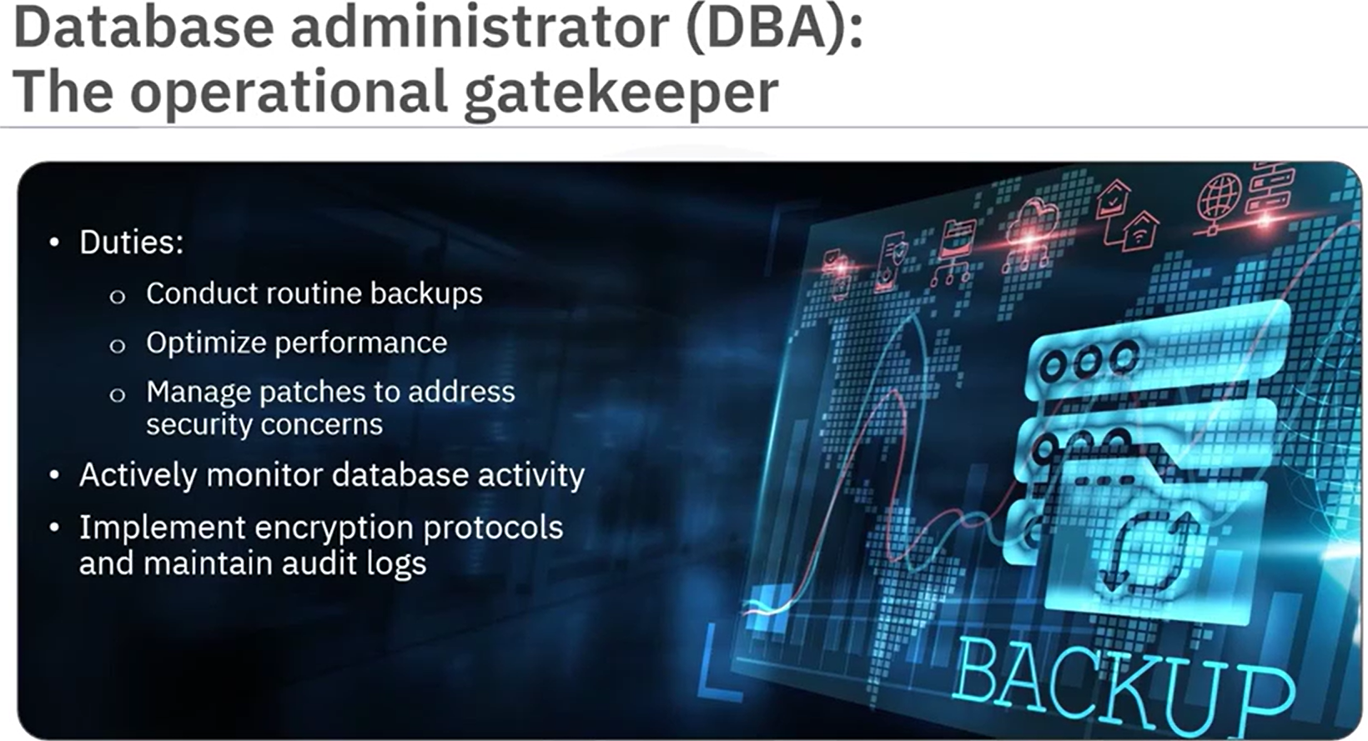

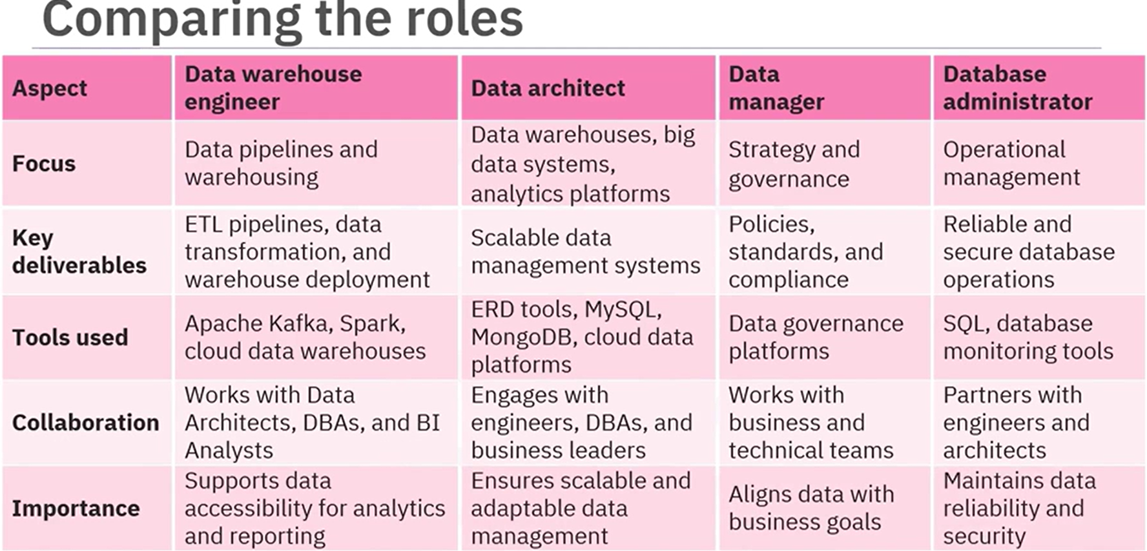

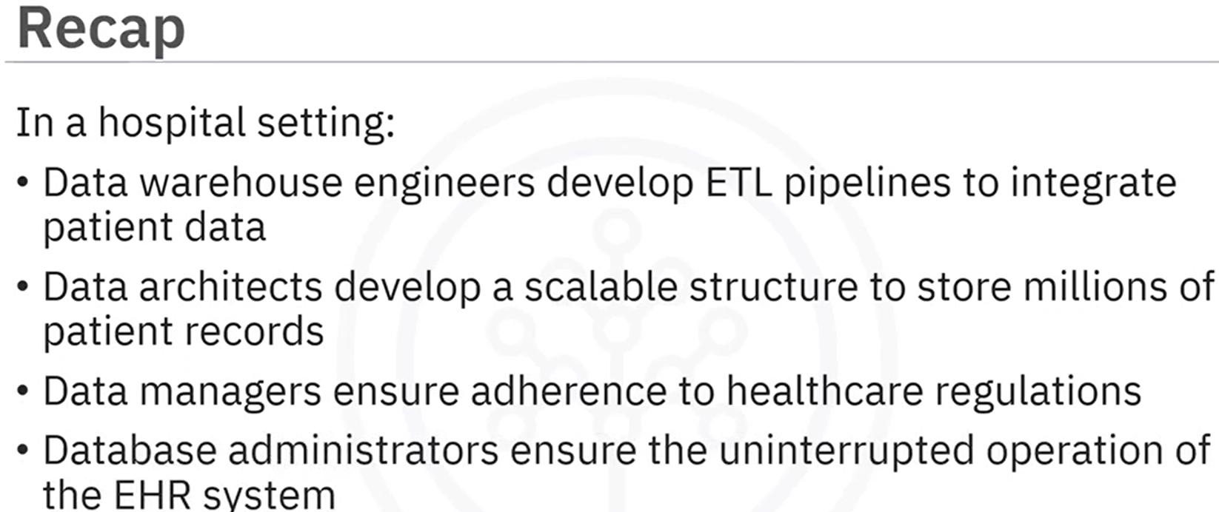

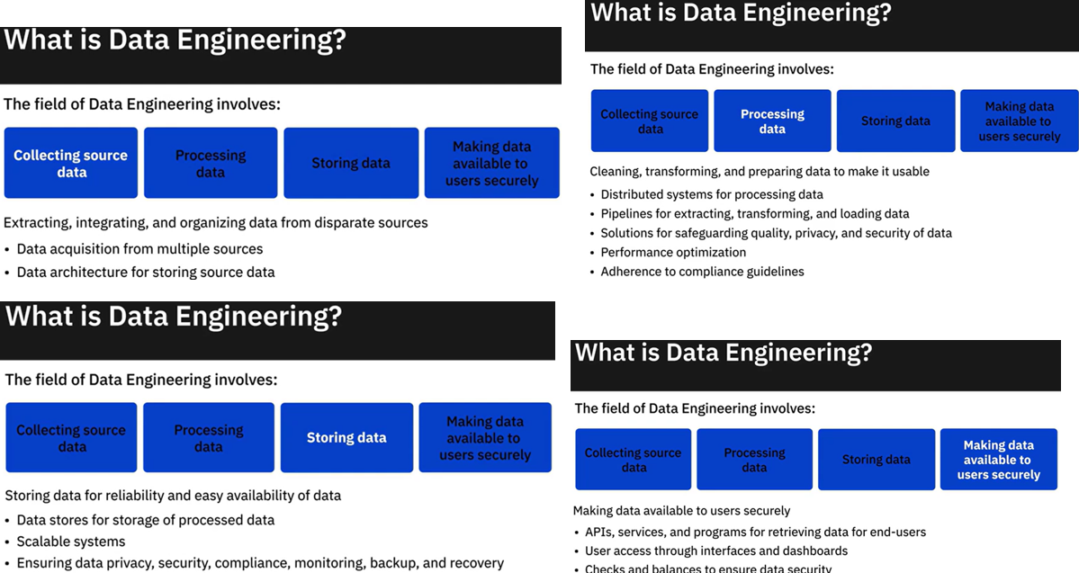

Summary and Highlights

In this lesson, you have learned:

Modern data ecosystem includes a network of interconnected and continually evolving entities that include:

* Data, that is available in a host of different formats, structures, and sources.
* Enterprise Data Environment, in which raw data is staged so it can be organized, cleaned, and optimized for use by end-users.
* End-users, such as business stakeholders, analysts, and programmers who consume data for various purposes.

Emerging technologies such as Cloud Computing, Machine Learning, and Big Data, are continually reshaping the data ecosystem and the possibilities it offers.

Data Engineers, Data Analysts, Data Scientists, Business Analysts, and Business Intelligence Analysts, all play a vital role in the ecosystem for deriving insights and business results from data.

The goal of Data Engineering is to make quality data available for analytics and decision-making. And it does this by collecting raw source data, processing data so it becomes usable, storing data, and making quality data available to users securely.

### **Practice Quiz**

**1. Which emerging technology has made it possible for every enterprise to have access to limitless storage and high-performance computing?**

Big Data

Machine Learning

Cloud Computing

Internet of Things

**Correct**

Cloud technologies has made it possible for every enterprise, regardless of its size, to have access to limitless storage and high-performance computing at nominal costs.

**Question 2. Which of the data roles is responsible for extracting, integrating, and organizing data into data repositories?**

Data Analyst

Data Scientist

Data Engineer

Business Intelligence Analyst

**Correct**

Data Engineers are responsible for extracting, integrating, and organizing data into data repositories.

**Question 3. The field of data engineering concerns itself with the mechanics for the flow and access of data. Which one of the following statements captures the goal of data engineering?**

Make quality data available for fact-finding and business decision-making

Design pipelines for extracting, transforming, and loading data into data repositories

Maintain distributed systems for large-scale processing of data

Architect data stores for the storage of processed data

**Correct**

Data engineering is the process of collecting raw data and converting it into analytics-ready data by cleaning, transforming, and preparing data so that it is reliable.

### Graded Quiz

**1. A modern data ecosystem includes a network of continually evolving entities. It includes:**

Data sources, enterprise data repository, business stakeholders, and tools, applications, and infrastructure to manage data

Social media sources, data repositories, and APIs

Data providers, databases, and programming languages

Data sources, databases, and programming languages

**Correct**

These are the key entities of a modern data ecosystem.

**Question 2. Data Engineers work within the data ecosystem to:**

Develop and maintain data architectures

Provide business intelligence solutions by monitoring data on different business functions

Analyze data for actionable insights

Analyze data for deriving insights

**Correct**

One of the responsibilities of a Data Engineer in a data ecosystem is to develop and maintain data architectures so that data is available for business operations and analysis.

**Question 3. The goal of data engineering is to make quality data available for fact-finding and decision-making. Which one of these statements captures the process of data engineering?**

Processing data and making it available to users securely

Collecting, processing, storing, and making data available to users securely

Collecting, processing, and storing data

Collecting, processing, and making data available to users securely

**Correct**

Data engineering includes the collection of data from disparate sources, processing data so that it is usable, storing processed data, and making it available to users securely.

**Question 4. Data extracted from disparate sources can be stored in:**

Data Warehouses only

Databases, data warehouses, data lakes, or any other type of data repository

Data Lakes only

Databases only

**Correct**

Data extracted from multiple sources can be stored in any type of data repository, such as, databases, data warehouses, and data lakes.

**Question 5. From the provided list, select the three emerging technologies that are shaping today’s data ecosystem.**

Machine Language, Cloud Computing, and Internet of Things

Big Data, Internet of Things, and Dashboarding

Cloud Computing, Internet of Things, and Dashboarding

Cloud Computing, Machine Learning, and Big Data

**Correct**

Emerging technologies such as Cloud Computing, Machine Learning, and Big Data are shaping today’s data ecosystem and its possibilities.



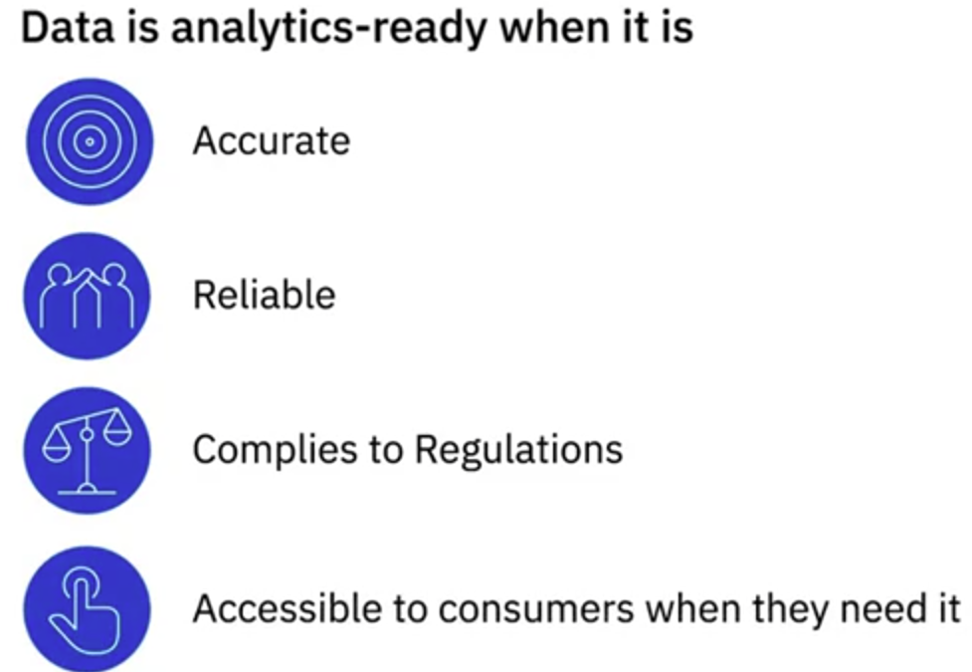 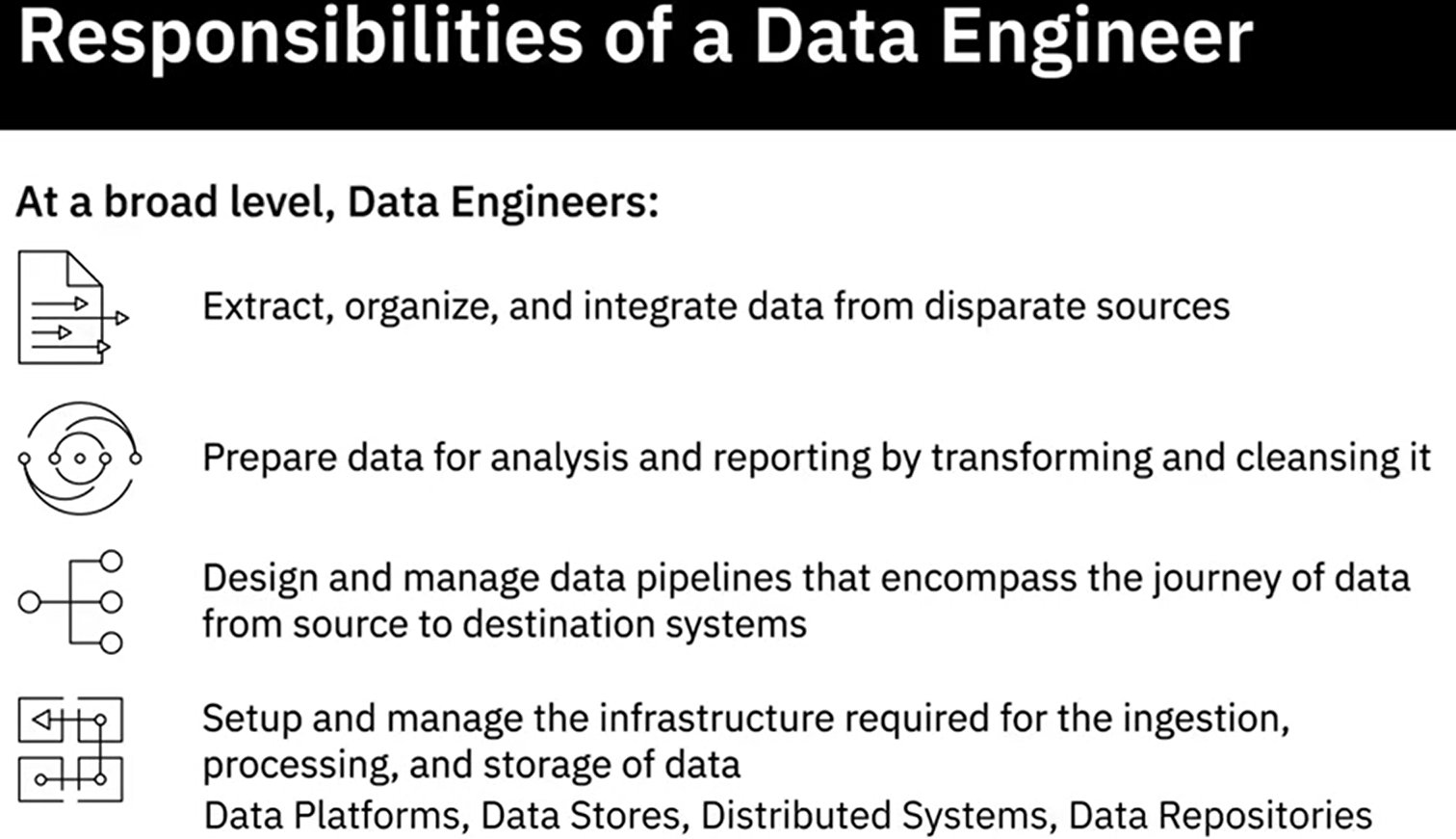

**Technical Skills**

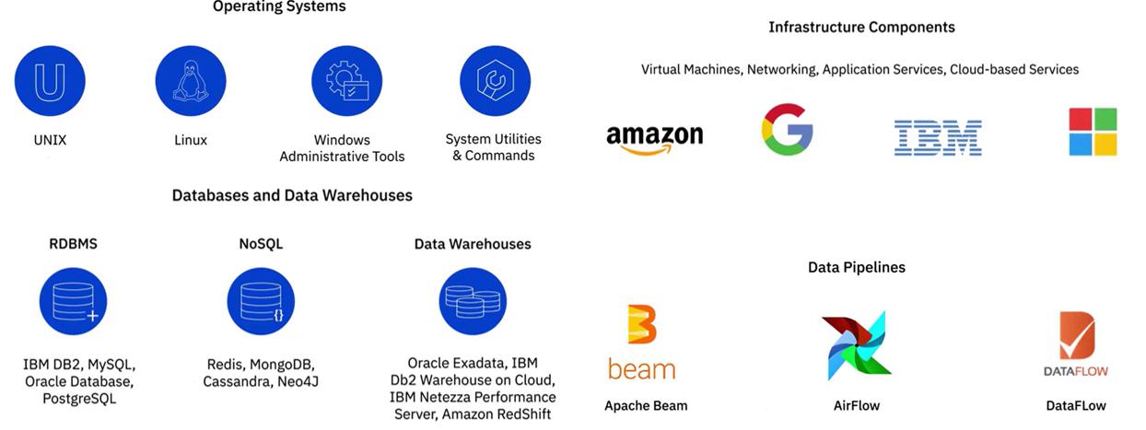

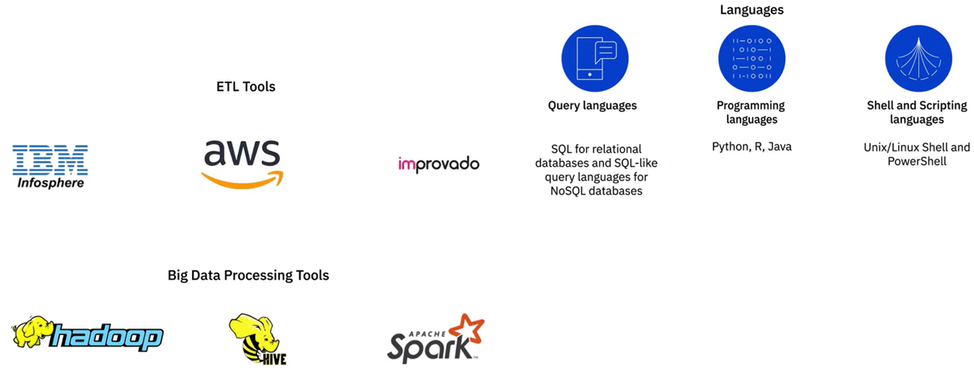

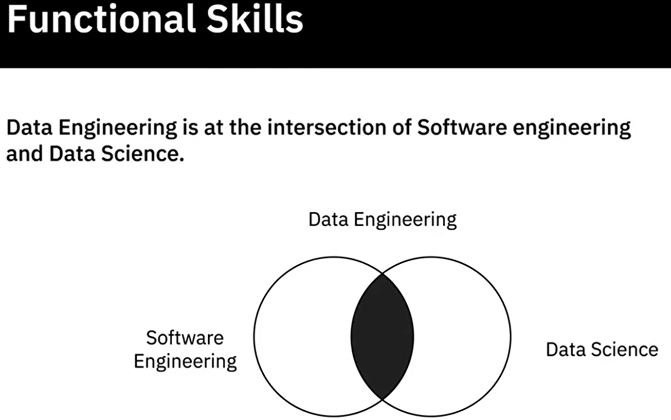

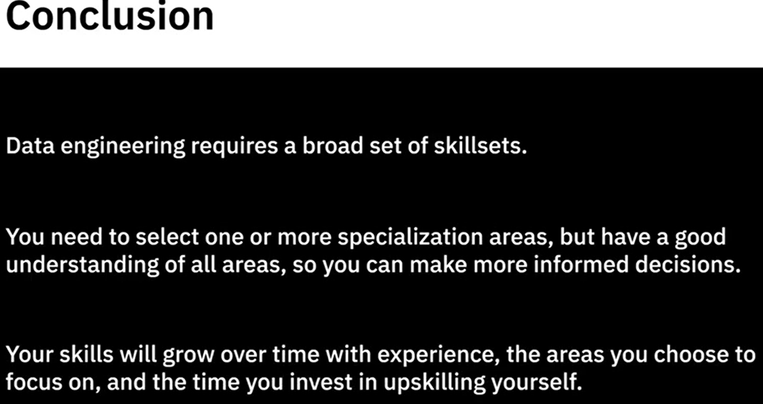

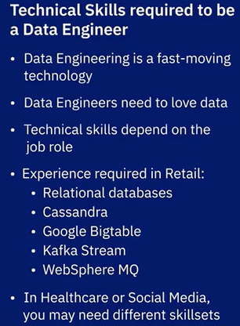

Example: Quieren mantener un ojo atento en todas las Redes sociales y saber lo que dicen las comunidades en línea como Twitter, Facebook, Instagram, plataformas de comercio electrónico, y bloggers sobre su producto. Comentarios positivos, comentarios negativos, sugerencias, incluso comparaciones con sus favoritos actuales.

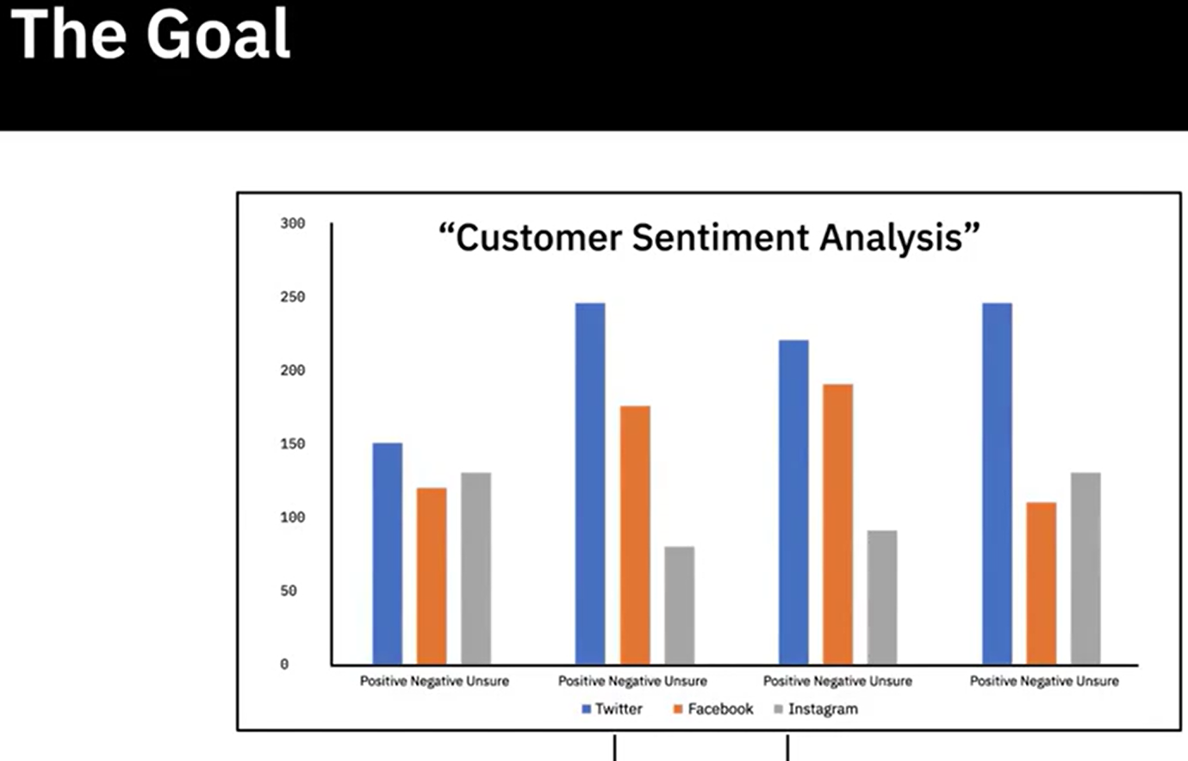

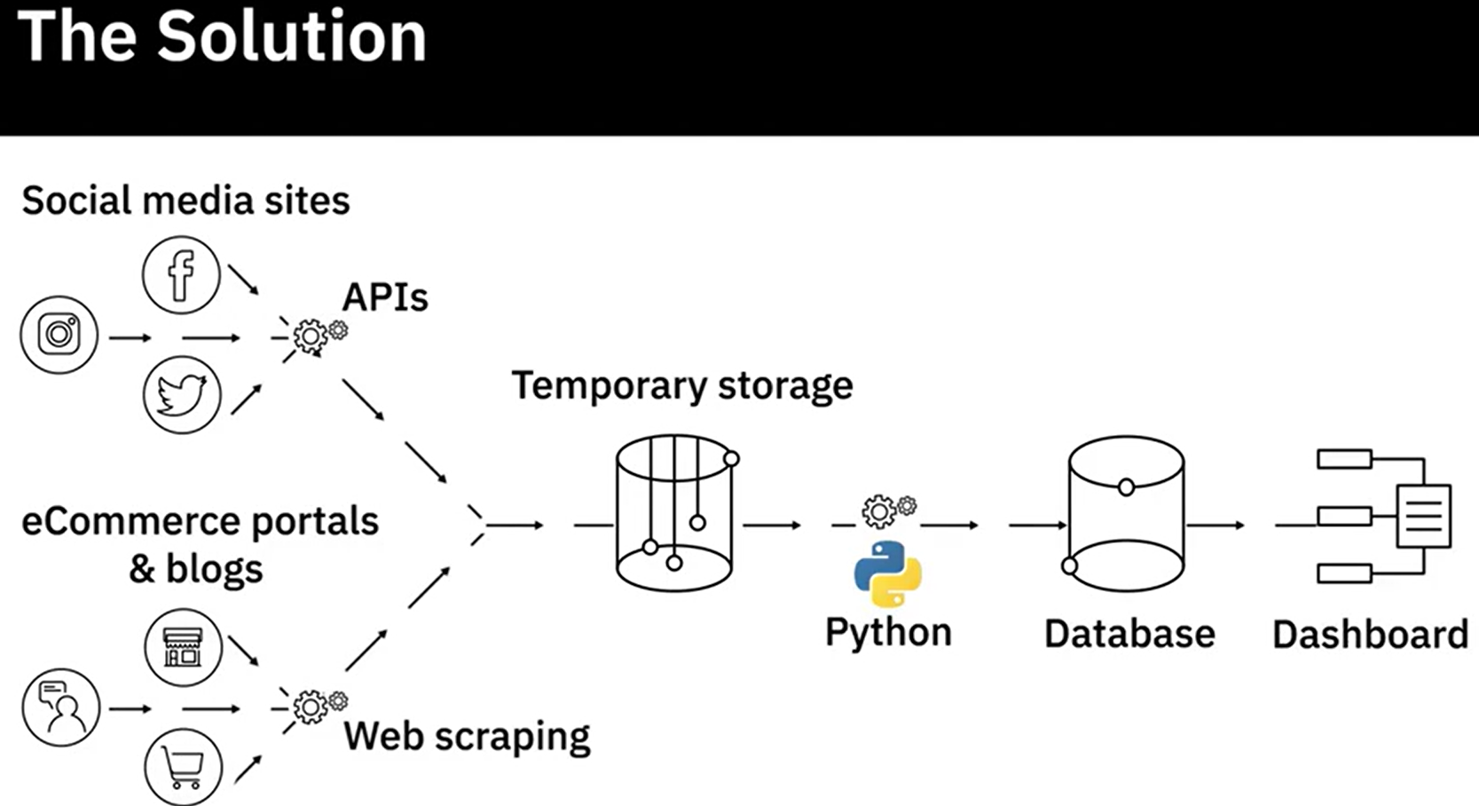

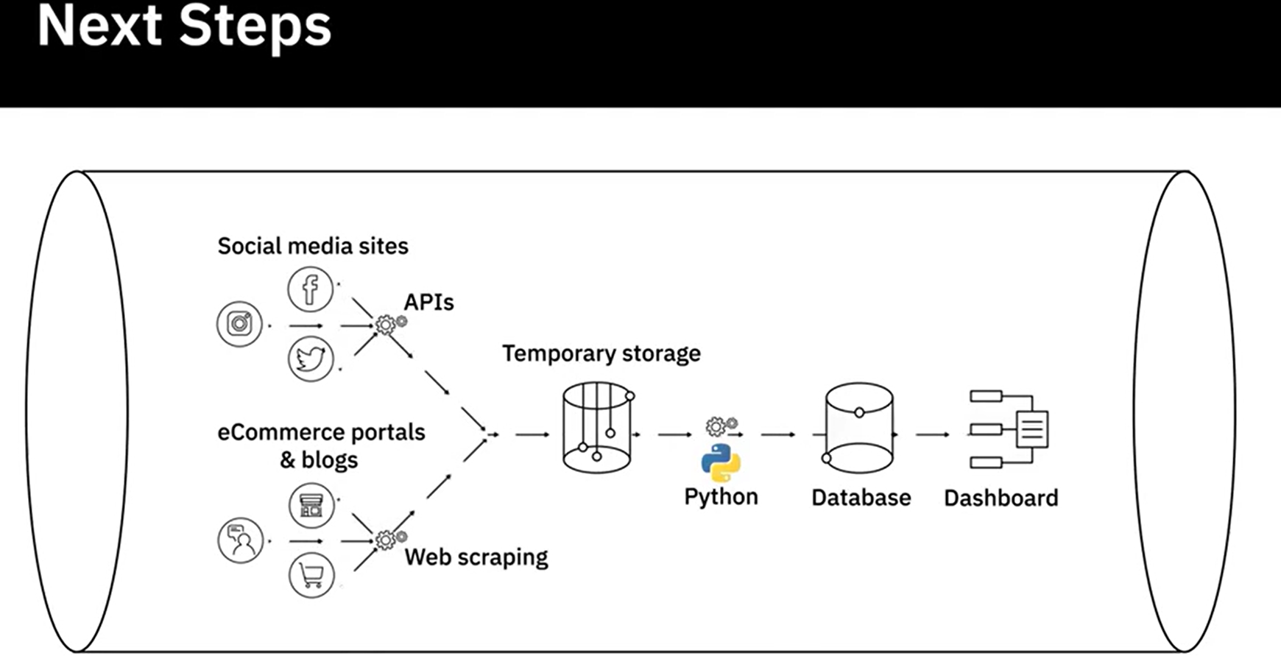

Lo ideal sería que pudieran sintonizar con el sentimiento del cliente y la percepción de la marca en tiempo real. Por lo tanto, la siguiente acción es construir un flujo de datos que extraiga, transforme, y cargue los datos de manera continua. Una vez que este proceso esté en marcha, los equipos de negocio podrán ver una proyección en tiempo real cada vez que inicien sesión en el panel de control.

**Summary and Highlights**

In this lesson, you have learned:

The role of a Data Engineer includes:

* Gathering data from disparate sources.
* Integrating data into a unified view for data consumers.
* Preparing data for analytics and reporting.
* Managing data pipelines for a continuous flow of data from source to destination systems.
* Managing the complete infrastructure for the collection, processing, and storage of data.

To be successful in their role, Data Engineers need a mix of technical, functional, and soft skills.

* Technical Skills include working with different operating systems and infrastructure components such as virtual machines, networks, and application services. It also includes working with databases and data warehouses, data pipelines, ETL tools, big data processing tools, and languages for querying, manipulating, and processing data.
* An understanding of the potential application of data in business is an important skill for a data engineer. Other functional skills include the ability to convert business requirements into technical specifications, an understanding of the software development lifecycle, and the areas of data quality, privacy, security, and governance.
* Soft Skills include interpersonal skills, the ability to work collaboratively, teamwork, and effective communication.

**Quiz**  
**Question 1. Which one of these skills is essential to the role of a Data Engineer?**

Proficiency in Statistics

To setup and manage the infrastructure required for the ingestion, processing, and storage of data

Proficiency in creating Deep Learning models

To inspect analytics-ready data for deriving insights

**Correct**

Data Engineers are responsible for setting up and managing the infrastructure required for ingesting raw data, processing it, and storing it so that it is available for analytics.

**Question 2. What, according to Sarah Flinch, needs to be tracked and analyzed in order to keep business updated on the overall sentiment of the consumers?**

eCommerce platforms

Blogging sites

Social media posts, customer reviews and ratings on eCommerce platforms, and product reviews on blogging sites

Social media sites

**Correct**

How a product gets talked about on social media, eCommerce platforms, and blogging sites has an immediate impact on sales numbers and brand perception.

**Graded quiz**

**1. Which one of these functional skills is essential to the role of a Data Engineer?**

Inspect analytics-ready data for deriving insights

The ability to work with the software development lifecycle

Proficiency in Mathematics

Proficiency in working with ETL Tools

**Correct**

As a Data Engineer, you will be required to work through different phases of the software development lifecycle, which includes, ideation, architecture, design, prototyping, testing, deployment, and monitoring.

**2. Oracle Exadata, IBM Db2 Warehouse on Cloud, IBM Netezza Performance Server, and Amazon RedShift are some of the popular __________________ in use today.**

NoSQL Databases

Data Warehouses

Big Data Platforms

ETL Tools

**Correct**

These are some of the popularly used data warehouses.

**Question 3. Data Engineers manage the infrastructure required for the ingestion, processing, and storage of data.**

True

False

**Correct**

This is one of the primary responsibilities of a Data Engineer.

## **Module 2**

### **The Data Ecosystem and Languages for Data Professionals**

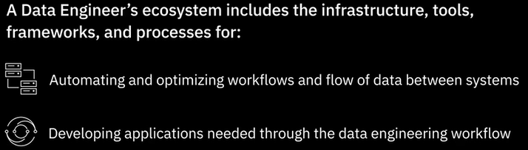

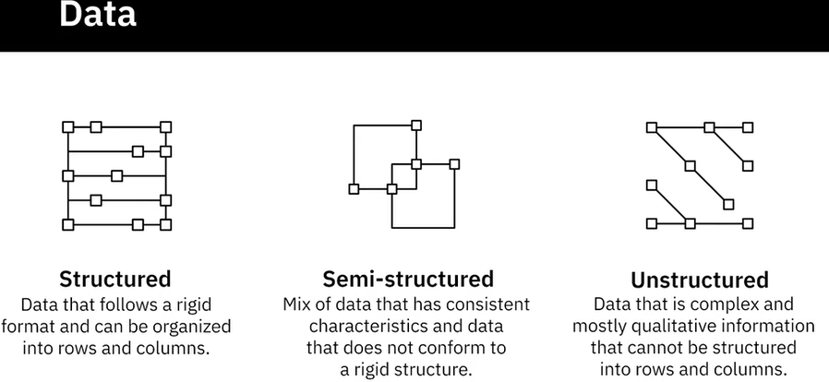

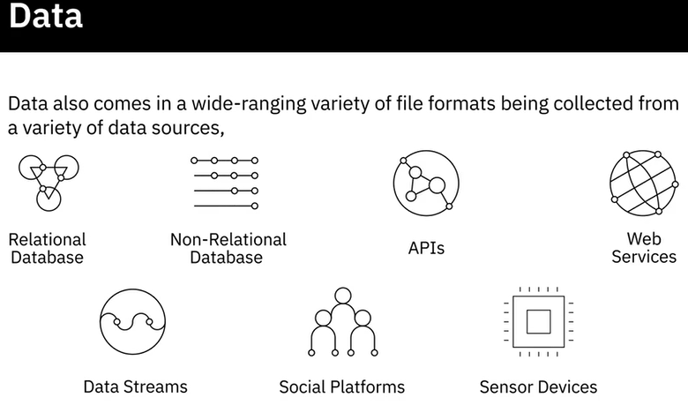

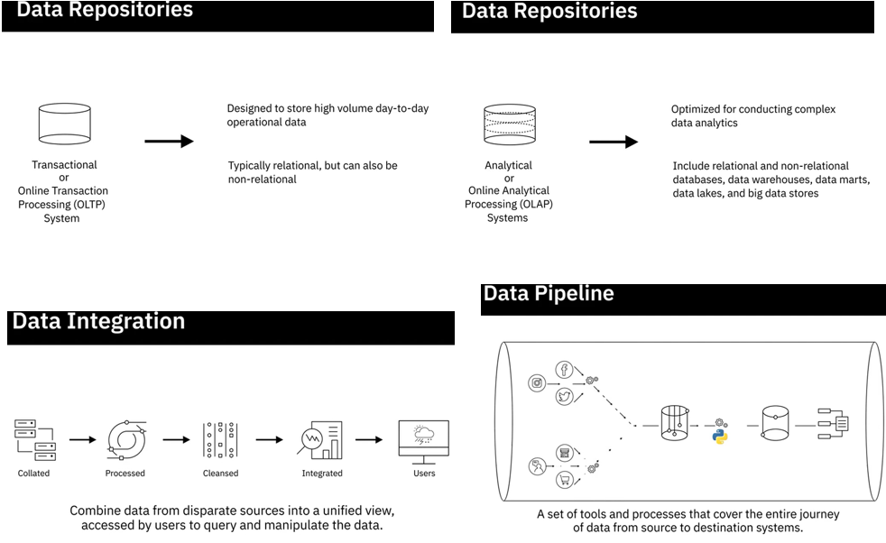

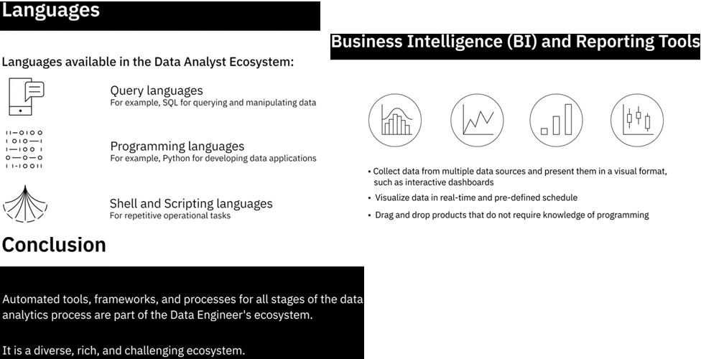

### Type of data

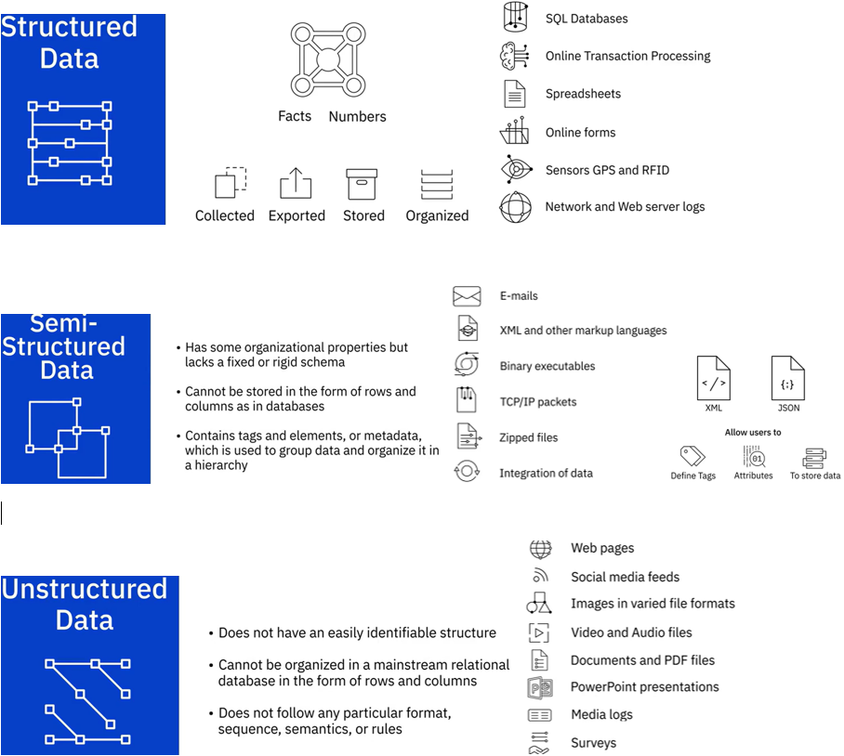

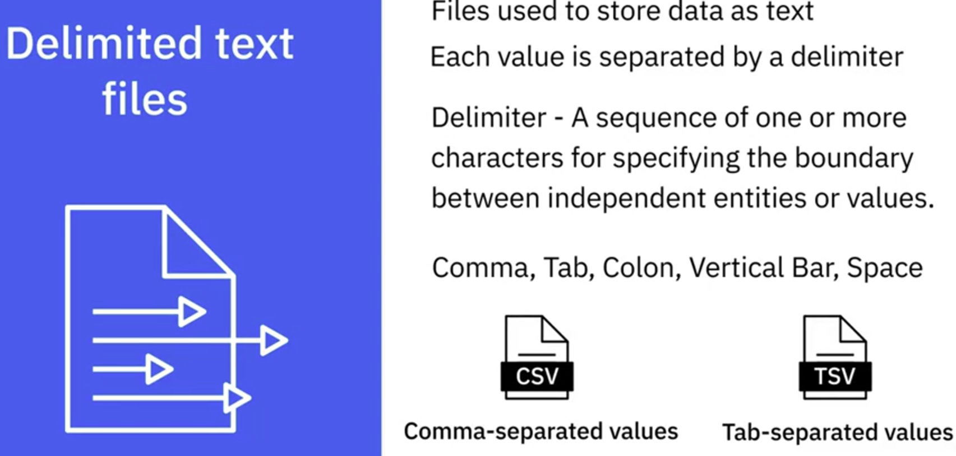

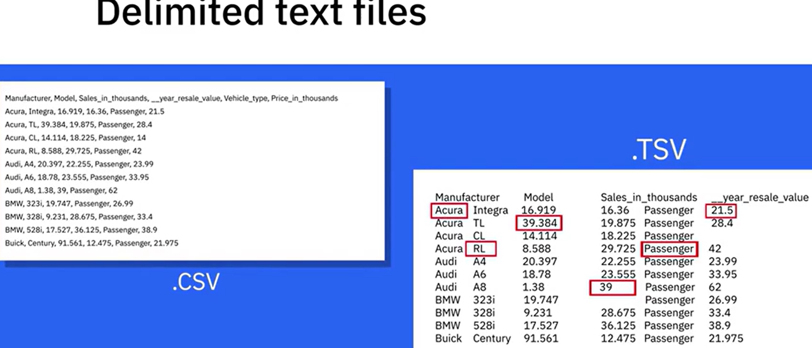

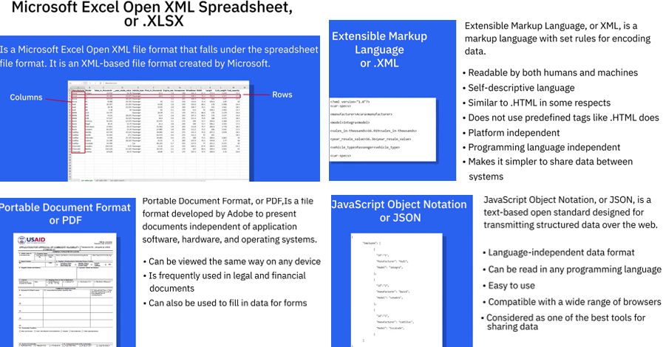

### **Sources of Data**

Common sources of data:

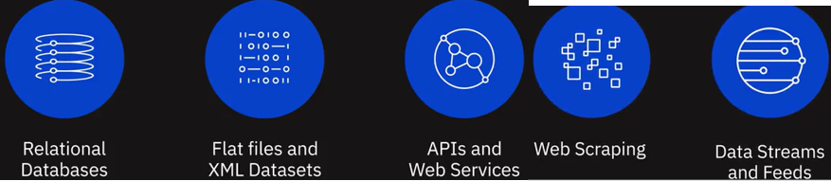

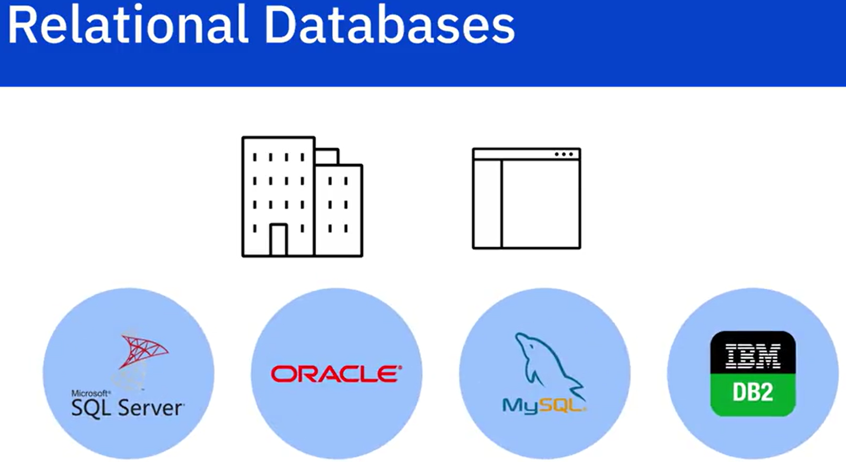

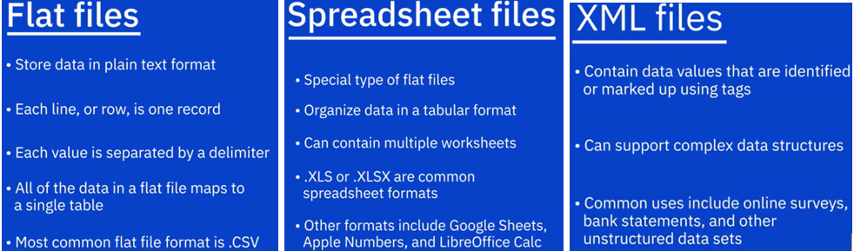

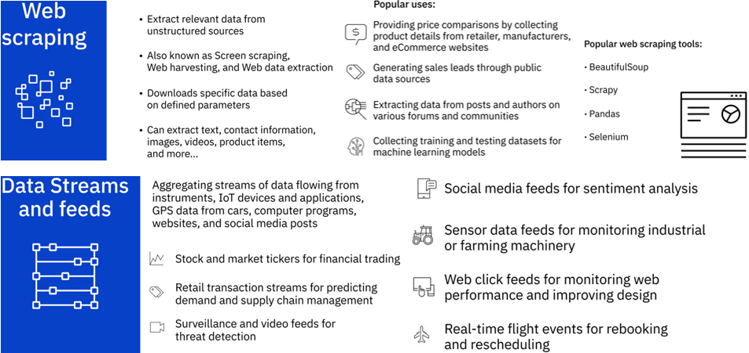

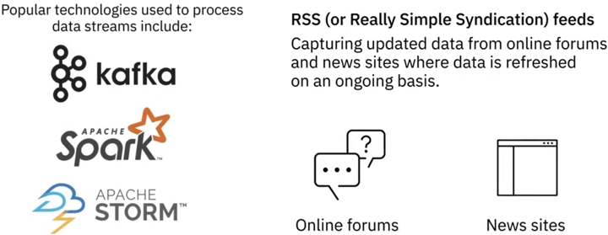

### Language for Data Professionals

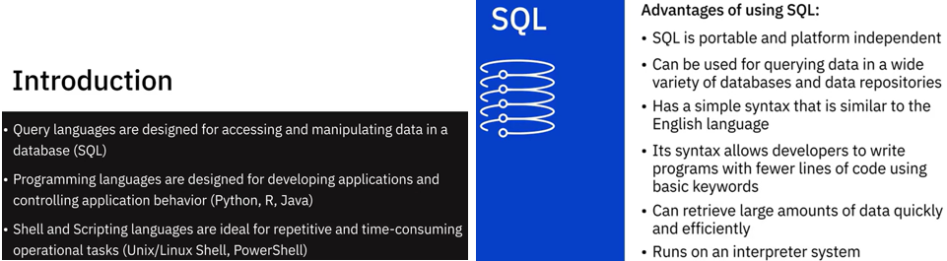

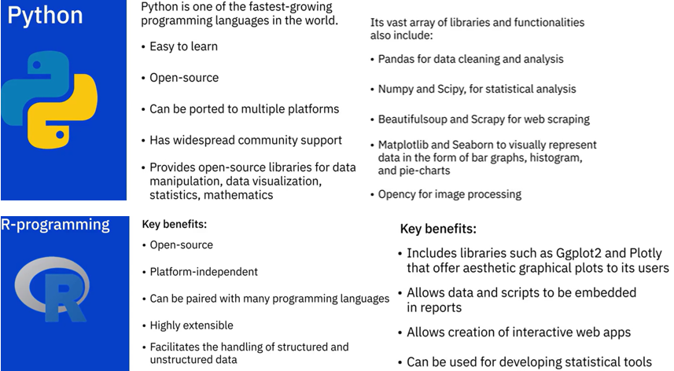

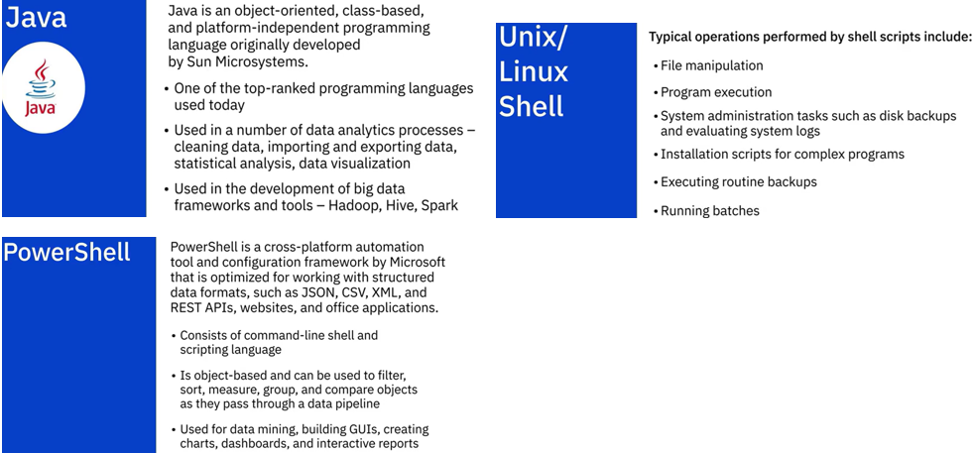

### **Summary Metadata**

**What is metadata?**

Metadata is data that provides information about other data.

This is a very broad definintion. Here we will consider the concept of metadata within the context of databases, data warehousing, business intelligence systems, and all kinds of data repositories and platforms.

We'll consider the following three main types of metadata:

* Technical metadata
* Process metadata, and
* Business metadata

**Technical metadata**

Technical metadata is metadata which defines the data structures in data repositories or platforms, primarily from a technical perspective.

For example, technical metadata in a data warehouse includes assets such as:

* Tables that record information about the tables stored in a database, like:
  + each table's name
  + the number of columns and rows each table has
* A data catalog, which is an inventory of tables that contain information, like:
  + the name of each database in the enteprise data warehouse
  + the name of each column present in each database
  + the names of every table that each column is contained in
  + the type of data that each column contains

The technical metadata for relational databases is typically stored in specialized tables in the database called the System Catalog.

**Process metadata**

Process metadata describes the processes that operate behind business systems such as data warehouses, accounting systems, or customer relationship management tools.

Many important enterprise systems are responsible for collecting and processing data from various sources. Such critical systems need to be monitored for failures and any performance anomalies that arise. Process metadata for such sytems includes tracking things like:

* process start and end times
* disk usage
* where data was moved from and to, and
* how many users access the system at any given time

This sort of data is invaluable for troubleshooting and optimizing workflows and ad hoc queries.

**Business metadata**

Users who want to explore and analyze data within and outside the enterprise are typically interested in *data discovery*. They need to be able to find data which is meaningful and valuable to them and know where that data can be accessed from. These business-minded users are thus interested in business metadata, which is information about the data described in readily interpretable ways, such as:

* how the data is acquired
* what the data is measuring or describing
* the connection between the data and other data sources

Business metadata also serves as documentation for the entire data warehouse system.

**Managing metadata**

Managing metadata includes developing and administering policies and processes to ensure information can be accessed and integrated from various sources and appropriately shared across the entire enterprise.

Creation of a reliable, user-friendly data catalog is a primary objective of a metadata management model. The data catalog is a core component of a modern metadata management system, serving as the main asset around which metadata management is administered. It serves as the basis by which companies can inventory and efficiently organize their data systems. A modern metadata managment model will include a web-based user interface that enables engineers and business users to easily search for and find information on key attributes such as CustomerName or ProductType. This kind of model is central to any Data Governance initiative.

**Why is metadata management important?**

Good metadata management has many valuable benefits. Having access to a well implemented data catalog greatly enhances data discovery, repeatability, governance, and can also facilitate access to data.

Well managed metadata helps you to understand both the business context associated with the enterprise data and the data lineage, which helps to improve data governance. Data lineage provides information about the origin of the data and how it gets transformed and moved, and thus it facilitates tracing of data errors back to their root cause. Data governance is a data management concept concerning the capability that enables an organization to ensure that high data quality exists throughout the complete lifecycle of the data, and data controls are implemented that support business objectives.

The key focus areas of data governance include availability, usability, consistency, data integrity and data security and includes establishing processes to ensure effective data management throughout the enterprise such as accountability for the adverse effects of poor data quality and ensuring that the data which an enterprise has can be used by the entire organization.

**Popular tools for metadata management**

Popular metadata management tools include:

* IBM InfoSphere Information Server
* CA Erwin Data Modeler
* Oracle Warehouse Builder
* SAS Data Integration Server
* Talend Data Fabric
* Alation Data Catalog
* SAP Information Steward
* Microsoft Azure Data Catalog
* IBM Watson Knowledge Catalog
* Oracle Enterprise Metadata Management (OEMM)
* Adaptive Metadata Manager
* Unifi Data Catalog
* data.world
* Informatica Enterprise Data Catalog

**Summary**

In this reading, you learned that:

* Metadata is data that provides information about other data, and includes three main types: technical, process, and business metadata
* The technical metadata for relational databases is typically stored in specialized tables in the database called the system catalog
* A primary objective of business metadata management modelling is the creation and maintenance of a reliable, user-friendly data catalog
* Having access to a well-implemented data catalog greatly enhances data discovery, repeatability, governance, and can also facilitate access to data
* Metadata management tools from IBM include InfoSphere Information Server and Watson Knowledge Catalog

### Summary and Highlights

In this lesson, you have learned:

A Data Engineer’s ecosystem includes the infrastructure, tools, frameworks, and processes for extracting data, architecting and managing data pipelines and data repositories, managing workflows, developing applications, and managing BI and Reporting tools.

Based on how well-defined the structure of the data is, data can be categorized as

* Structured data, that is data which is well organized in formats that can be stored in databases.
* Semi-structured data, that is data which is partially organized and partially free-form.
* Unstructured data, that is data which can not be organized conventionally into rows and columns.

Data comes in a wide-ranging variety of file formats, such as, delimited text files, spreadsheets, XML, PDF, and JSON, each with its own list of benefits and limitations of use.

Data is extracted from multiple data sources, ranging from relational and non-relational databases, to APIs, web services, data streams, social platforms, and sensor devices.

Once the data is identified and gathered from different sources, it needs to be staged in a data repository so that it can be prepared for analysis. The type, format, and sources of data influence the type of data repository that can be used.

Data professionals need a host of languages that can help them extract, prepare, and analyse data. These can be classified as:

* Querying languages, such as SQL, used for accessing and manipulating data from databases.
* Programming languages such as Python, R, and Java, for developing applications and controlling application behavior.
* Shell and Scripting languages, such as Unix/Linux Shell, and PowerShell, for automating repetitive operational tasks.

**Practice Quiz**

**Question 1. Automated tools, frameworks, and processes for all stages of the data analytics process are part of the Data Engineer’s ecosystem. What role do data integration tools play in this ecosystem?**

Conduct complex data analytics

Combine data from multiple sources into a unified view that is accessed by data consumers to query and manipulate data

Cover the entire journey of data from source to destination

Store high-volume day-to-day operational data in data repositories

**Correct**

Data Integration tools provide a unified view to data collected from disparate sources so that it can be accessed via a single interface for query and manipulation by data consumers.

**Question 2. Which of these data sources is an example of semi-structured data?**

Emails

Social media feeds

Documents

Network and web logs

**Correct**

Emails are a source of semi-structured data as they have a mix of data with some organizational properties but do not follow a rigid schema.

**Question 3. Which one of the provided file formats is commonly used by APIs and Web Services to return data?**

XLS

Delimited file

JSON

XML

**Correct**

JSON is the format that is most used by APIs and Web Services to return data.

**Question 4. What is one example of the relational databases discussed in the video?**

Spreadsheet

SQL Server

Flat files

XML

**Correct**

SQL Server is one of the examples of relational databases shared in the video.

**Question 5. Which of the following languages is one of the most popular querying languages in use today?**

SQL

Python

R

Java

**Correct**

SQL, or Structured Query Language, is one of the most popular querying languages in use today.

**Graded Quiz**

**Question 1. There are two main types of data repositories – Transactional and Analytical. For high-volume day-to-day operational data such as banking transactions, Transactional, or OLTP, systems are the ideal choice.**

True

False

**Correct**

Transactional, or OLTP, systems are designed and optimized for handling high-volume transactions.

**Question 2. Which of the following is an example of unstructured data?**

Zipped files

Video and Audio files

Spreadsheets

XML

**Correct**

Video and audio files are examples of unstructured data.

**Question 3. Which one of these file formats is independent of software, hardware, and operating systems, and can be viewed the same way on any device?**

XML

XLSX

Delimited text file

PDF

**Correct**

This is not true of delimited text files.

**Question 4. Which data source can return data in plain text, XML, HTML, or JSON among others?**

XML

Delimited text file

APIs

PDF

**Correct**

APIs can return data in a wide variety of formats such as plain text, XML, HTML, or JSON among others.

**Question 5. In the data engineer’s ecosystem, languages are classified by type. What are shell and scripting languages most commonly used for?**

Building apps

Automating repetitive operational tasks

Manipulating data

Querying data

**Correct**

Shell and scripting languages are commonly used for automating repetitive operational tasks.

### **Data Repositories, Data Pipelines, and Data Integration Platforms**

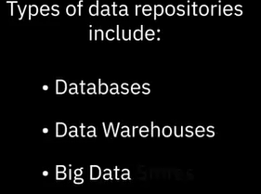 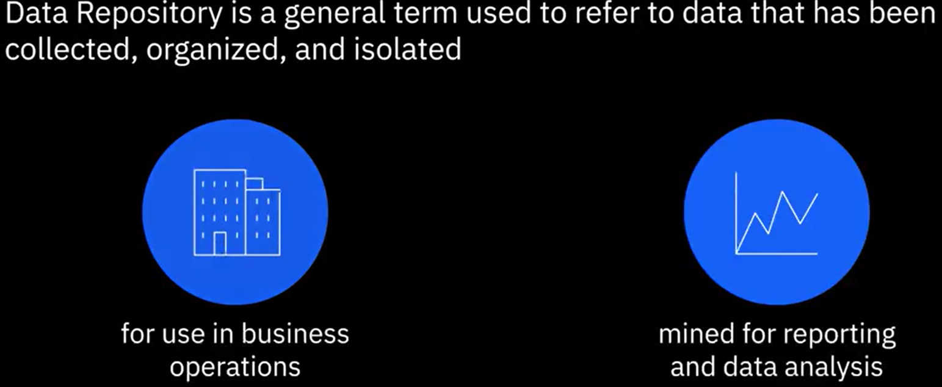

Database management system (DBMS):



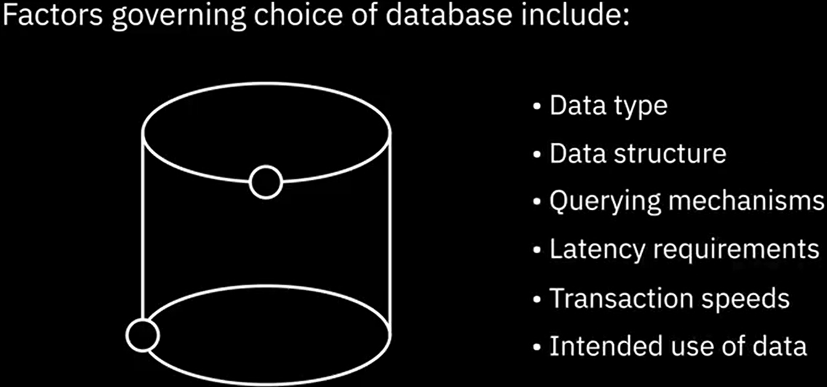

|  |  |
| --- | --- |
| Relational DB: | Non-Relational DB: |

**Data warehouse**

A data warehouse works as a central repository that merges information coming from disparate sources and consolidates it through the extract, transform, and load process, also known as the ETL process, into one comprehensive database for analytics and business intelligence.

At a very high-level, the ETL process helps you to extract data from different data sources, transform the data into a clean and usable state, and load the data into the enterprise’s data repository.

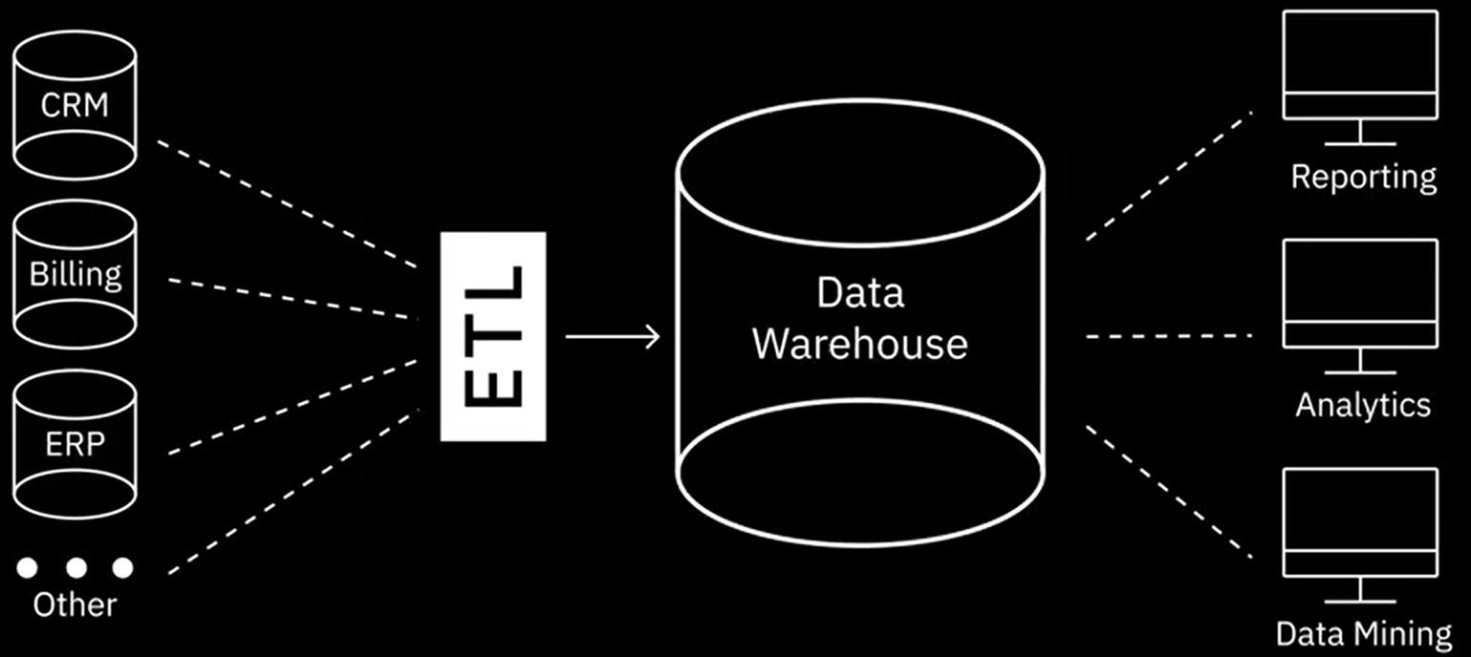

**Big Data Stores:**

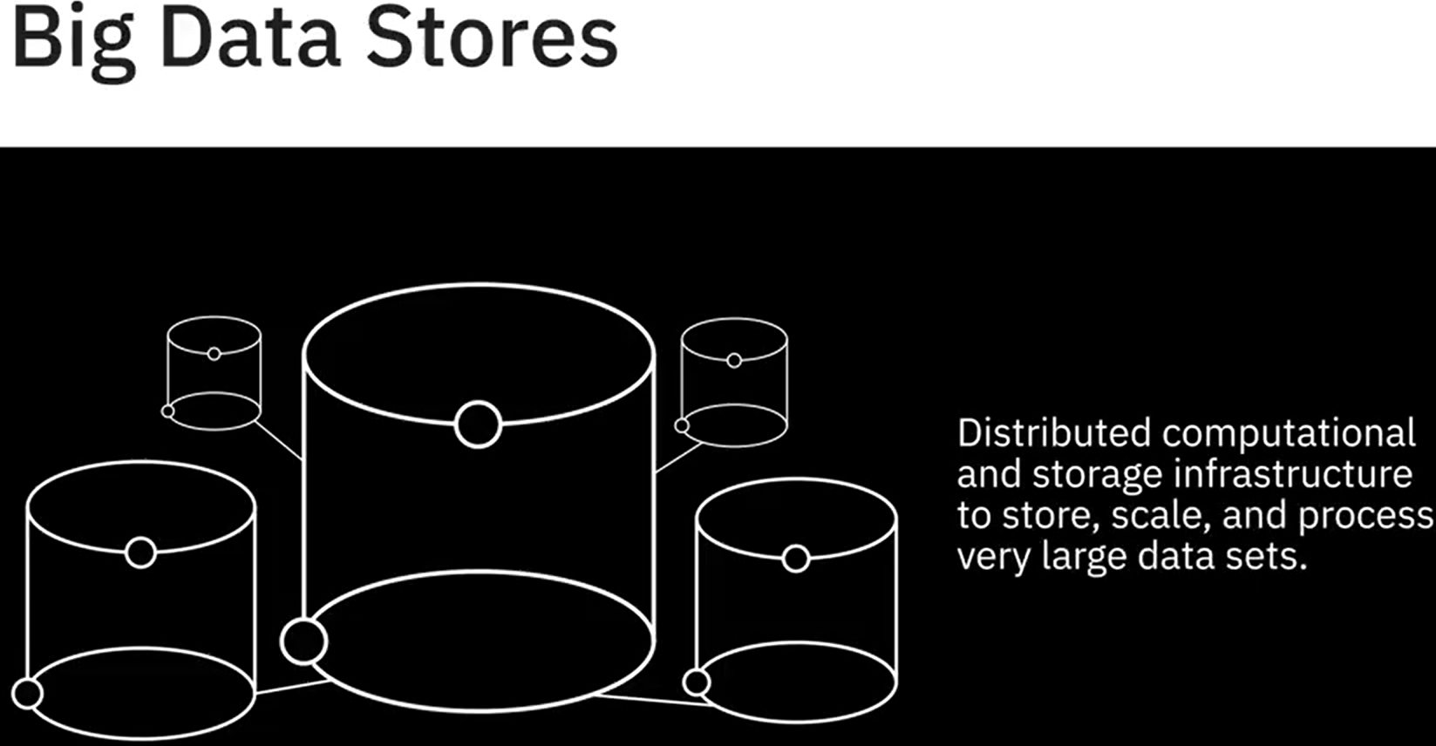



RDBMS (Relational database Management system)

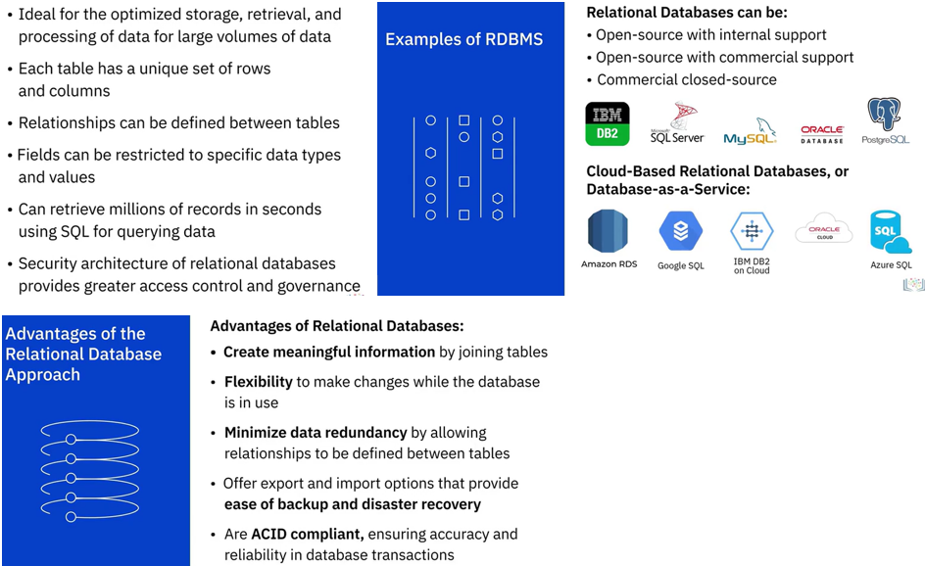

ACID (Atomicidad, Consistencia, Aislamiento, y Durabilidad)

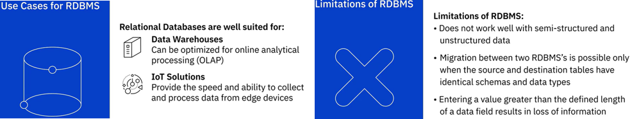

**NoSQL**

Based on the model being used for storing data, there are four common types of NoSQL databases: Key-value store, Document-based, Column-based, and graph-based

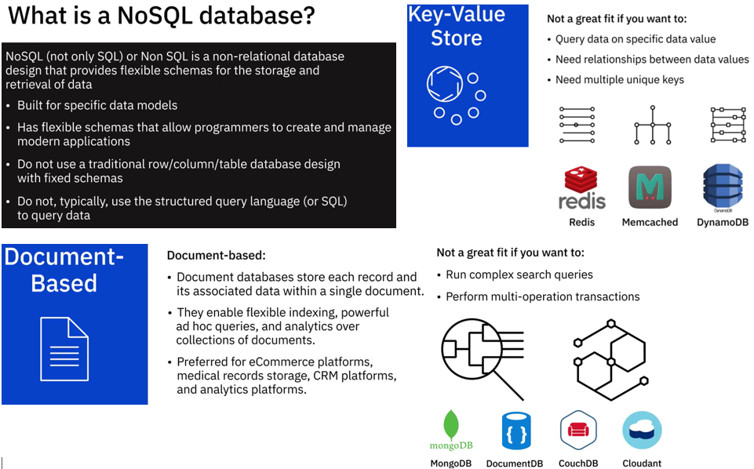

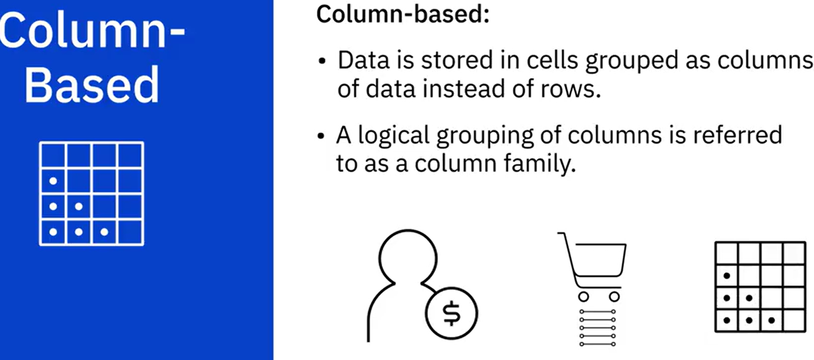 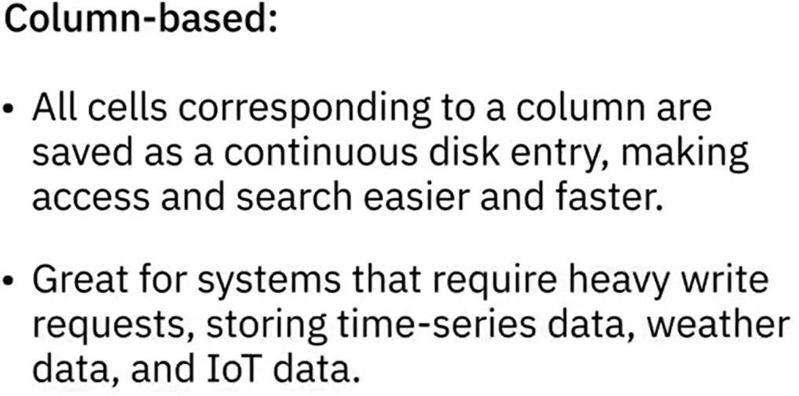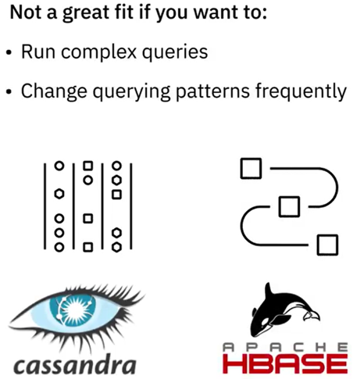

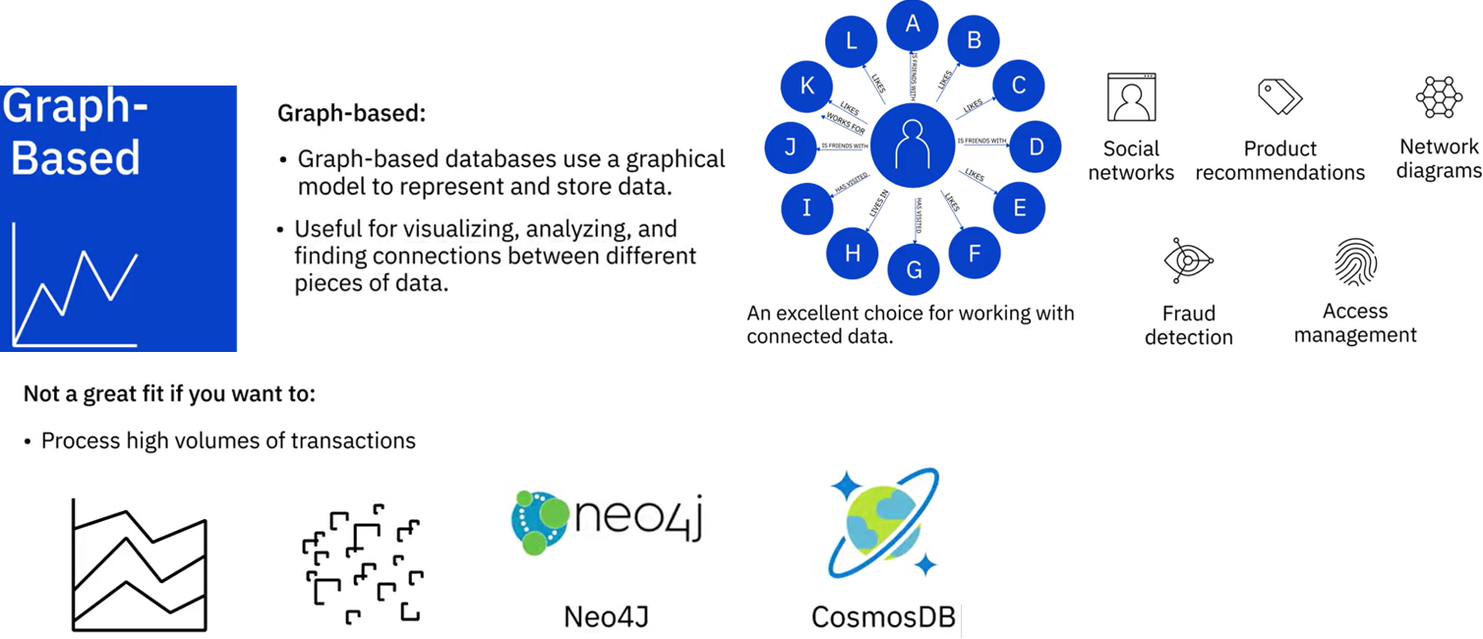

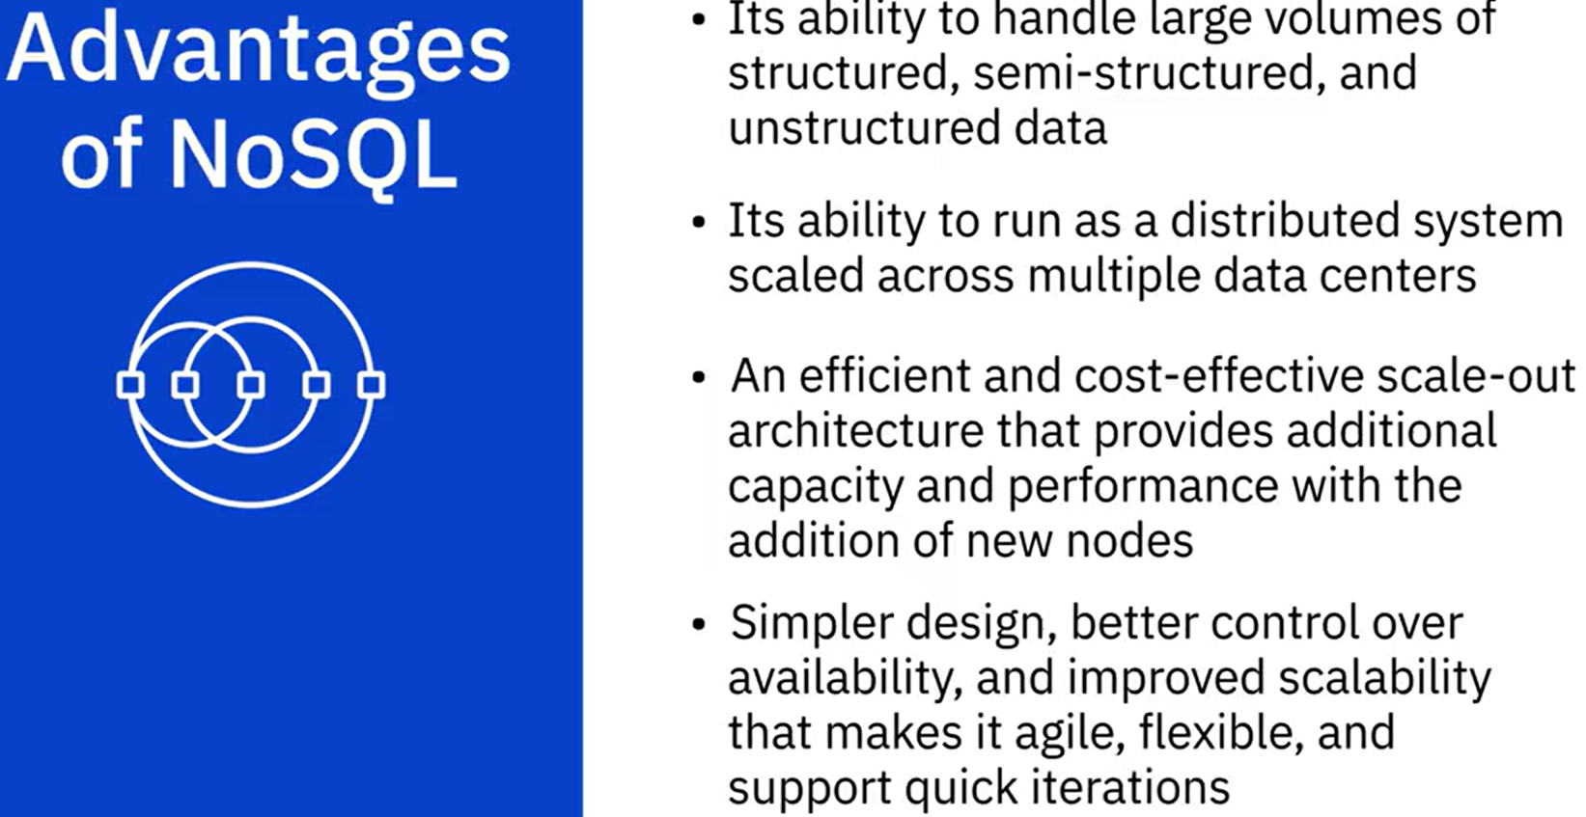

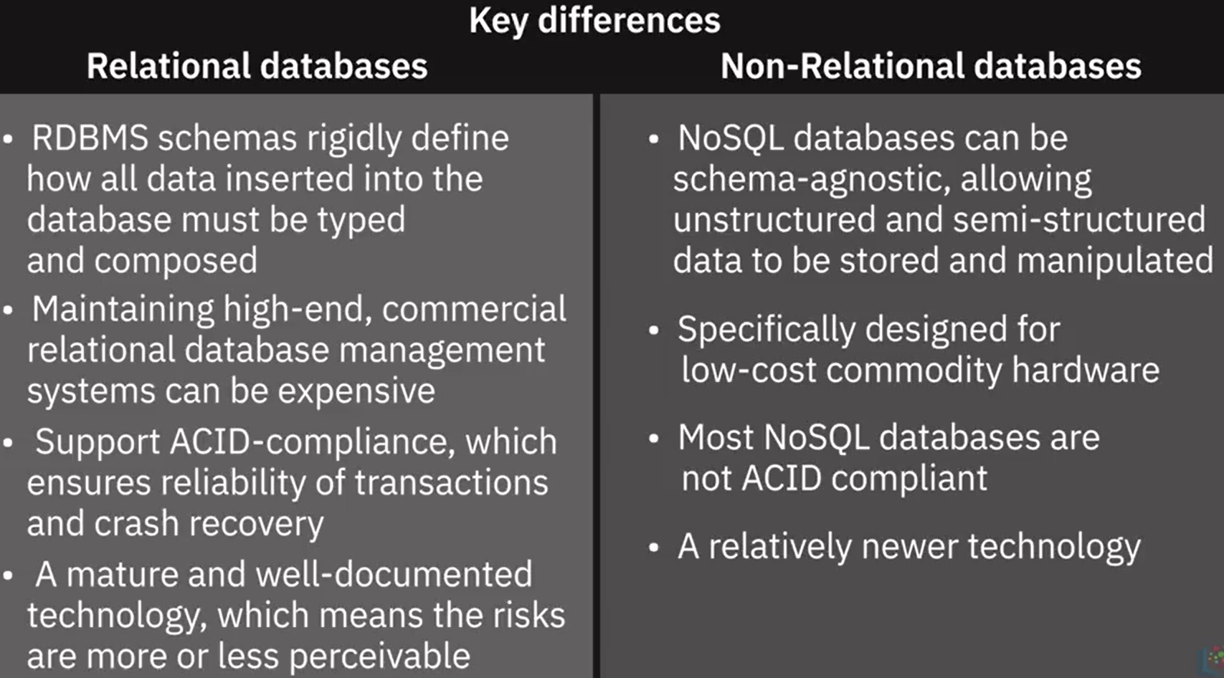

### Data Warehouses, Data Marts, and Data Lakes

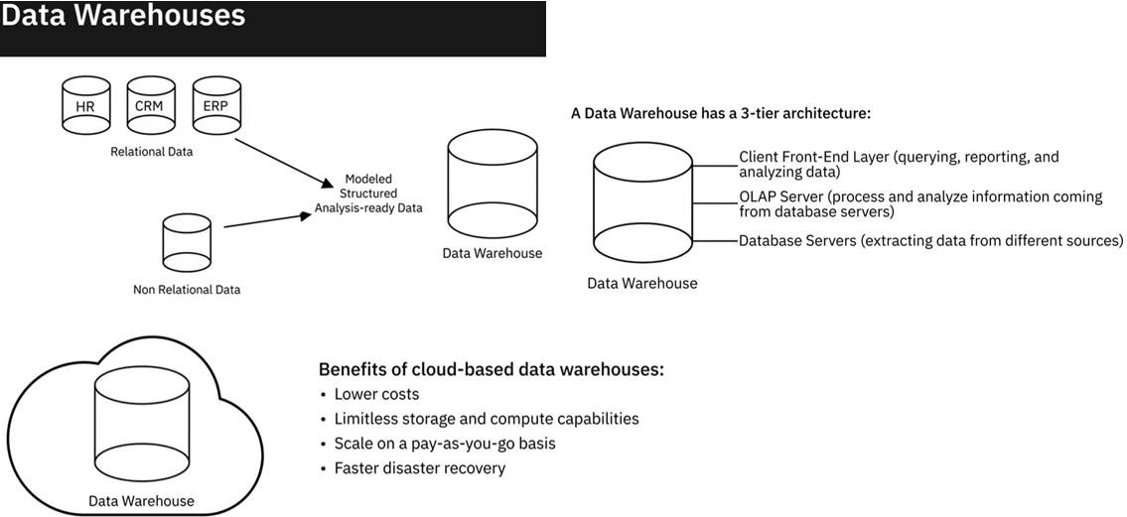

Examples of Data Warehouses:

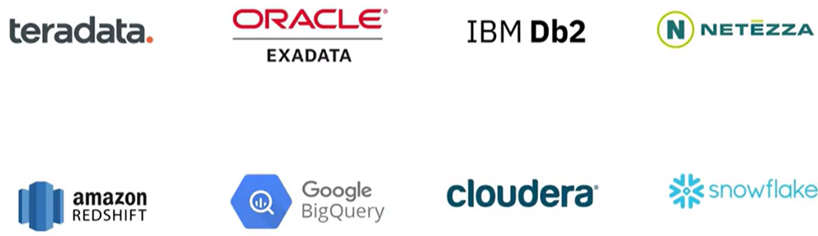

Data Marts (Mercado de datos)

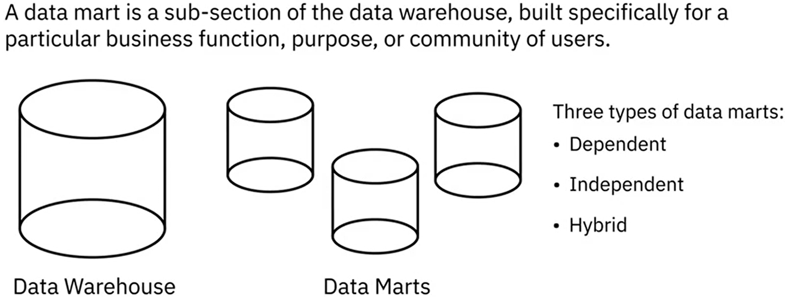 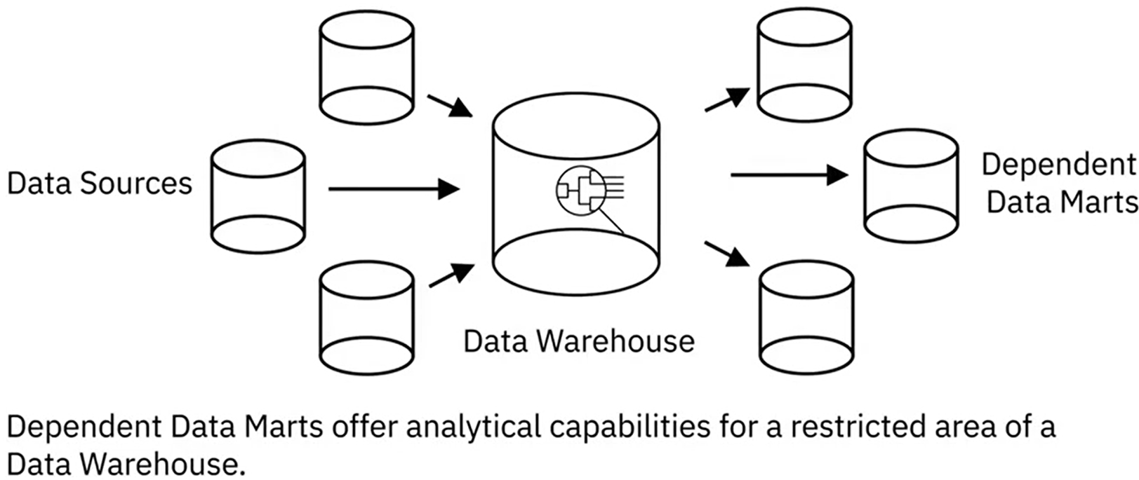

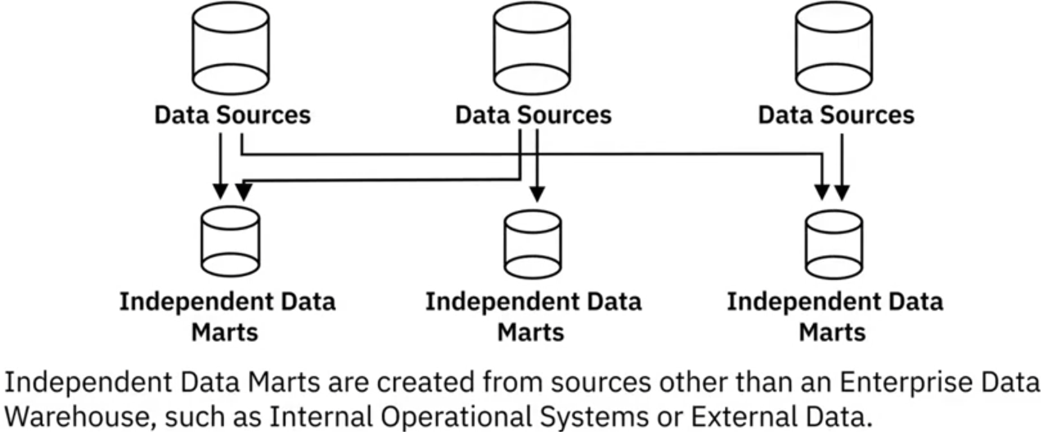 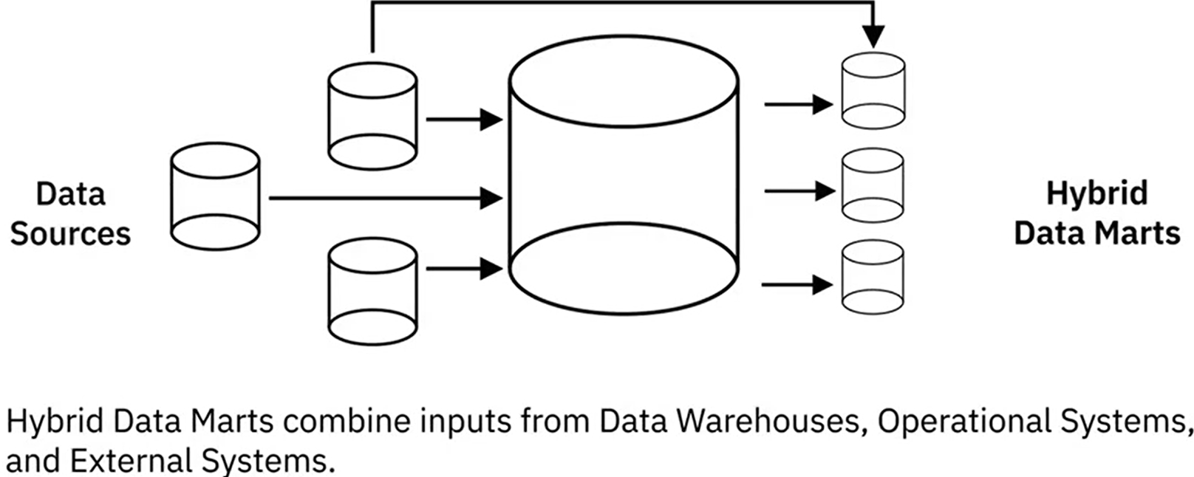

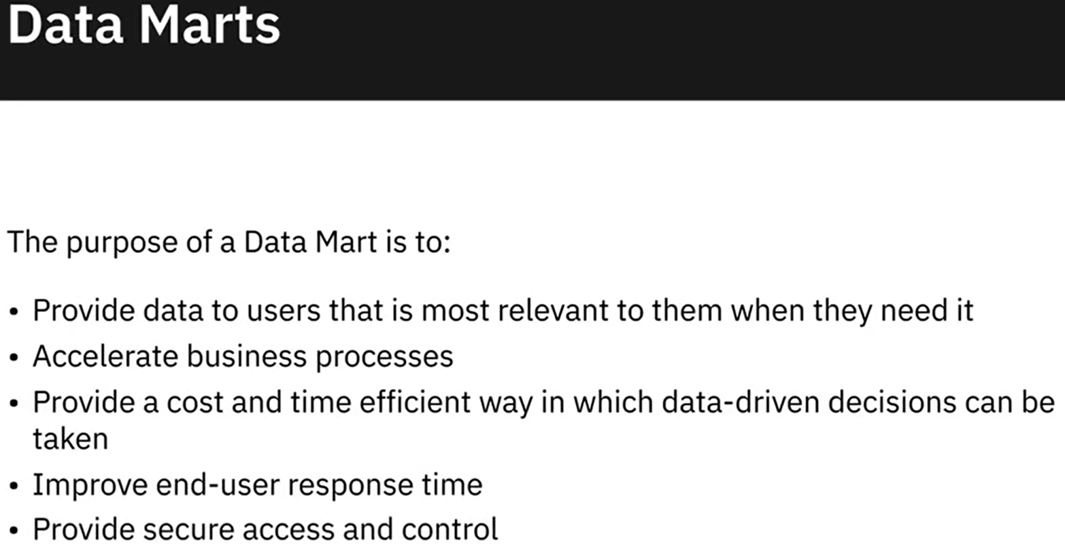

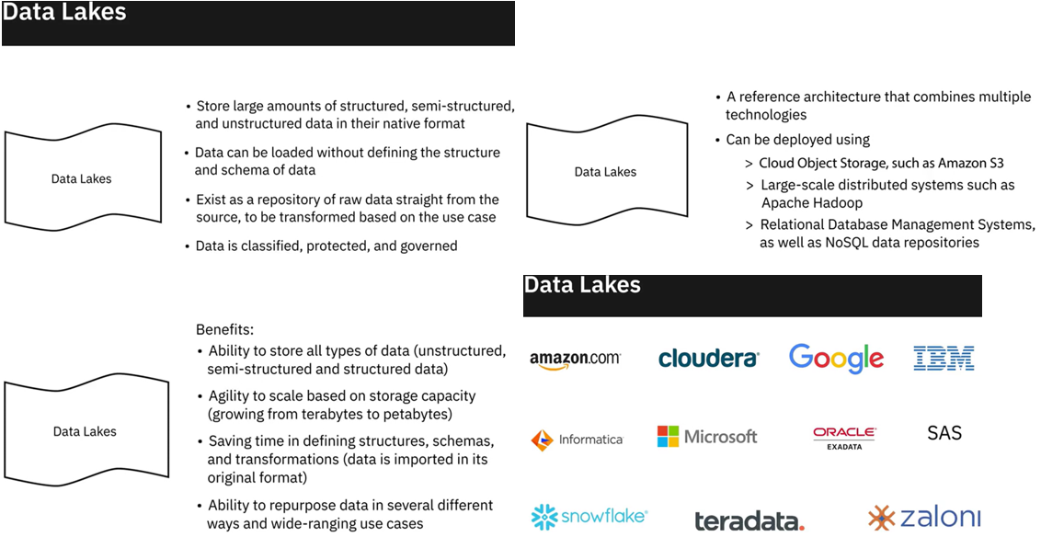

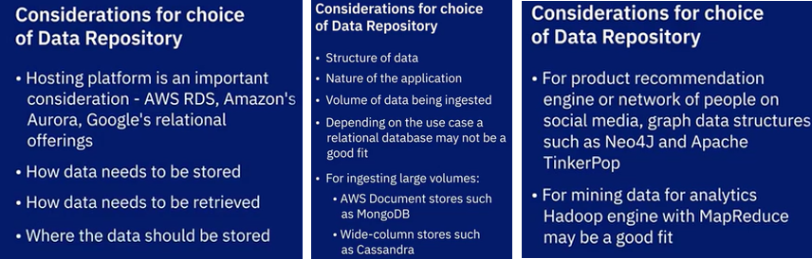

### **ETL, ELT, and Data Pipelines**

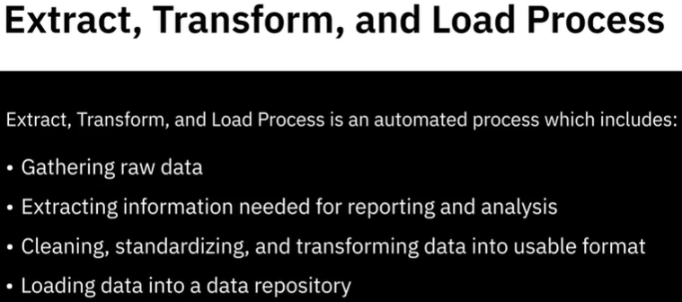 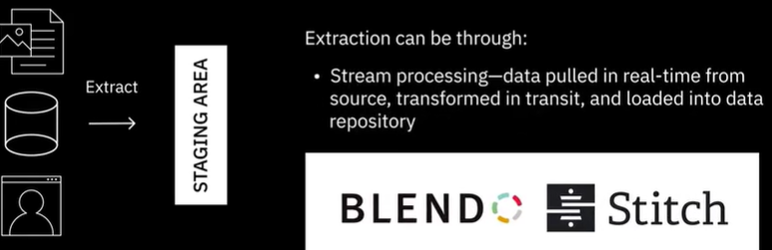

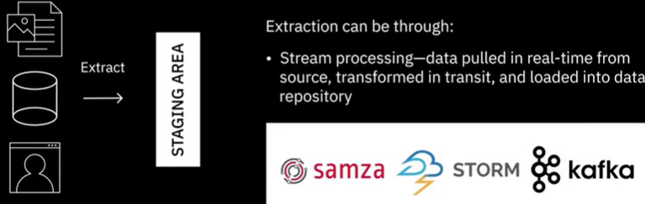

Las herramientas para el procesamiento de transmisiones incluyen Apache SAMSA, Apache Storm, y Apache Kafka.

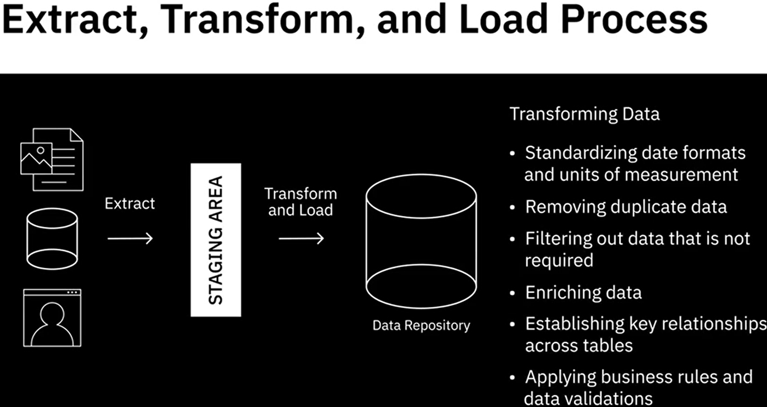 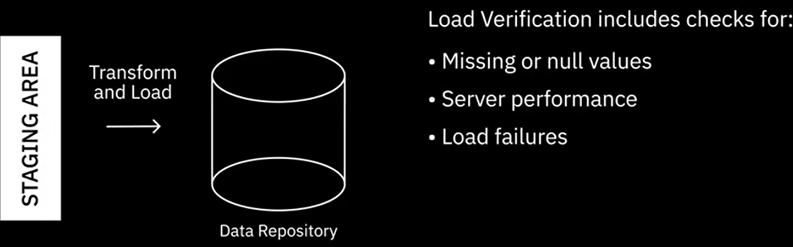

Popular ETLs:



Ahora veamos una variación del proceso ETL. En el proceso ELT, los datos extraídos se cargan primero en el sistema de destino y las transformaciones se aplican en el sistema de destino. El sistema de destino para una canalización ELT es muy probablemente un lago de datos, aunque también puede ser un almacén de datos.

ELT es útil para procesar grandes conjuntos de datos no estructurados y no relacionales.

El proceso ELT tiene varias ventajas. Dado que los datos en bruto se entregan directamente al sistema de destino en lugar de a un entorno de preparación, esto acorta el ciclo entre la extracción y la entrega.

ELT combinado con un lago de datos te permite ingerir volúmenes de datos en bruto tan pronto como los datos estén disponibles. En comparación con el proceso ETL, ELT ofrece mayor flexibilidad a los analistas y científicos de datos para la analítica de datos exploratoria.

ELT transforma solo aquellos datos que se requieren para un análisis particular, por lo que puede aprovecharse para Casos de uso múltiples.

En el proceso ETL, puede ser necesario modificar toda la estructura de los datos en el almacén si no es adecuada para un nuevo caso de uso. ELT está más adaptado para trabajar con big data.

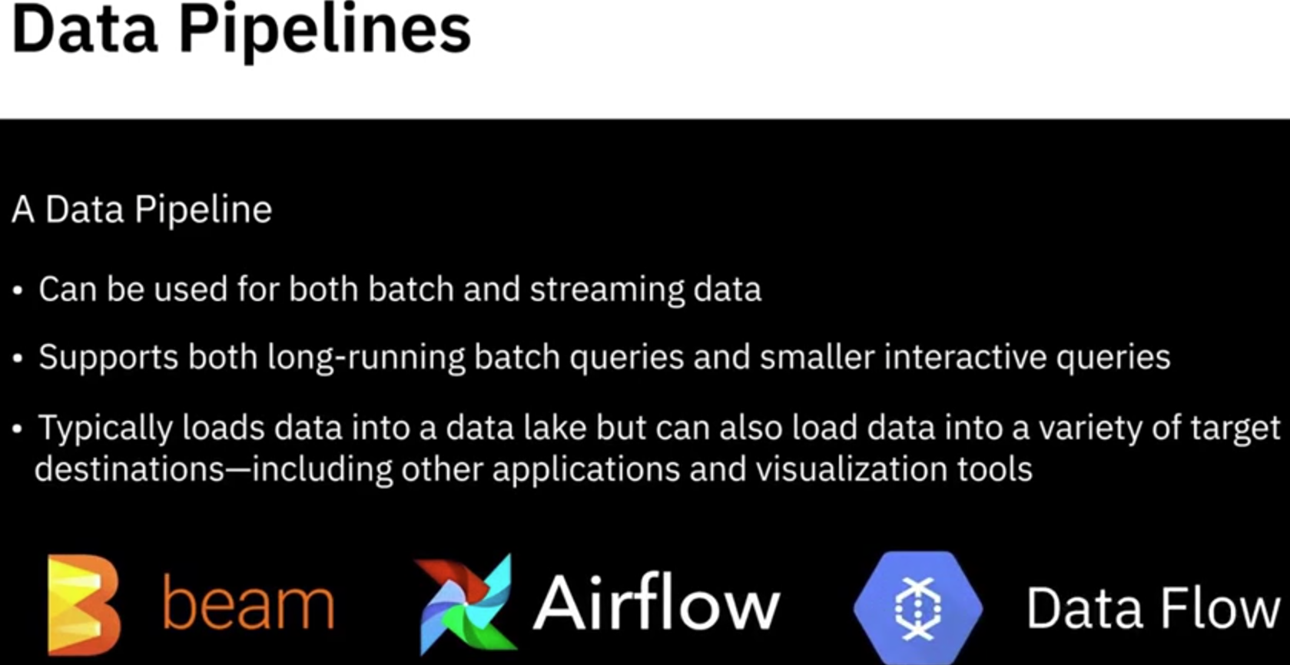 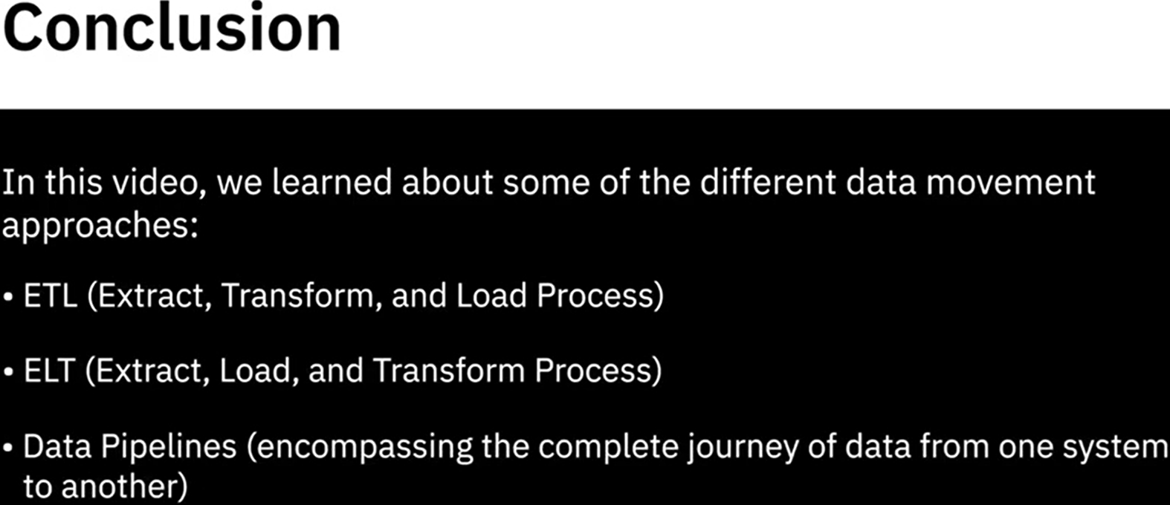

Hay varias soluciones de canalización de datos disponibles, siendo las más populares Apache Beam, Airflow, y Dataflow.

### Data integration platform

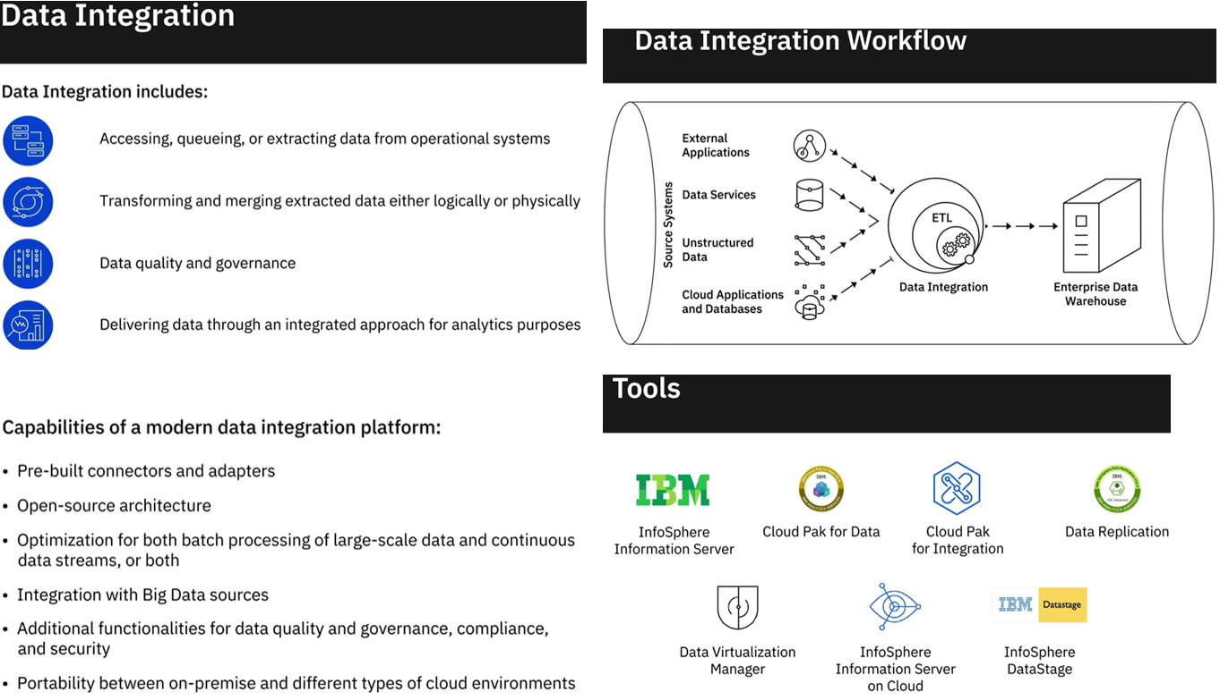Las herramientas de integración de datos de Talend incluyen Talend Data Fabric, Talend Cloud, Talend Data Catalog, Talend Data Management, Talend Big Data, Talend Data Services y Talend Open Studio. Además, se debe considerar la Administración de datos y UO. SAP, Oracle, Denodo, SAS, Microsoft, Qlik y TIBCO son algunos de los otros proveedores que ofrecen herramientas y plataformas de integración de datos.

Algunos ejemplos de marcos de código abierto incluyen Dell Boomi, Jitterbit, y SnapLogic. Hay una cantidad significativa de proveedores que ofrecen una plataforma de integración basada en la nube como servicio, o IPaaS, como un servicio alojado a través de una nube privada virtual o una nube híbrida, como Adeptia Integration Suite, Cooperation 534 de Google Cloud, Application Integration Suite on Cloud de IBM y Integration Cloud de Informatica.

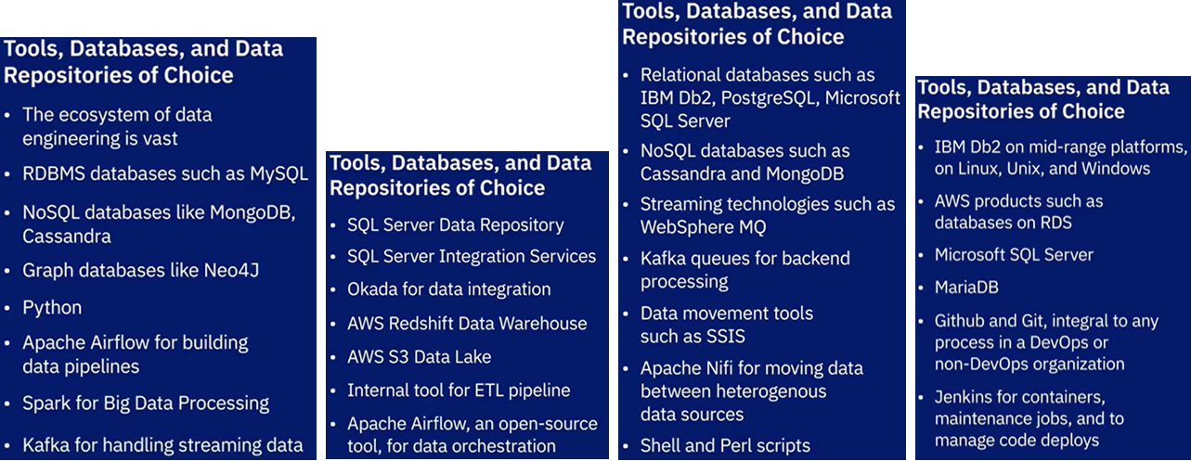

**Summary:**

In this lesson, you have learned:

A Data Repository is a general term that refers to data that has been collected, organized, and isolated so that it can be used for reporting, analytics, and also for archival purposes.

The different types of Data Repositories include:

* Databases, which can be relational or non-relational, each following a set of organizational principles, the types of data they can store, and the tools that can be used to query, organize, and retrieve data.
* Data Warehouses, that consolidate incoming data into one comprehensive store house.
* Data Marts, that are essentially sub-sections of a data warehouse, built to isolate data for a particular business function or use case.
* Data Lakes, that serve as storage repositories for large amounts of structured, semi-structured, and unstructured data in their native format.
* Big Data Stores, that provide distributed computational and storage infrastructure to store, scale, and process very large data sets.

The ETL, or Extract Transform and Load, Process is an automated process that converts raw data into analysis-ready data by:

* Extracting data from source locations.
* Transforming raw data by cleaning, enriching, standardizing, and validating it.
* Loading the processed data into a destination system or data repository.

The ELT, or Extract Load and Transfer, Process is a variation of the ETL Process. In this process, extracted data is loaded into the target system before the transformations are applied. This process is ideal for Data Lakes and working with Big Data.

Data Pipeline, sometimes used interchangeably with ETL and ELT, encompasses the entire journey of moving data from its source to a destination data lake or application, using the ETL or ELT process.

Data Integration Platforms combine disparate sources of data, physically or logically, to provide a unified view of the data for analytics purposes.

Practice Quiz

**1. The term “data repositories” exclusively refers to RDBMes and NoSQL databases that are used to collect, organize, and isolate data for analytics.**

True

False

**Correct**

The term “data repositories” includes not just RDBMSes and NoSQL databases, it also includes data warehouses, data marts, and data lakes.

**Question 2. In use cases for RDBMS, what is one of the reasons that relational databases are so well suited for OLTP applications?**

Minimize data redundancy

Support the ability to insert, update, or delete small amounts of data

Offer easy backup and restore options

Allow you to make changes in the database even while a query is being executed

**Question 3. Which NoSQL database type stores each record and its associated data within a single document and also works well with Analytics platforms?**

Column-based

Key-value store

Document-based

Graph-based

**Correct**

Document-based NoSQL databases store each record and its associated data within a single document and work well with Analytics platforms.

**Question 4. What type of data repository is used to isolate a subset of data for a particular business function, purpose, or community of users?**

Data Lake

Data Mart

Data Pipeline

Data Warehouse

**Correct**

A data mart is a sub-section of the data warehouse used to isolate a subset of data for a particular business function, purpose, or community of users.

**Question 5. ____________ is ideal for data lakes where transformations on data are applied after raw data is loaded into the data lake.**

ETL (Extract-Transform-Load) Process

ELT (Extract-Load-Transform) Process

Batch Processing

Data Pipeline

**Correct**

ELT is useful for processing large sets of unstructured and non-relational data, which makes it ideal for use in data lakes, generally used for storing large amounts of structured, semi-structured, and unstructured data in their native format.

**Question 6. Which one of these statements explains what data integration is?**

Data Integration includes extracting, transforming, merging, and delivering quality data for analytical purposes

Data Integration is the process of loading data into a data repository

Data Integration is the process of applying business logic to source data

Data Integration is the process of extracting data

**Correct**

Data Integration extracts and combines disparate source data into a unified view so that data consumers can query and analyze the integrated data.

**Graded Quiz**

Question 1. Data Marts and Data Warehouses have typically been relational, but the emergence of what technology has helped to let these be used for non-relational data?

Data Lake

NoSQL

SQL

ETL

**Question 2. What is one of the most significant advantages of an RDBMS?**

Can store only structured data

Requires source and destination tables to be identical for migrating data

Enforces a limit on the length of data fields

Is ACID-Compliant

**Correct**

ACID-Compliance is one of the significant advantages of an RDBMS.

**Question 3. Which one of the NoSQL database types uses a graphical model to represent and store data, and is particularly useful for visualizing, analyzing, and finding connections between different pieces of data?**

Column-based

Document-based

Key value store

Graph-based

**Correct**

Graph-based NoSQL databases use a graphical model to represent and store data and are used for visualizing, analyzing, and finding connections between different pieces of data.

**Question 4. Which of the data repositories serves as a pool of raw data and stores large amounts of structured, semi-structured, and unstructured data in their native formats?**

Data Marts

Data Warehouses

Data Lakes

Relational Databases

**Correct**

A Data Lake can store large amounts of structured, semi-structured, and unstructured data in their native format, classified and tagged with metadata.

**Question 5. While data integration combines disparate data into a unified view of the data, a data pipeline covers the entire data movement journey from source to destination systems, and ETL is a process within data integration.**

True

False

**Correct**

A data pipeline covers the entire journey of data from source to destination. Data integration is performed within a data pipeline, while ETL is a process within data integration.

### [Optional] Create an instance of IBM Db2 database

IBM Db2 is a popular relational database from IBM that is used for both OLTP and Data Warehousing workloads.

In these labs you will:

1. Obtain a Feature Code for IBM Cloud
2. Create an IBM Cloud account using the feature code (so you don't have to provide a credit card)
3. Create an instance of IBM Db2 Lite

**Obtain IBM Cloud Feature Code and Activate Trial Account:**

[IBM Cloud](https://cloud.ibm.com/)

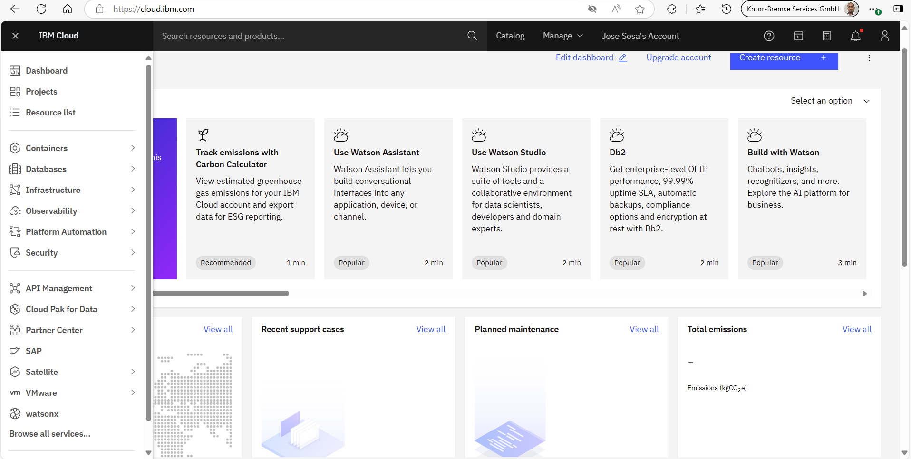

Now you may explore the [IBM Catalog](https://cloud.ibm.com/catalog?utm_source=skills_network&utm_content=in_lab_content_link&utm_id=Lab-IBM-CC0100EN-SkillsNetwork) for exploring the services and resources offered by IBM Cloud.

**LAB: Provision an instance of IBM Db2 Lite plan**

NOTE: IBM Cloud also provides variants of Db2, such as Db2 Hosted and Db2 Warehouse on Cloud. However, we will utilize the Db2 service for the lab in this course since it comes with a Lite plan, which is free to use.

Please follow the steps given below to provision your instance of IBM Db2 on Cloud.

1. Go to: [Log in to IBM Cloud](https://cloud.ibm.com/login?utm_source=skills_network&utm_content=in_lab_content_link&utm_id=Lab-IBM-DB0100EN-SkillsNetwork) and log in using your credentials.
2. Click on the **Catalog** menu item, Scroll down and check the **Databases** box.

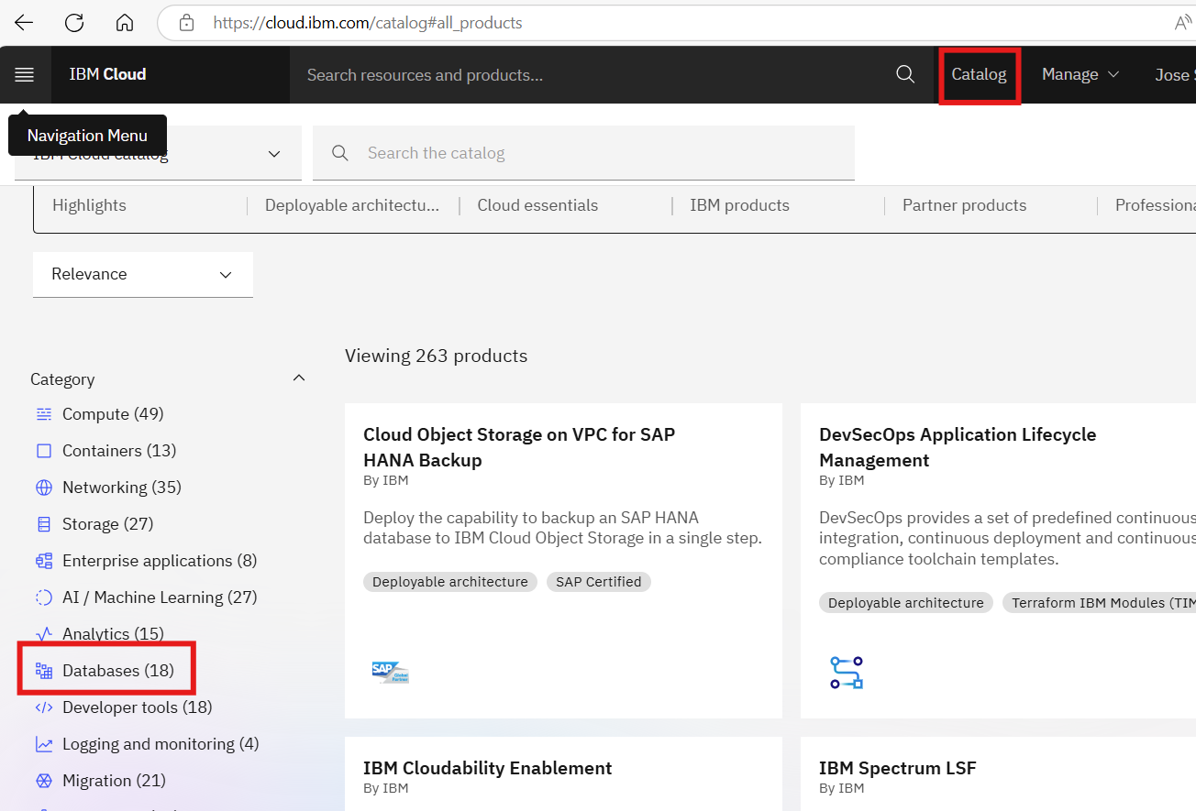

Scroll down and click on the tile for **Db2** service.

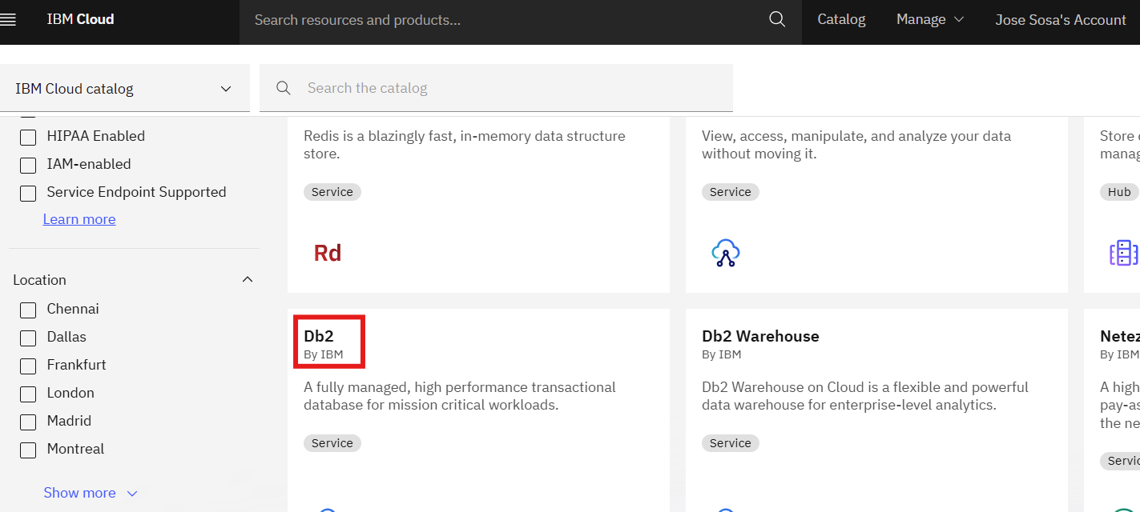

The **Create** tab will be active by default.

**Note**: Depending on the Country of your IBM Cloud Lite account, a region/location to deploy will be pre-selected. For example, if you are in the US, the default data center location will be Dallas. Users from the UK will see London, and so on. Please select either London or Dallas as your region to create DB2 lite plan. Lite plan is unavailable in other regions.

Scroll down to **Select a pricing plan** and select the **Lite** plan. It is a free plan and does not require your credit card information.

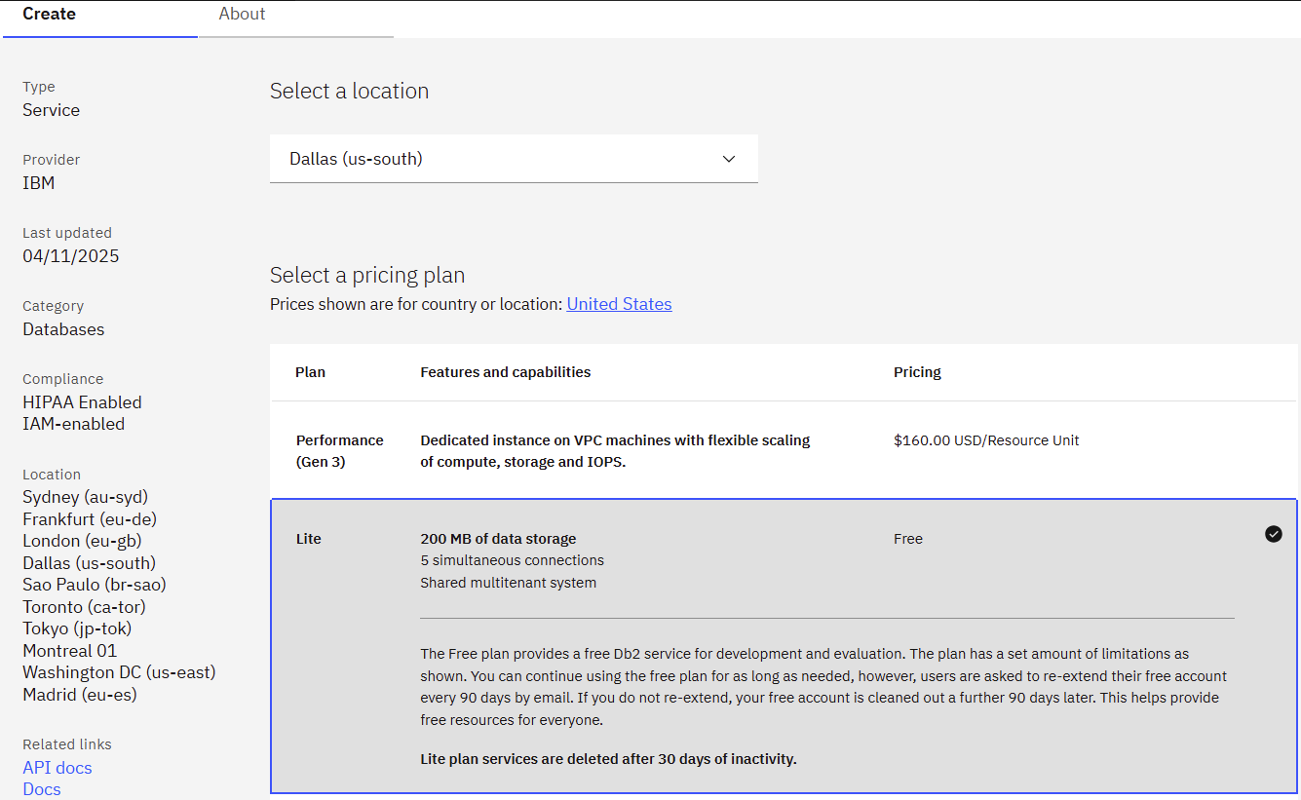

Click on Create:

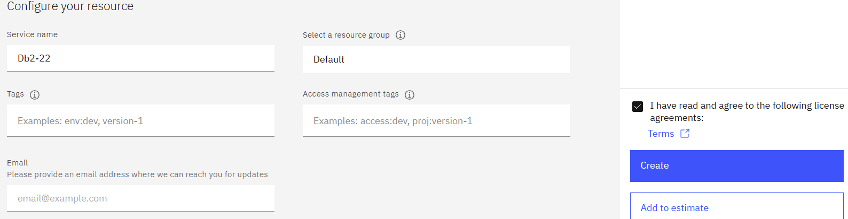

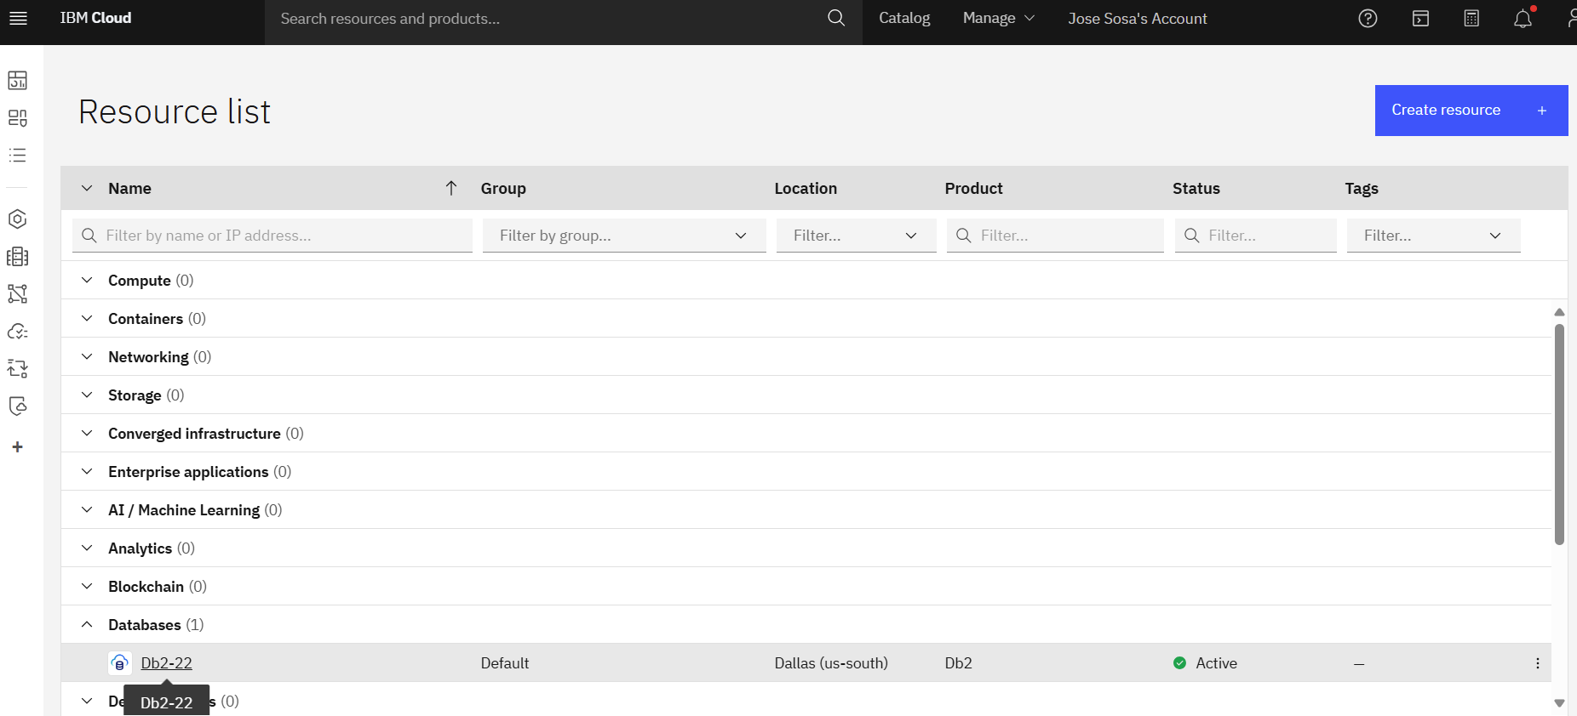

Select the Db, then Click on **Service credentials** and then on **New credential**.

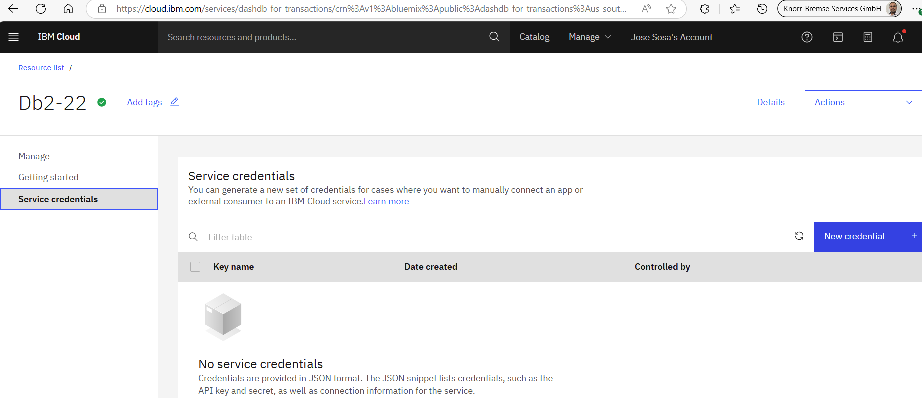

The **Create credential** dialog box will open with default values in the **Name** and **Role** fields. We suggest you keep the default names for purposes of this lab.

Click **Add** to create your credentials.

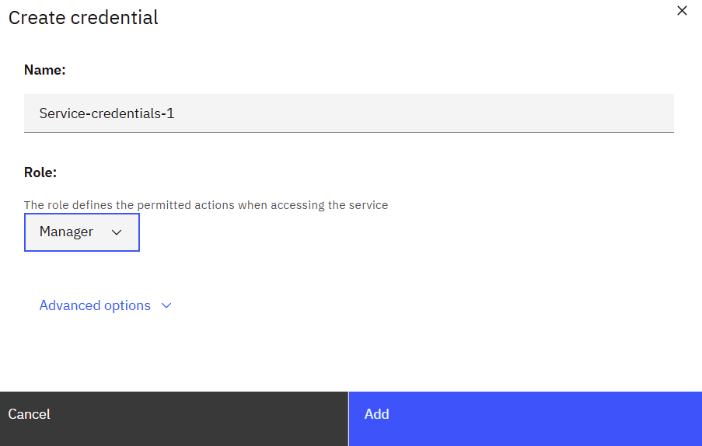

Now we have created **an instance of Db2 using your IBM Cloud Lite account.**

### **Big Data Platforms**

**Foundations of Big Data**

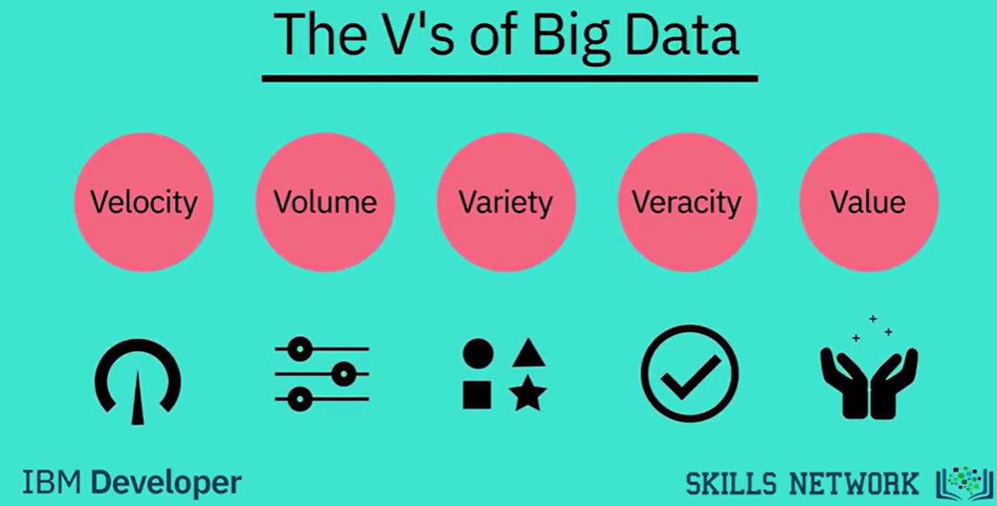

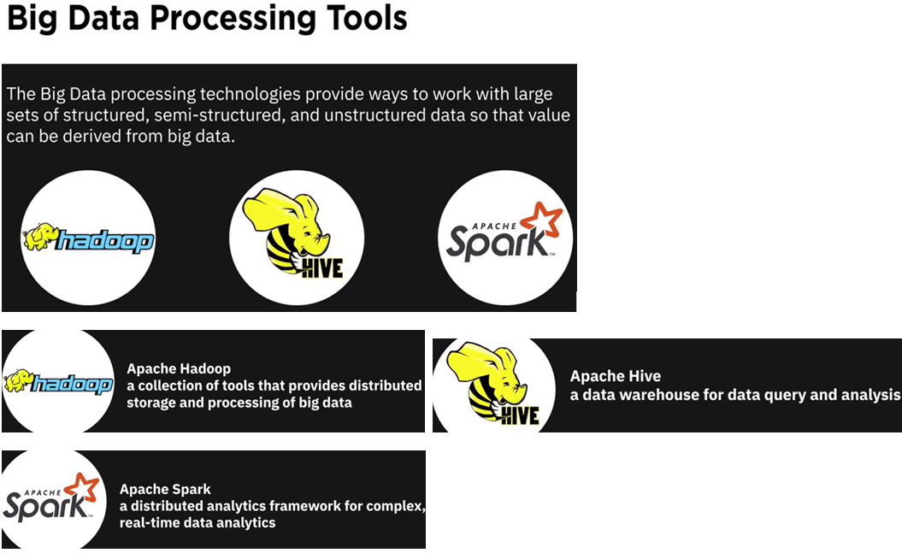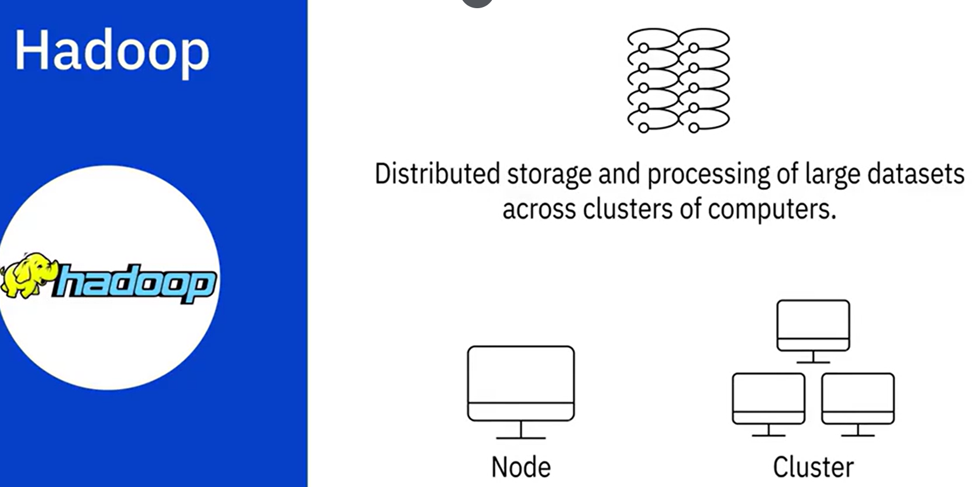

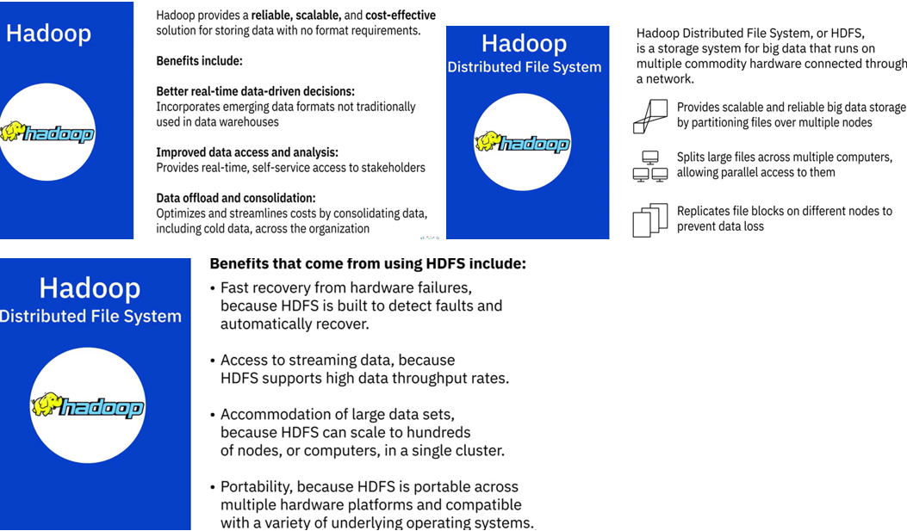

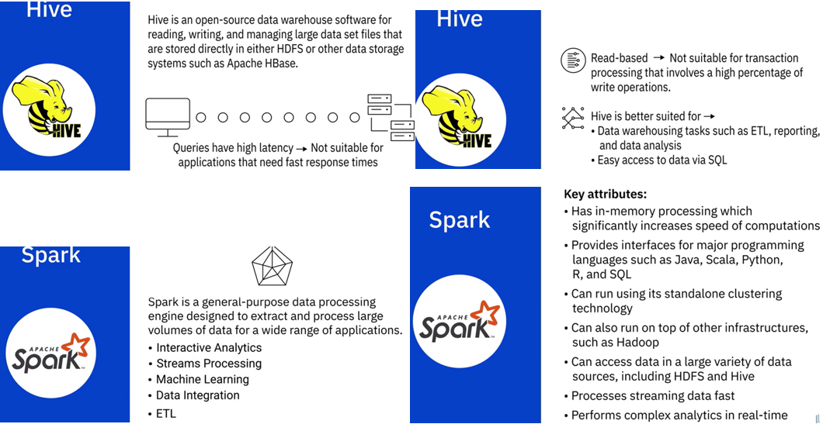

**Summary**

Big Data refers to the vast amounts of data that is being produced each moment of every day, by people, tools, and machines. The sheer velocity, volume, and variety of data challenged the tools and systems used for conventional data, leading to the emergence of processing tools and platforms designed specifically for Big Data. Big Data processing technologies help derive value from big data. These include NoSQL databases and Data Lakes and open-source technologies such as Apache Hadoop, Apache Hive, and Apache Spark.

* Hadoop provides distributed storage and processing of large datasets across clusters of computers. One of its main components, the Hadoop File Distribution System, or HDFS, is a storage system for big data.
* Hive is a data warehouse software for reading, writing, and managing large datasets.
* Spark is a general-purpose data processing engine designed to extract and process large volumes of data.

**Practice Quiz**

**Question 1. What does the attribute “Velocity” imply in the context of Big Data?**

Scale of data

Quality and origin of data

Diversity of data

The speed at which data accumulates

**Question 2. Which of the Big Data processing tools provides distributed storage and processing of Big Data?**

Hive

Hadoop

Spark

ETL

**Correct**

Hadoop, a java-based open-source framework, allows distributed storage and processing of large datasets across clusters of computers.

**Graded Quiz**

**Question 1. What does the attribute “Veracity” imply in the context of Big Data?**

The speed at which data accumulates

Scale of data

Diversity of the type and sources of data

Accuracy and conformity of data to facts

**Question 2. ______________, in the context of Big Data, is the speed at which data accumulates.**

Velocity

Variety

Value

Volume

**Question 3. What does the attribute “Value” imply in the context of Big Data?**

Our ability and need to turn data into value

The accuracy and conformity of data to facts

The diversity of the type and sources of data

The speed at which data accumulates

**Question 4. Apache Spark is a general-purpose data processing engine designed to extract and process Big Data for a wide range of applications. What is one of its key use cases?**

Scalable and reliable Big Data storage

Fast recovery from hardware failures

Consolidate data across the organization

Perform complex analytics in real-time

**Correct**

Spark is a general-purpose data processing engine used for performing complex data analytics in real-time.

**Question 5. Which of the Big Data processing tools is used for reading, writing, and managing large data set files that are stored in either HDFS or Apache HBase?**

Hadoop

Spark

ETL

Hive

**Correct**

Hive is an open-source data warehouse software for reading, writing, and managing large data sets stored in data storage systems such as HDFS and Apache HBase.

## Module 3

### Data Platforms, Data stores and security

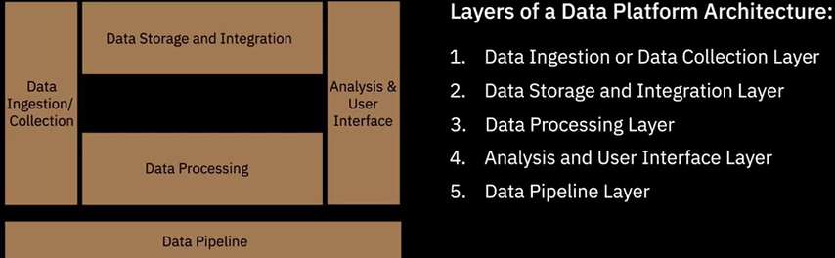

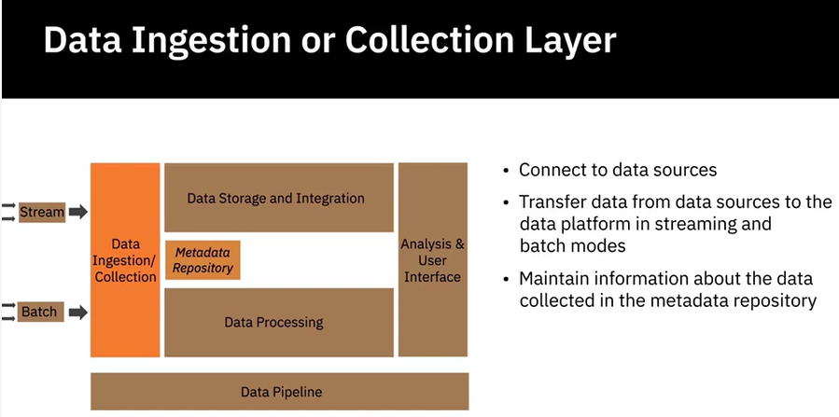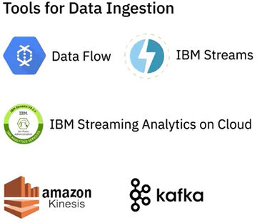

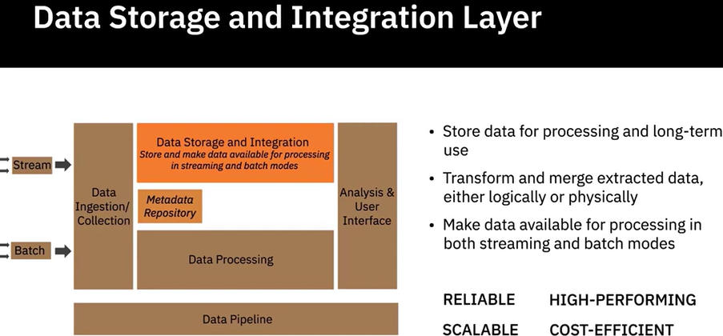 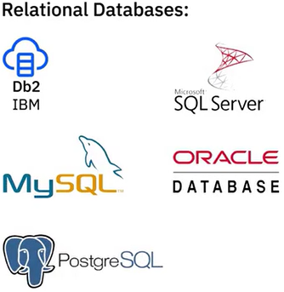

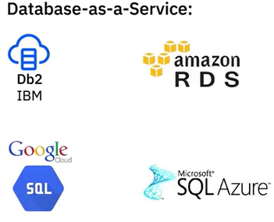 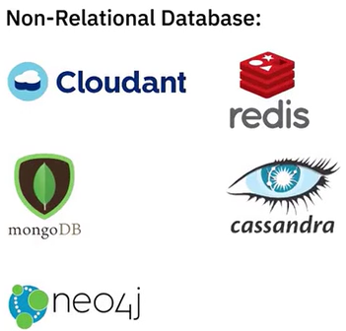 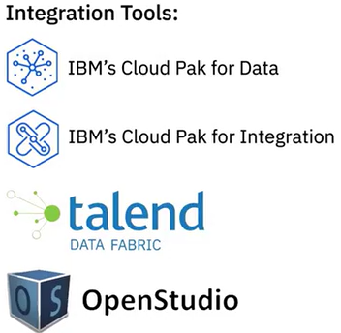 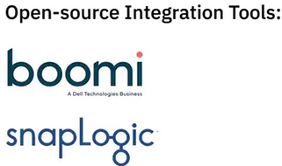

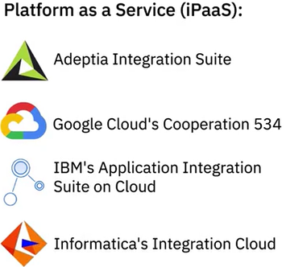

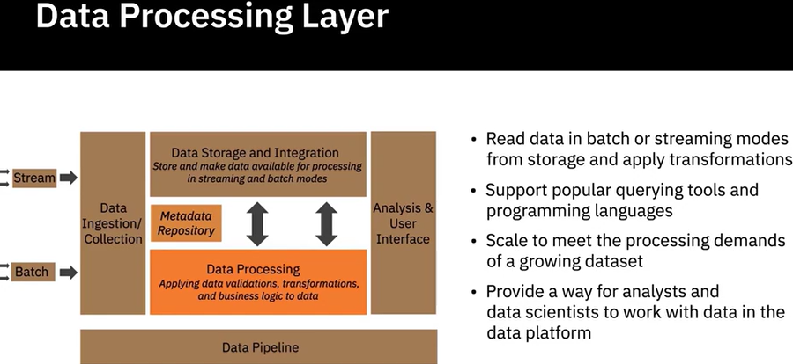 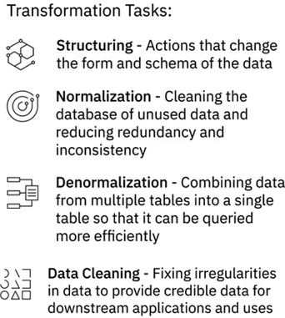

Hay una serie de herramientas disponibles para realizar estas transformaciones en los datos, seleccionadas por tamaño, estructura, y capacidades específicas de la herramienta, como Hojas de cálculo, OpenRefine, Google Data Prep, Watson Studio Refinery, y Trifacta Wrangler. Python y R también ofrecen varias bibliotecas y paquetes creados explícitamente para procesar datos.

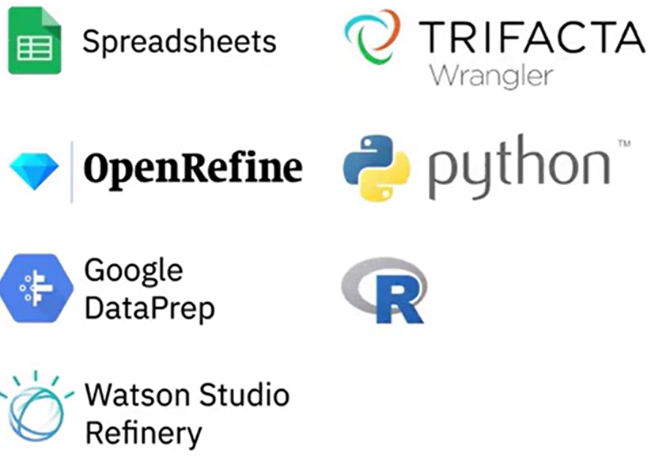 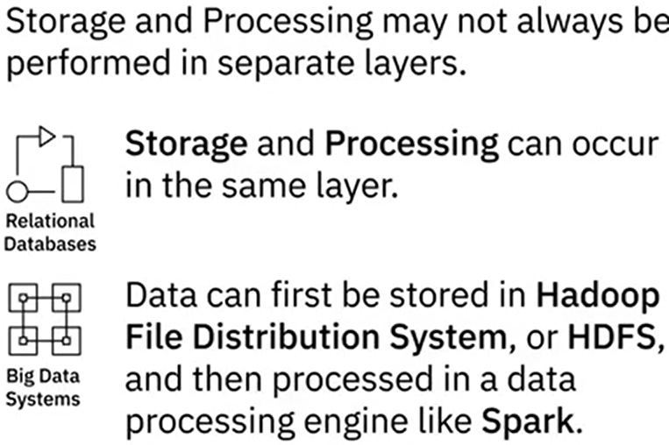

La capa de procesamiento de datos también puede preceder a la capa de almacenamiento de datos, donde se aplican transformaciones antes de que los datos se carguen o almacenen en la base de datos.

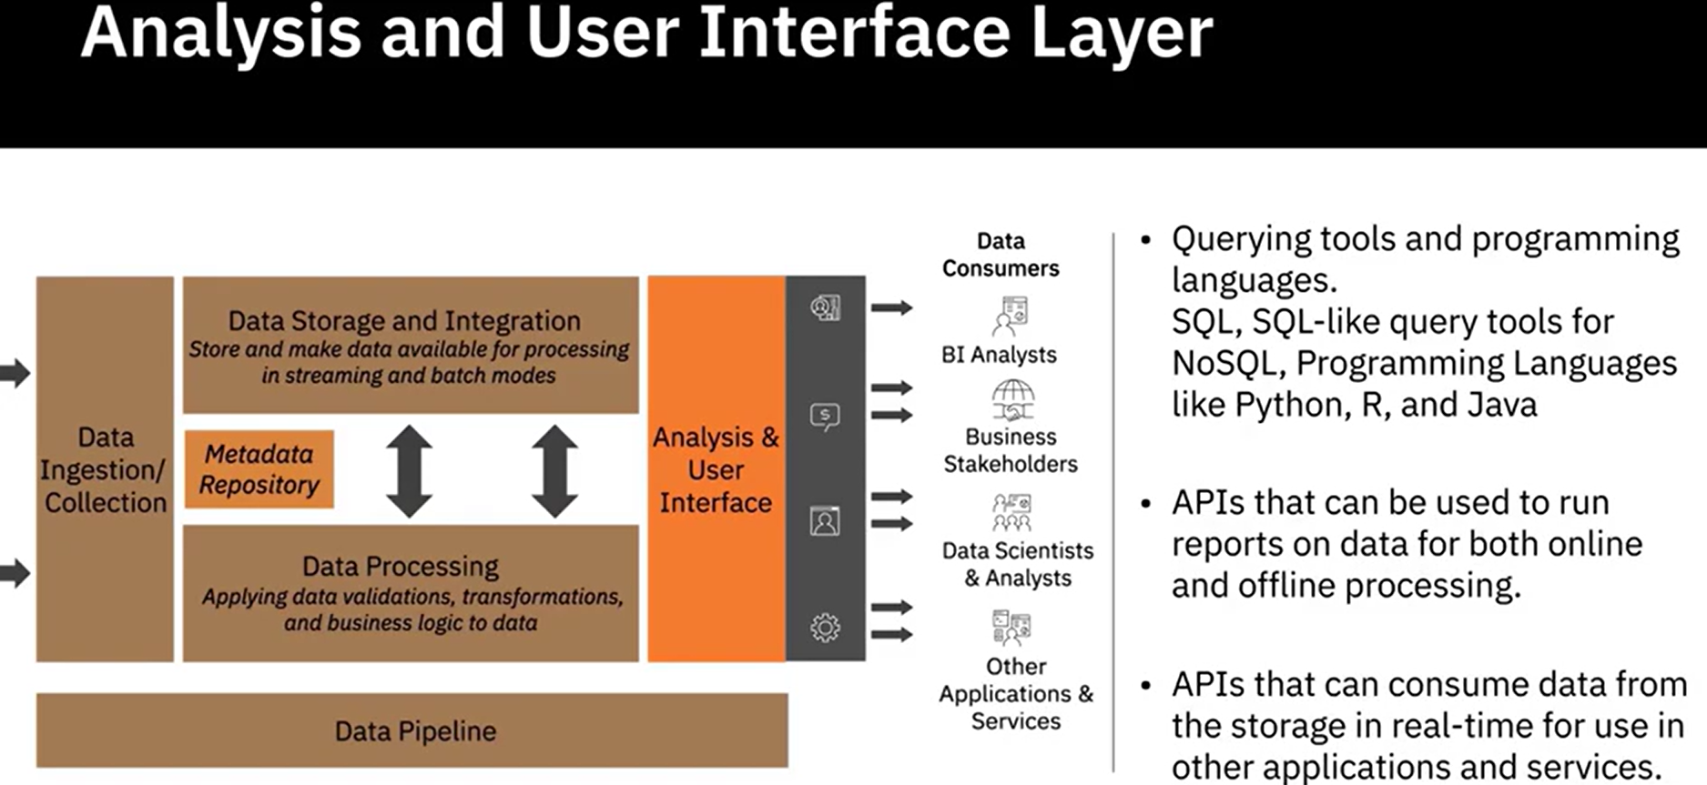

La capa de análisis necesita soportar herramientas de consulta y lenguajes de programación.

Pueden consumir datos del almacenamiento en tiempo real para su uso en otras aplicaciones y servicios y en aplicaciones de panel de control e inteligencia empresarial. Por ejemplo, IBM Cognos Analytics, Tableau, Notebook de Jupyter, bibliotecas de Python y R, y Microsoft Power BI.

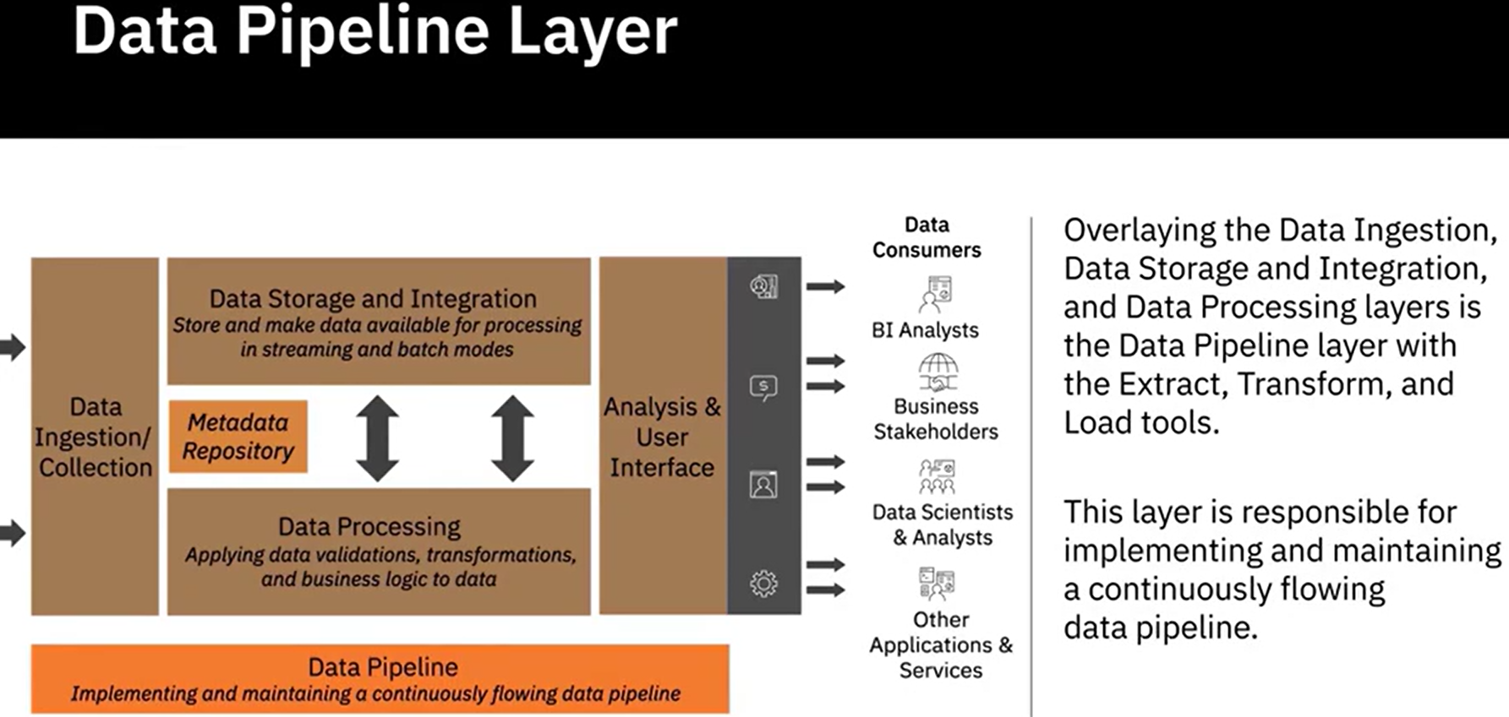 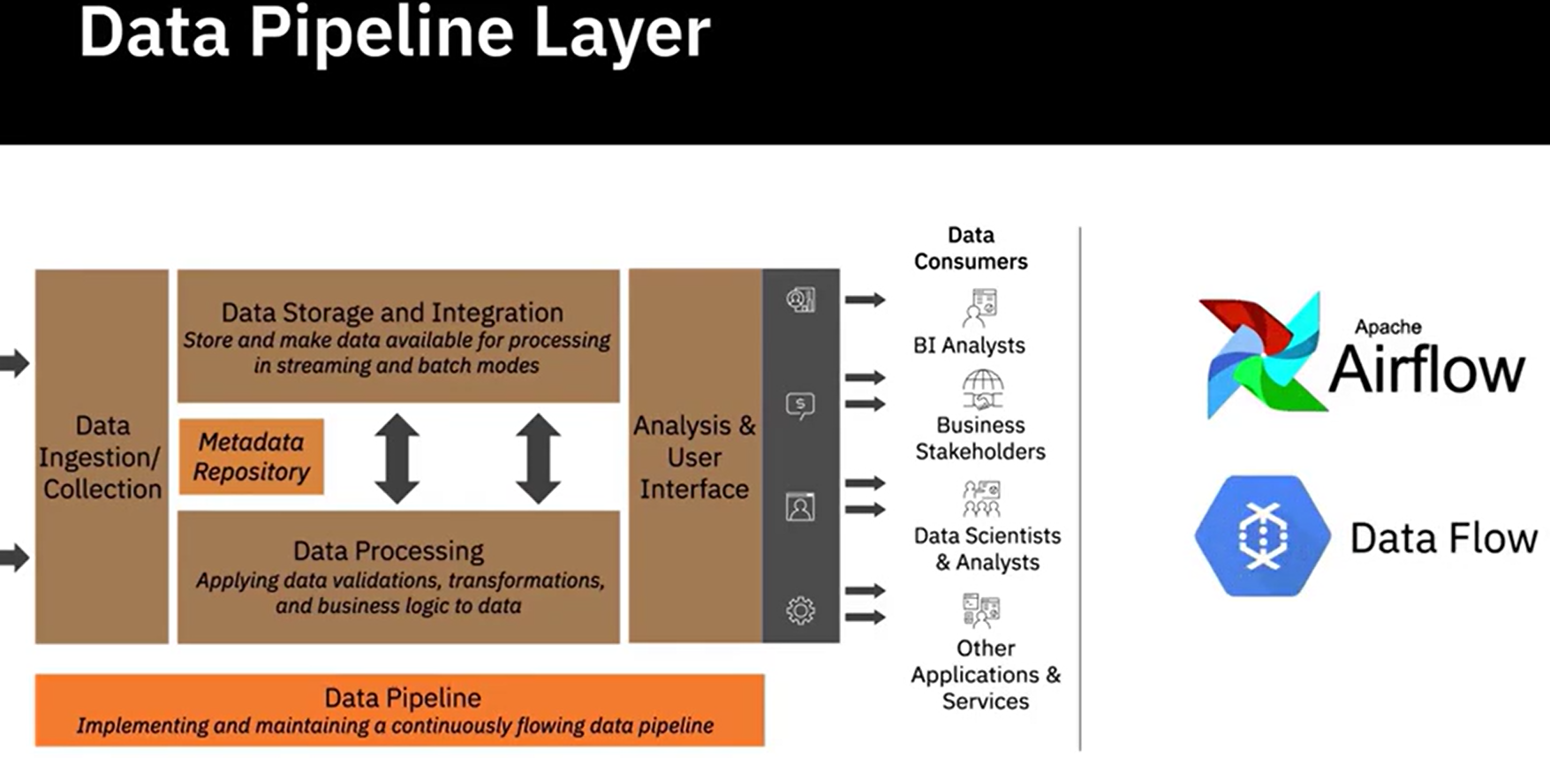

### **Factors for Selecting and Designing Data Stores**

Un almacén de datos o repositorio de datos es un término general utilizado para referirse a los datos que se han recopilado, organizado y aislado para que puedan usarse en operaciones comerciales o extraerse para informes y análisis de datos.

Un repositorio puede ser una base de datos, un almacén de datos, un Data Mart, un almacén de big data, o un data lake. Un repositorio de datos bien diseñado es esencial para construir un sistema que sea escalable y capaz de funcionar durante altas cargas de trabajo.

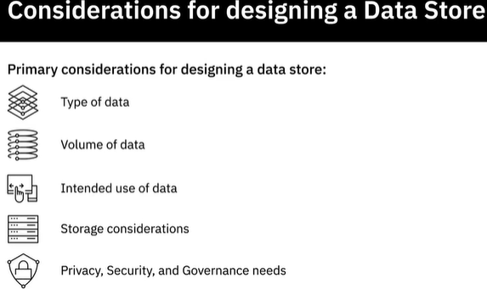 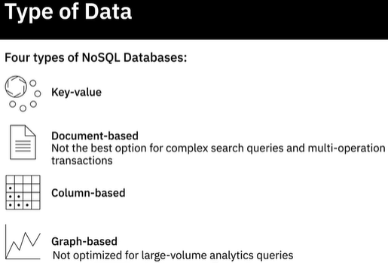

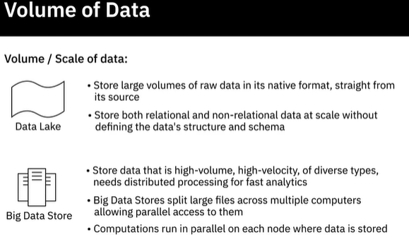 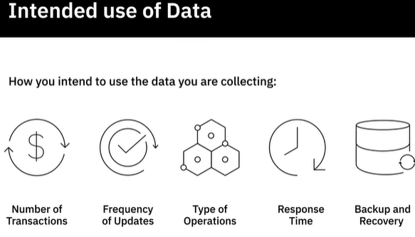

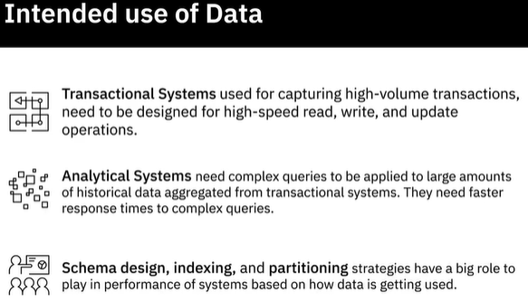 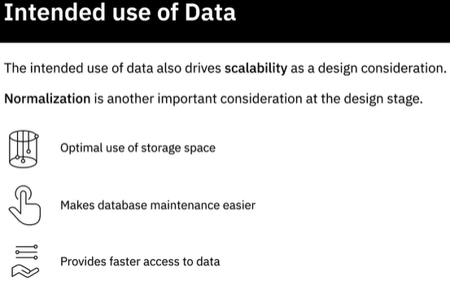

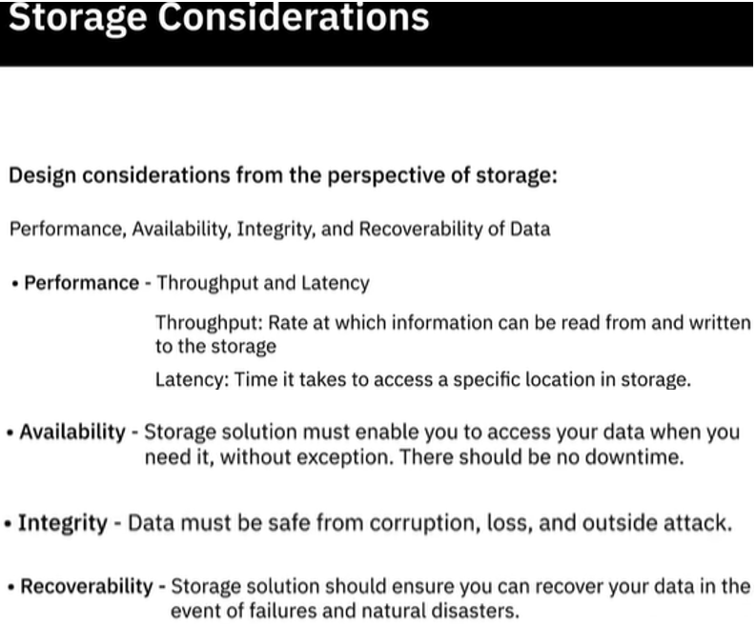

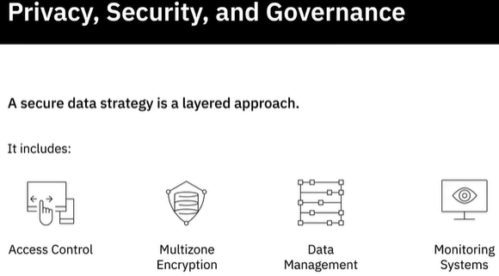 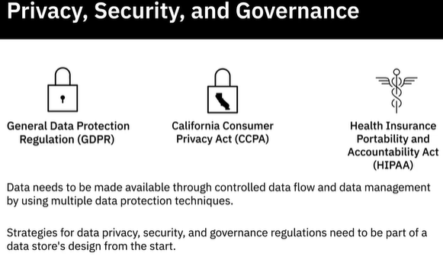

### **Security**

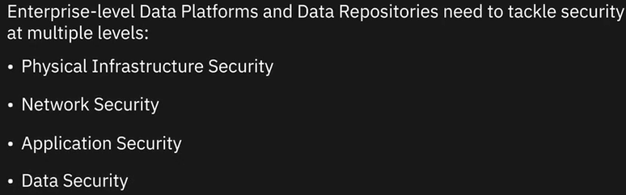

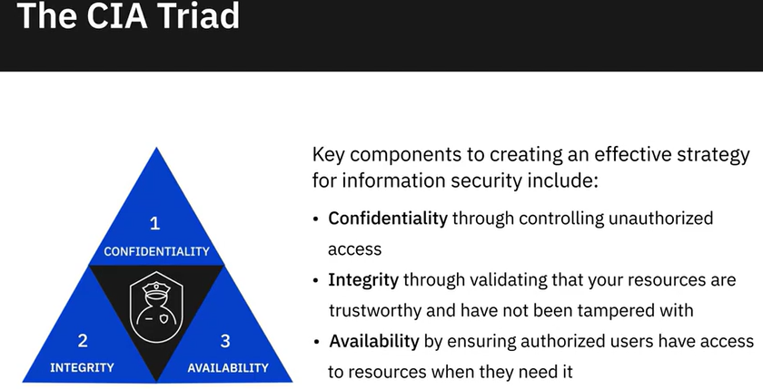

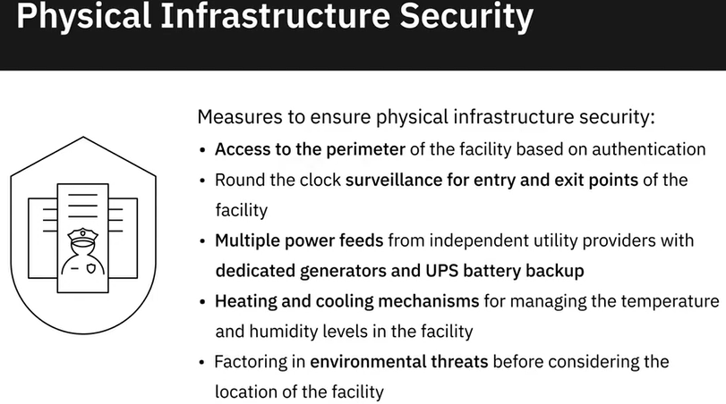 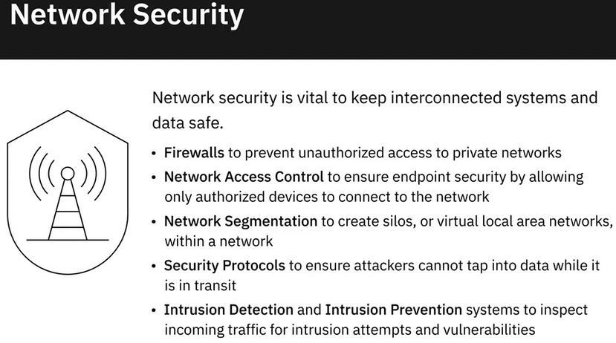

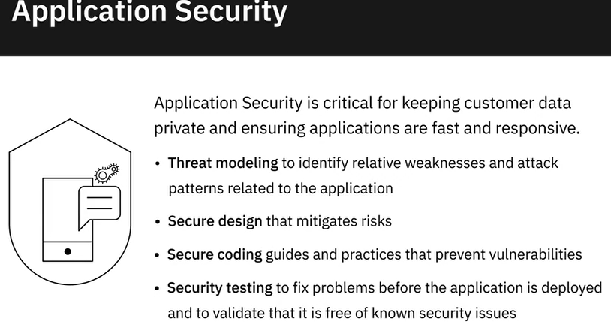 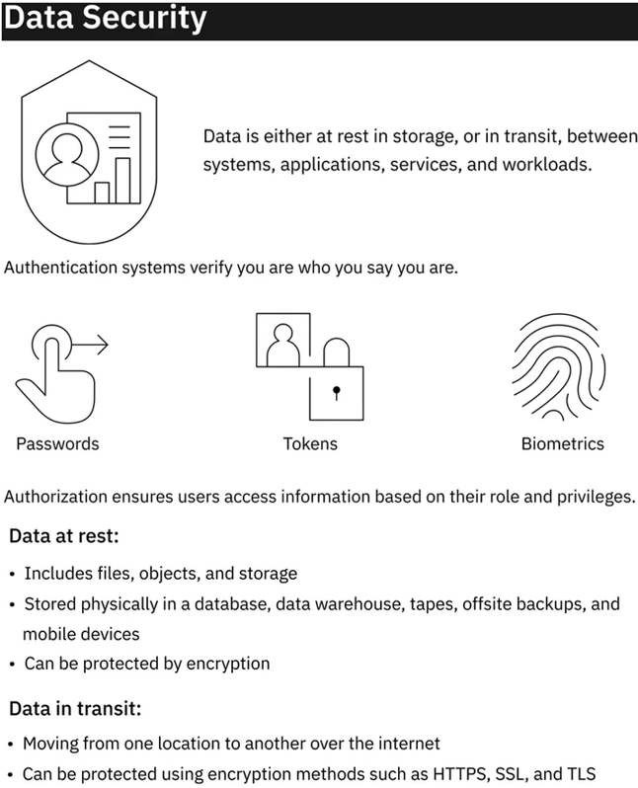

**Summary**

The architecture of a data platform can be seen as a set of layers, or functional components, each one performing a set of specific tasks. These layers include:

* Data Ingestion or Data Collection Layer, responsible for bringing data from source systems into the data platform.
* Data Storage and Integration Layer, responsible for storing and merging extracted data.
* Data Processing Layer, responsible for validating, transforming, and applying business rules to data.
* Analysis and User Interface Layer, responsible for delivering processed data to data consumers.
* Data Pipeline Layer, responsible for implementing and maintaining a continuously flowing data pipeline.

A well-designed data repository is essential for building a system that is scalable and capable of performing during high workloads. The choice or design of a data store is influenced by the type and volume of data that needs to be stored, the intended use of data, and storage considerations. The privacy, security, and governance needs of your organization also influence this choice. The CIA, or Confidentiality, Integrity, and Availability triad are three key components of an effective strategy for information security. The CIA triad is applicable to all facets of security, be it infrastructure, network, application, or data security.

**Practice Quiz**

**Question 1. Which one of these steps is an intrinsic part of the “Data Storage and Integration Layer” of a data platform?**

Transform and merge extracted data, either logically or physically

Transfer data from data sources to the data platform in streaming, batch, or both modes

Deliver processed data to data consumers

Read data in batch or streaming modes from storage and apply transformations

**Correct**

The Storage and Integration layer in a data platform stores, transforms, and merges extracted data to make it available for data processing.

**Question 2. Systems that are used for capturing high-volume transactional data need to be designed for faster response times to complex queries.**

True

False

**Correct**

Systems that are used for capturing high-volume transactional data need to be designed for high-speed read, write, and update operations.

**Question 3. What is the role of “Intrusion Detection” and “Intrusion Prevention” in the area of network security?**

Ensure attackers cannot tap into data while it is in transit

Inspect incoming network traffic for intrusion attempts and vulnerabilities

Create silos, or virtual local area networks, within a network so that you can segregate your assets

Ensure endpoint security by allowing only authorized devices to connect to the network

**Correct**

Intrusion Detection and Intrusion Prevention systems inspect network vulnerabilities and intrusion attempts and prevent them from happening.

**Graded quiz**

**Question 1. Which one of these steps is an intrinsic part of the “Data Processing Layer” of a data platform?**

Transform and merge extracted data, either logically or physically

Transfer data from data sources to the data platform in streaming, batch, or both modes

Read data in batch or streaming modes from storage and apply transformations

Deliver processed data to data consumers

**Correct**

This task is performed in the “Data Processing Layer”.

**Question 2. Systems that are used for capturing high-volume transactional data need to be designed for high-speed read, write, and update operations.**

True

False

**Correct**

High-speed read, write, and update operations are essential for systems that need to capture large volumes of transactional data.

**Question 3. What is the role of “Network Access Control” systems in the area of network security?**

To inspect incoming network traffic for intrusion attempts and vulnerabilities

To create silos, or virtual local area networks, within a network so that you can segregate your assets

To ensure endpoint security by allowing only authorized devices to connect to the network

To ensure attackers cannot tap into data while it is in transit

**Correct**

This is achieved with the help of Network Access Control systems.

**Question 4. ____________ ensures that users access information based on their roles and the privileges assigned to their roles.**

Security Monitoring

Authorization

Authentication

Firewalls

**Correct**

One of the primary controls for data security is to enable access to data through a system of Authorization. It allows access to information based on a user’s role and role-based privileges.

**Question 5. Security Monitoring and Intelligence systems:**

Create virtual local area networks within a network so that you can segregate your assets

Ensure users access information based on their role and privileges

Create an audit history for triage and compliance purposes

Ensure only authorized devices can connect to a network

**Correct**

Security Monitoring and Intelligence systems create an audit trail and provide reports and alerts that help enterprises react to security violations in time.

### **Data Collection and Data Wrangling**

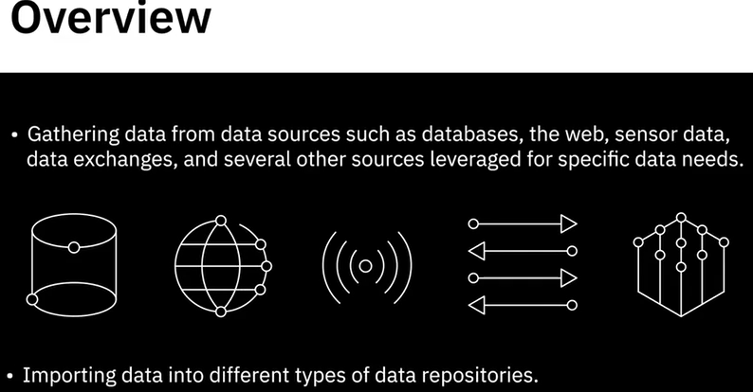

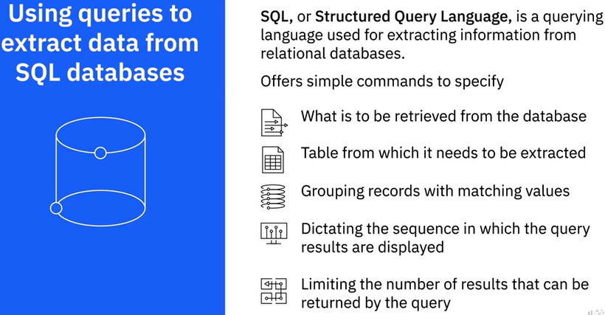

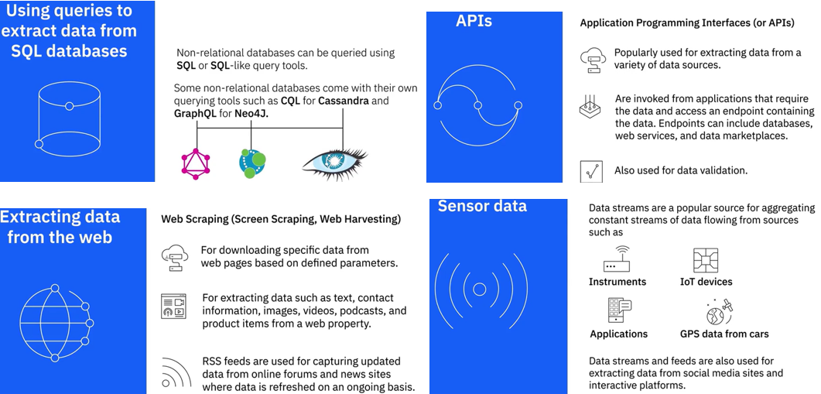

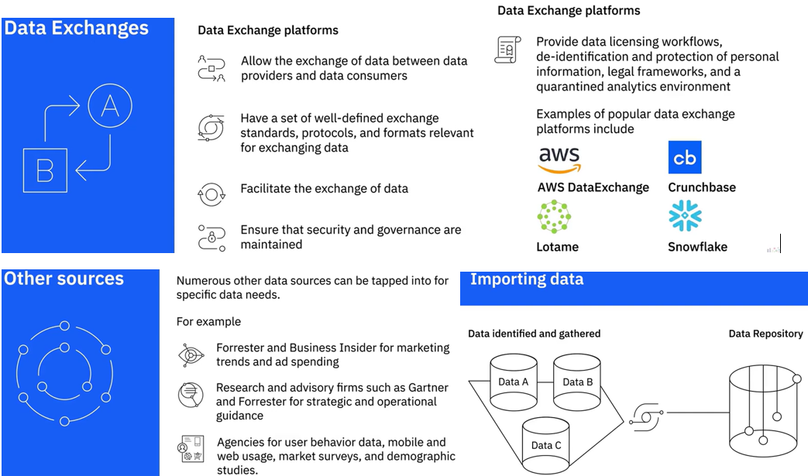

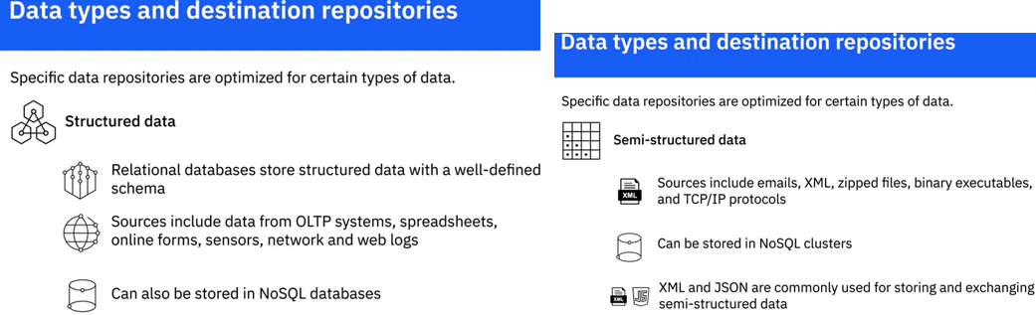

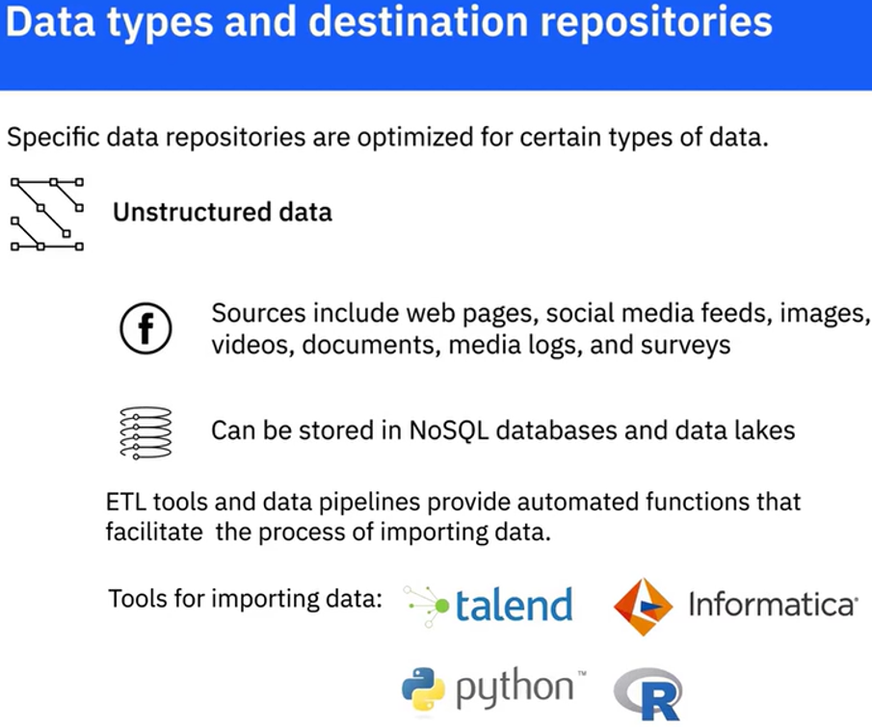

**Data wrangling (organización de datos)**

Los datos sin procesar deben pasar por una serie de transformaciones y actividades de limpieza para estar listos para el análisis

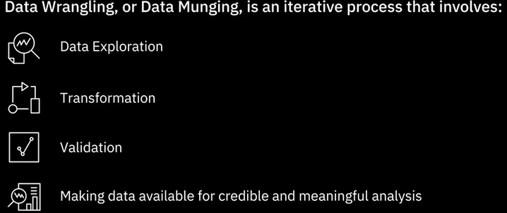 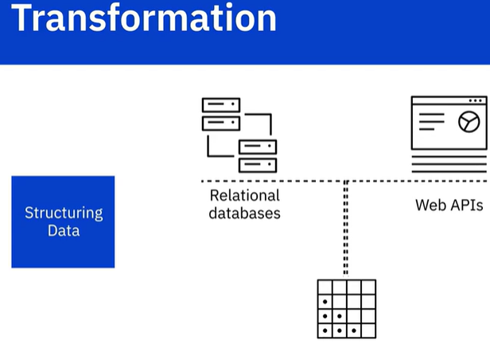

Es posible, por ejemplo, que tenga algunos datos que provengan de una base de datos relacional, y otros datos de API web. Para fusionarlos, necesitarás cambiar la forma o esquema de tus datos. Este cambio puede ser tan simple como cambiar el orden de los campos dentro de un registro A o conjunto de datos, o tan complejo como combinar campos en estructuras complejas.

Las uniones son las transformaciones estructurales más comunes que se utilizan para combinar datos de una o más tablas. La forma en que combinan los datos es diferente.

**JOIN combinan columnas.**

Cuando se unen dos tablas, las columnas de la primera tabla de origen se combinan con las columnas de la segunda tabla de origen, en la misma fila.

Por lo tanto, cada fila de la tabla resultante contiene columnas de ambas tablas.

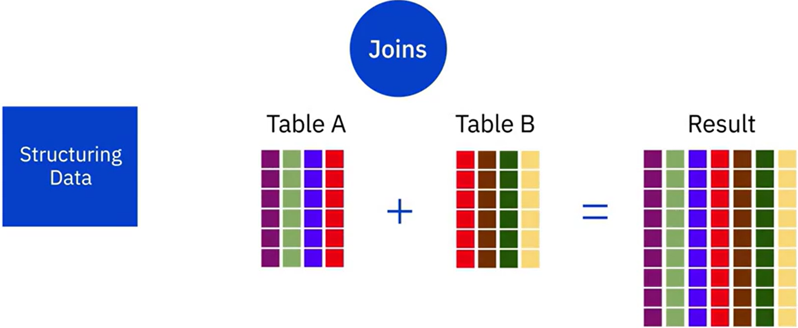

**Las uniones combinan filas.**

Las filas de datos de la primera tabla de origen se combinan con filas de datos de la segunda tabla de origen en una sola tabla. Cada fila de la tabla resultante proviene de una u otra tabla de origen.

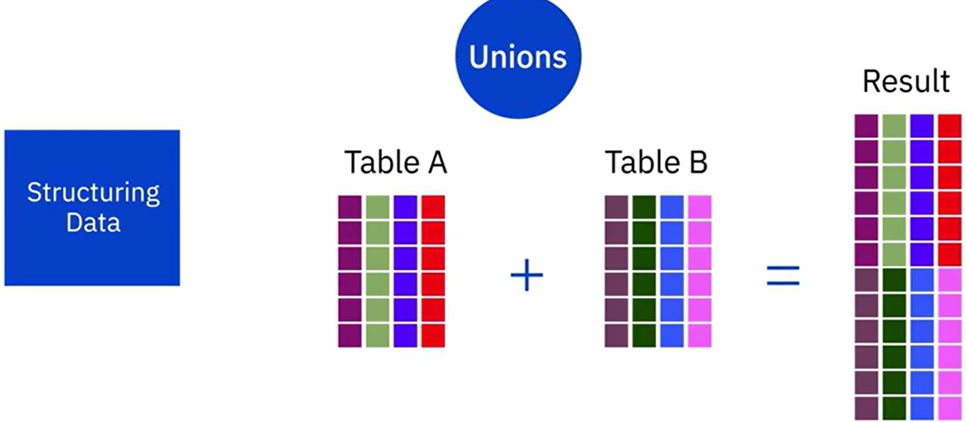

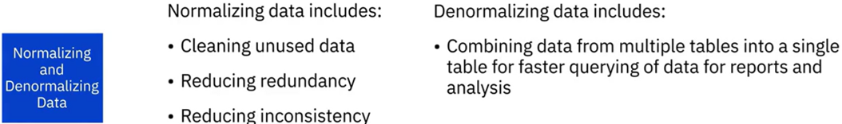

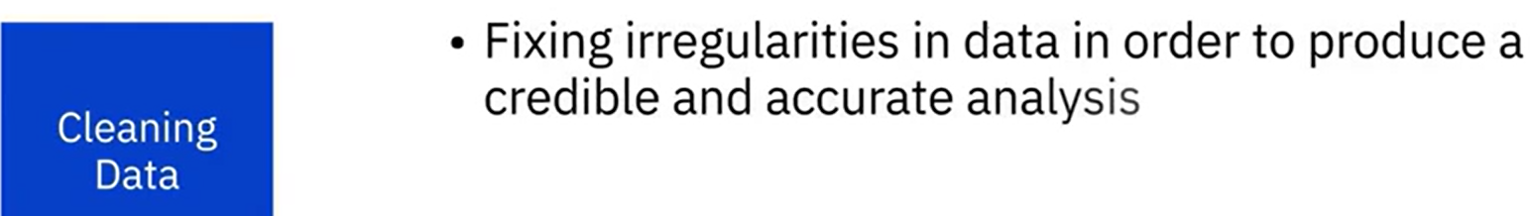

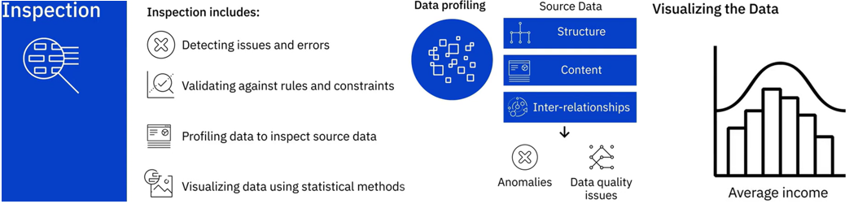

Graficar el ingreso promedio en un Conjunto de datos demográficos puede ayudarte a identificar valores atípicos. Las técnicas que aplique para limpiar su conjunto de datos dependerán del caso de uso y del tipo de problemas que encuentre.

**Cleaning**

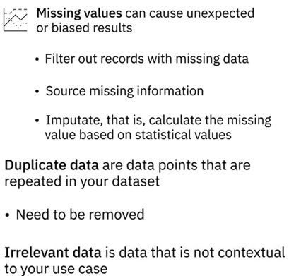 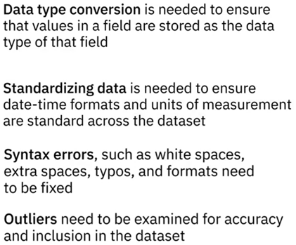

**Tools for Data Wrangling**

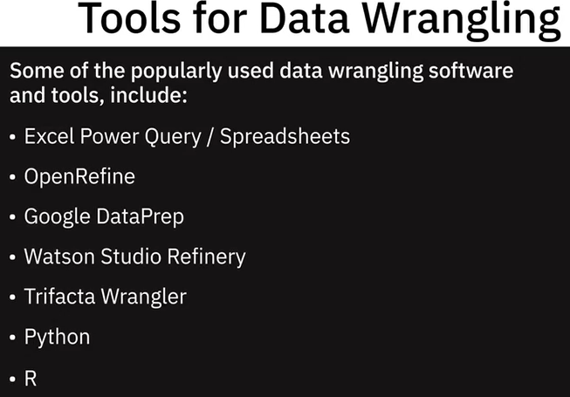

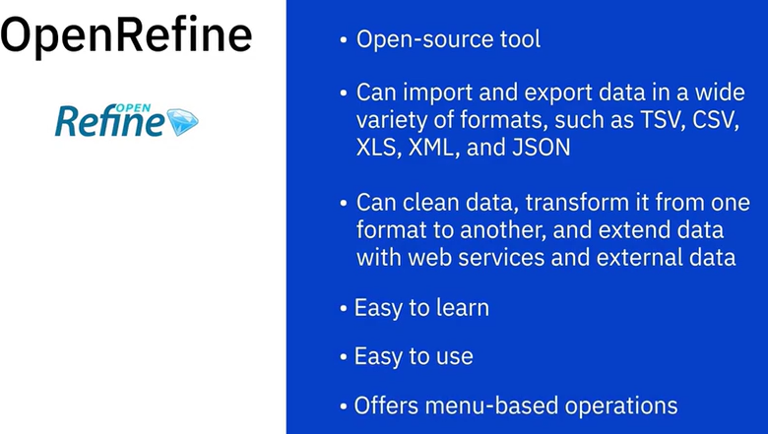 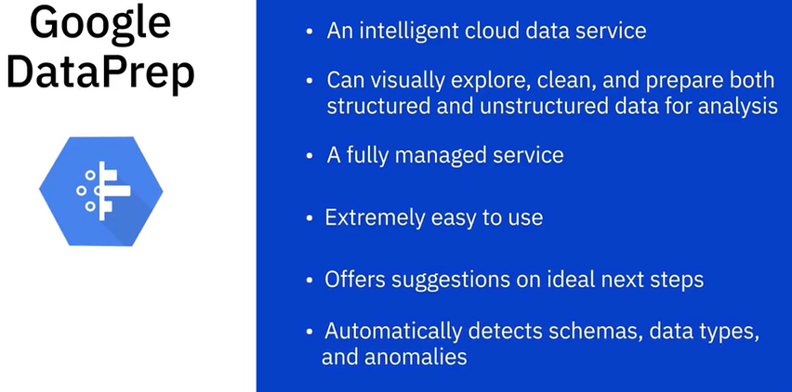

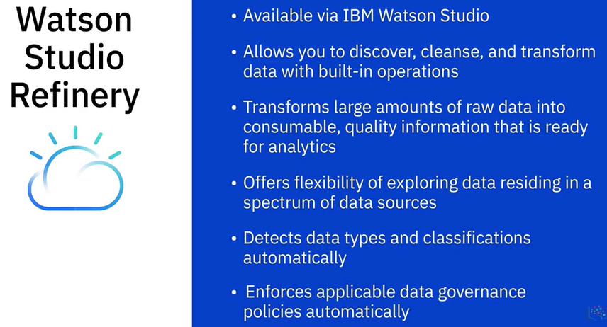 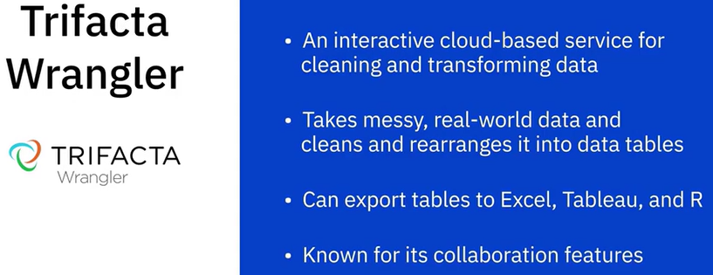

 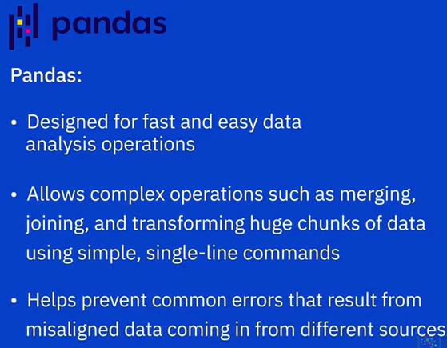

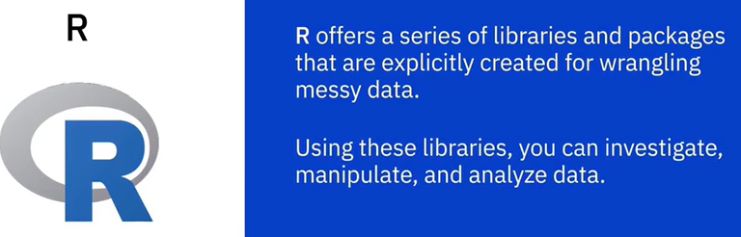 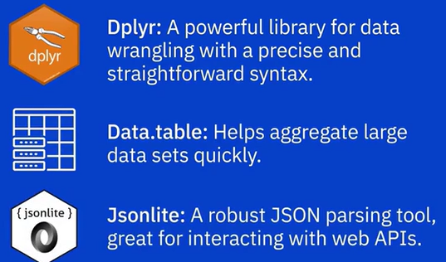

### Hands-On Lab: Load data into the Datasette from a CSV file

Load data from a csv file using a SQL practice tool called Datasette in the Skills Network Lab environment.

**Dataset used in this exercise:**

The dataset used in this exercise comes from the following source: [https://www.kaggle.com/antfarol/car-sale-advertisements](https://www.kaggle.com/antfarol/car-sale-advertisements?utm_medium=Exinfluencer&utm_source=Exinfluencer&utm_content=000026UJ&utm_term=10006555&utm_id=NA-SkillsNetwork-Channel-SkillsNetworkCoursesIBMDB0100ENSkillsNetwork23053252-2022-01-01) under a [CC0: Public Domain license](https://creativecommons.org/publicdomain/zero/1.0/?utm_medium=Exinfluencer&utm_source=Exinfluencer&utm_content=000026UJ&utm_term=10006555&utm_id=NA-SkillsNetwork-Channel-SkillsNetworkCoursesIBMDB0100ENSkillsNetwork23053252-2022-01-01).

*We are using a modified subset of that dataset for this lab. To follow the lab instructions successfully, please use the dataset provided with this exercise rather than the dataset from the original source.*

**Download the dataset**

<https://cf-courses-data.s3.us.cloud-object-storage.appdomain.cloud/IBM-DB0100EN-SkillsNetwork/labs/exercise03_car_sales_data.csv> is the csv file used in this lab.

**Exercise 1: Create a table by loading a CSV file using Datasette**

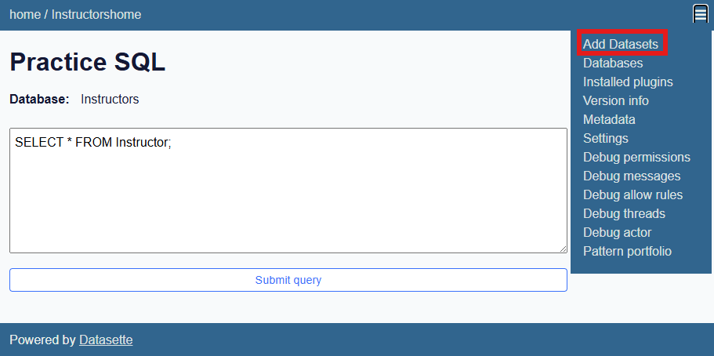

You will be redirected to a page where you need to enter the full URL of the CSV dataset in the text box.

Right-click on the link:

[exercise03_car_sales_data.csv](https://cf-courses-data.s3.us.cloud-object-storage.appdomain.cloud/IBM-DB0100EN-SkillsNetwork/labs/exercise03_car_sales_data.csv) and copy the link address (<https://cf-courses-data.s3.us.cloud-object-storage.appdomain.cloud/IBM-DB0100EN-SkillsNetwork/labs/exercise03_car_sales_data.csv>)

Enter the copied URL in the text box and click on the create button.

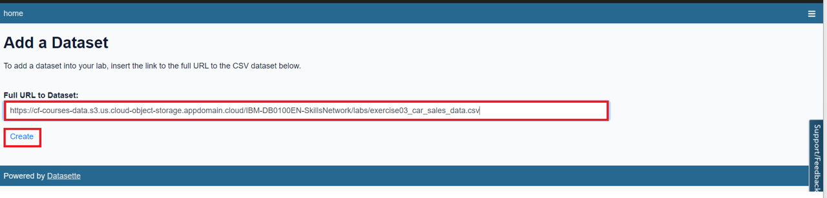The exercise03_car_sales_data table will be created with the data loaded from the CSV file.  
A **select** query related to the table will appear on the **text area** section of the following webpage.

Click on the **Submit Query** button to view the results.

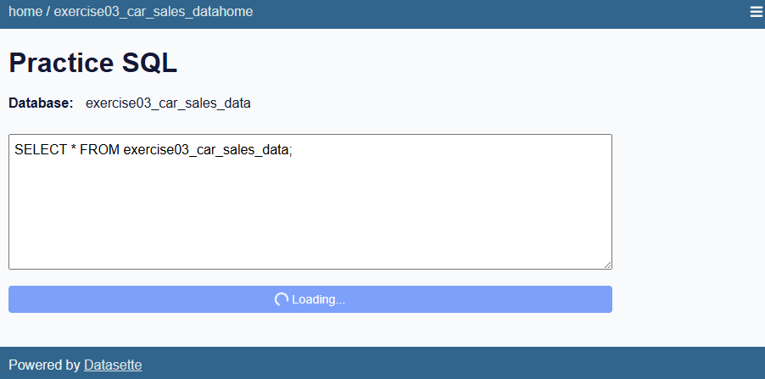 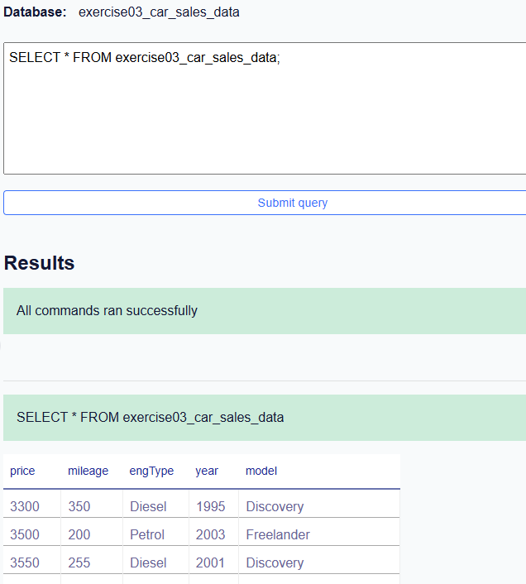

Next, modify the **select** query as follows:

SELECT COUNT(*) FROM exercise03_car_sales_data;

Once the query executes successfully, it displays the counts.

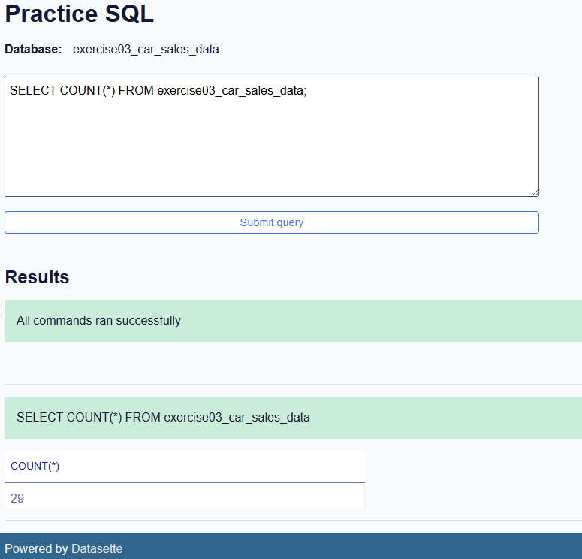

### Hands on Lab: **Load data into the IBM Db2 database from a CSV file**

The lab assumes that you have downloaded this CSV file: [exercise03_car_sales_data.csv](https://cf-courses-data.s3.us.cloud-object-storage.appdomain.cloud/IBM-DB0100EN-SkillsNetwork/labs/exercise03_car_sales_data.csv) to your local system.

1. Go to: [https://cloud.ibm.com/catalog/services/db2](https://cloud.ibm.com/catalog/services/db2?utm_source=skills_network&utm_content=in_lab_content_link&utm_id=Lab-IBM-DB0100EN-SkillsNetwork) to access your Db2 dashboard on Cloud.
2. If you’re not already logged in to your IBM Cloud Lite account, click on **Log in** at the bottom right of the screen to log in.
3. Go to:

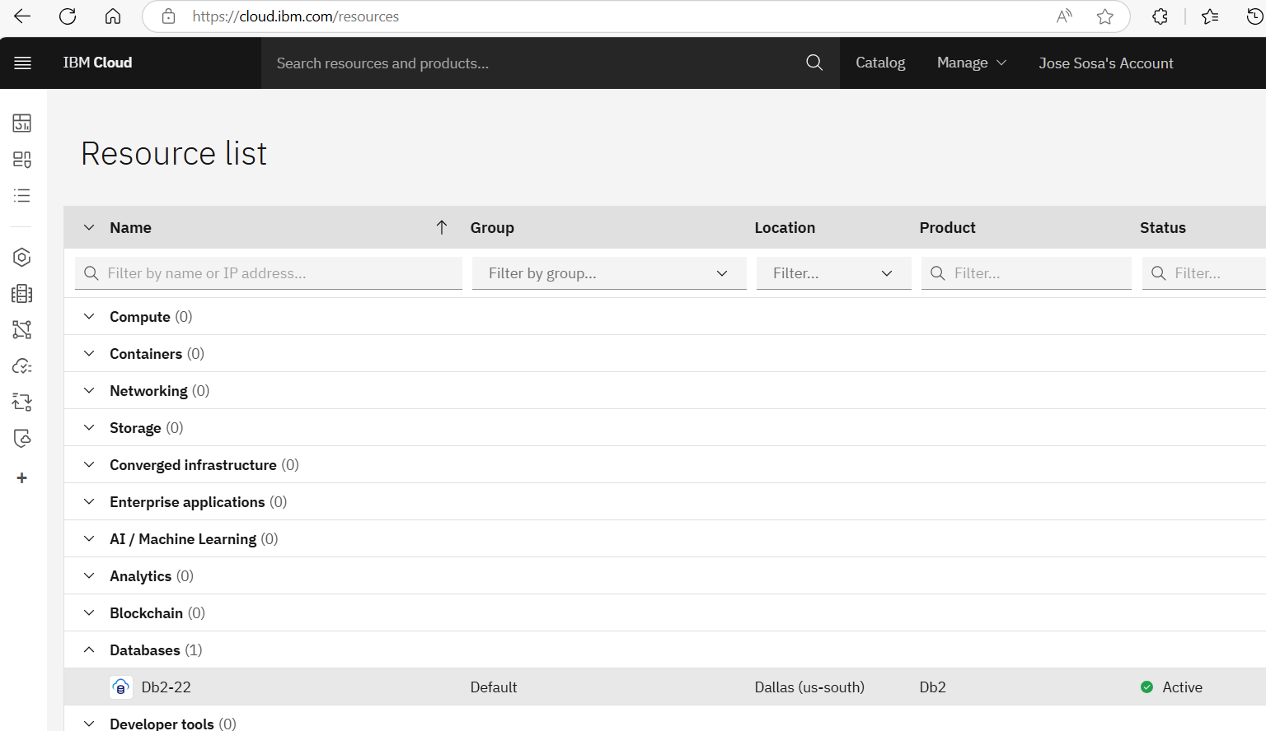

1. Select the Database, The **Manage** tab will be active by default in your services dashboard. Click on **Go to UI**.  
   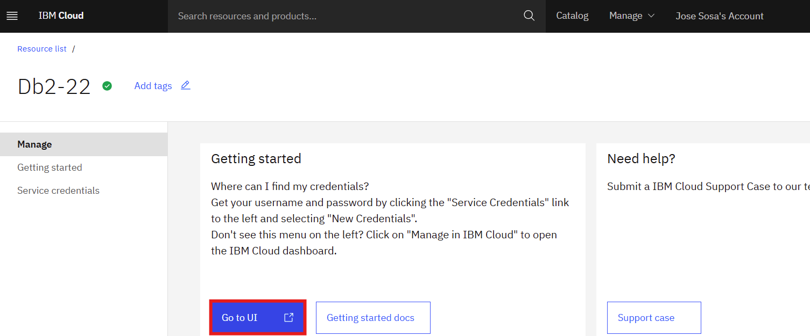
2. Now click on the menu bar icon in the top left corner of your Db2 service dashboard.

Click on **Load** **>** **Load Data**.

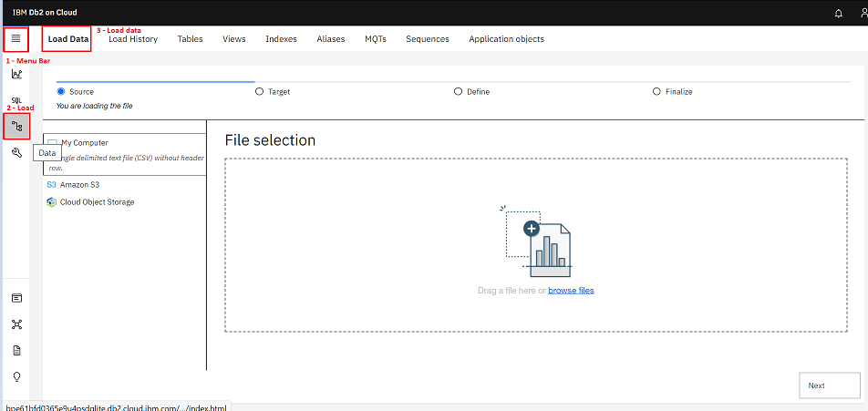

1. You can either drag and drop the CSV file into the **File selection** box, or you can click on the **browse files** link, also provided in the **File selection** box to browse your local folders to find and open the downloaded CSV file.

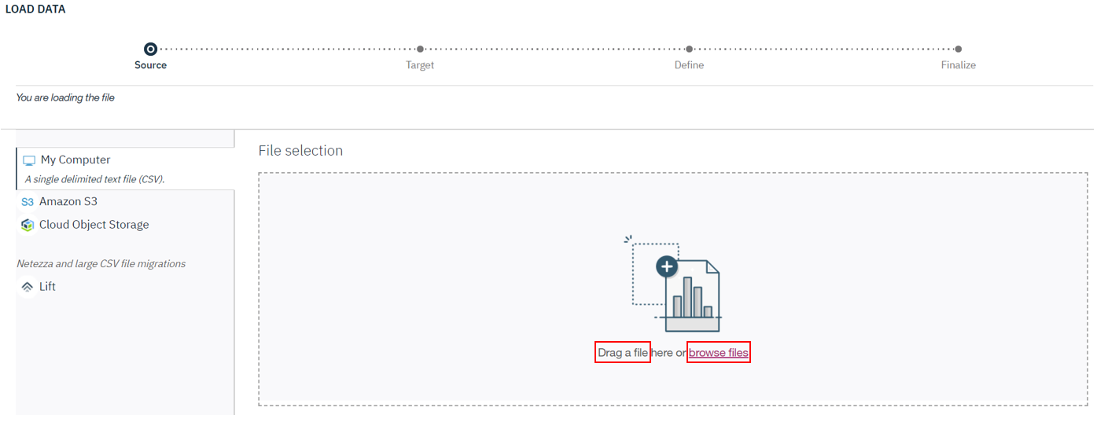

The name of the CSV file you have uploaded will appear in the **Selected file** section on the right.

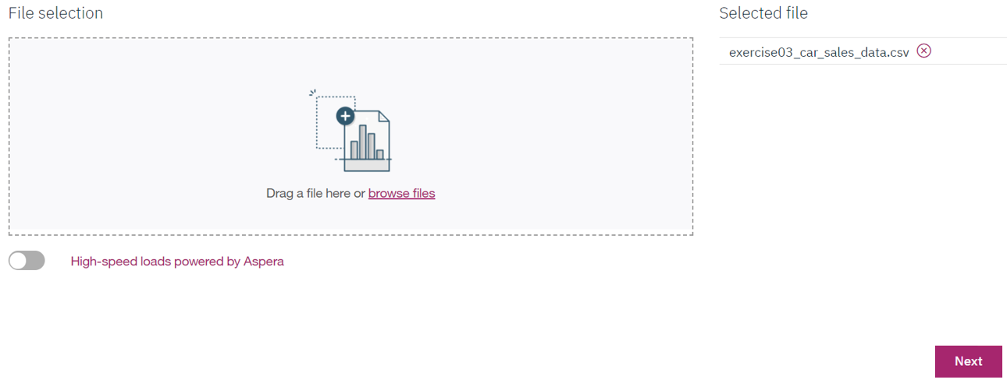

Click **Next** to proceed.

1. You will be asked to select a **Schema** from a list of schema names.

**NOTE:** Select the schema name with a random mix of alphabets and numbers. It will be similar to, but not the same as, the one you see in the screenshot below (*MGJ73335*). The ones that you do NOT have to select are AUDIT, DB2INST1, ERRORSCHEMA, and ST_INFORMTN_SCHEMA (and sometimes you might also see SQLxxxxx as well).

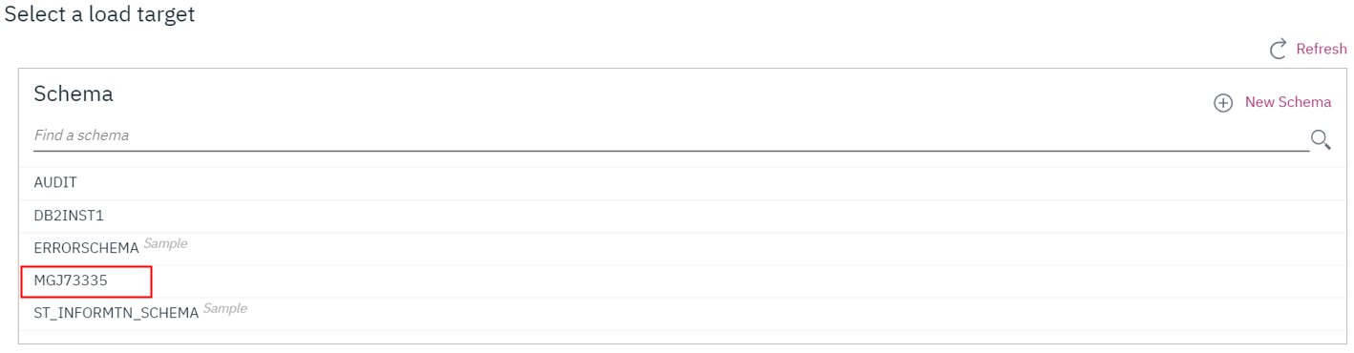  
  
8. Click on **New Table**.

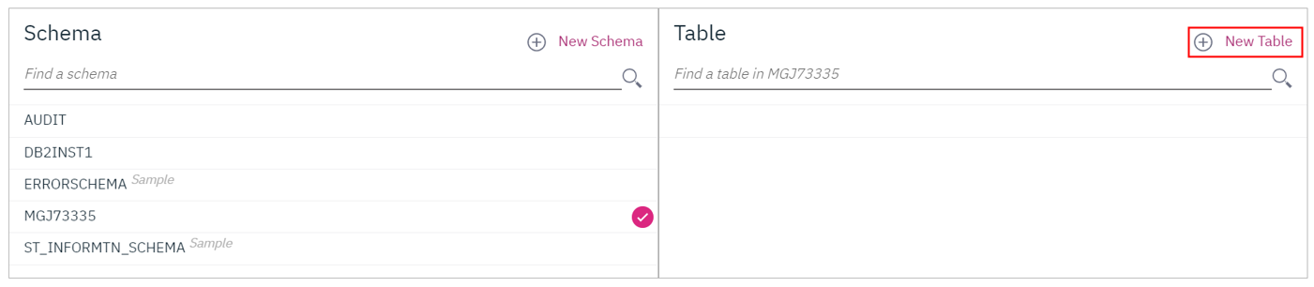

1. Enter the name **CARSALESTABLE** in the input box prompting you with ***NEW TABLE NAME***.

**Note:** You will be using this table name in the SQL queries you will execute in the next exercise.

Now click on **Create** to create the new table.

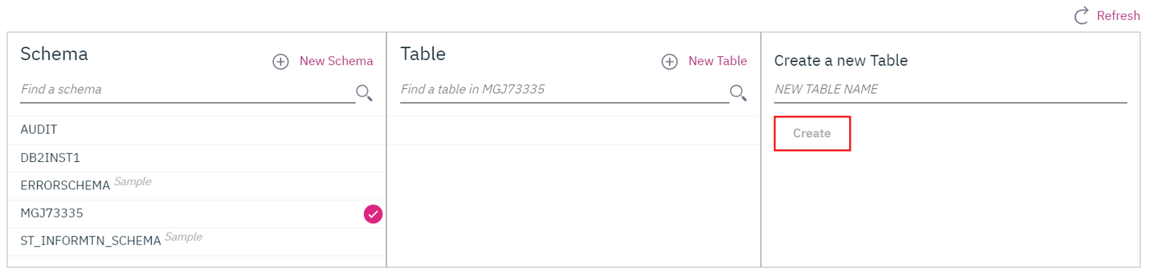

1. A table by the name of **CARSALESTABLE** has been created.

Click **Next** at the bottom right of the page to proceed.

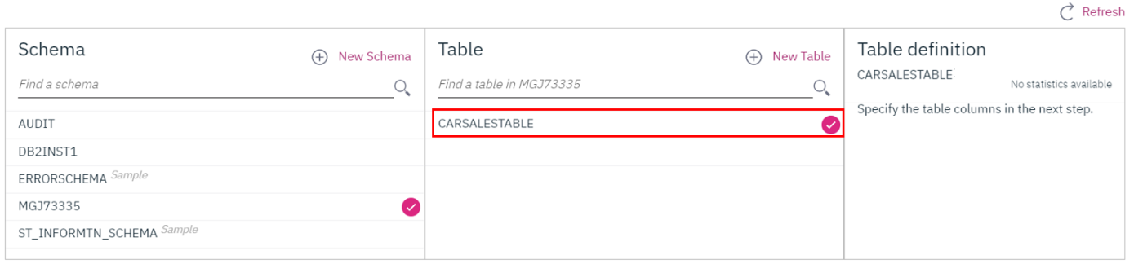

1. Click **Next** to proceed.

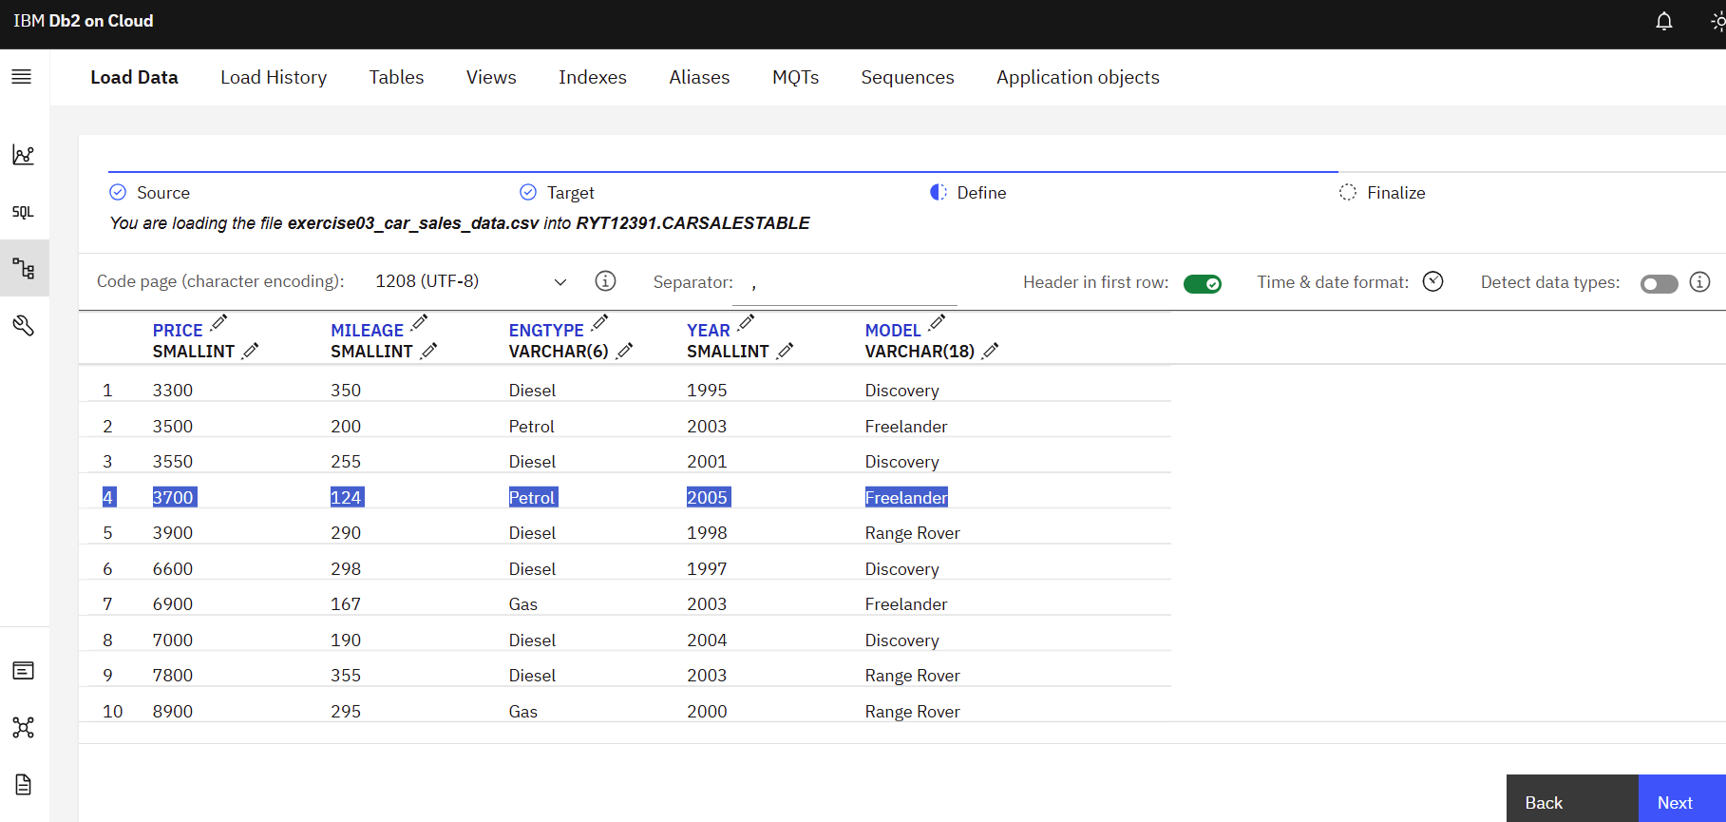

1. Then click **Begin Load** to begin the process of loading the data from the CSV into your database.

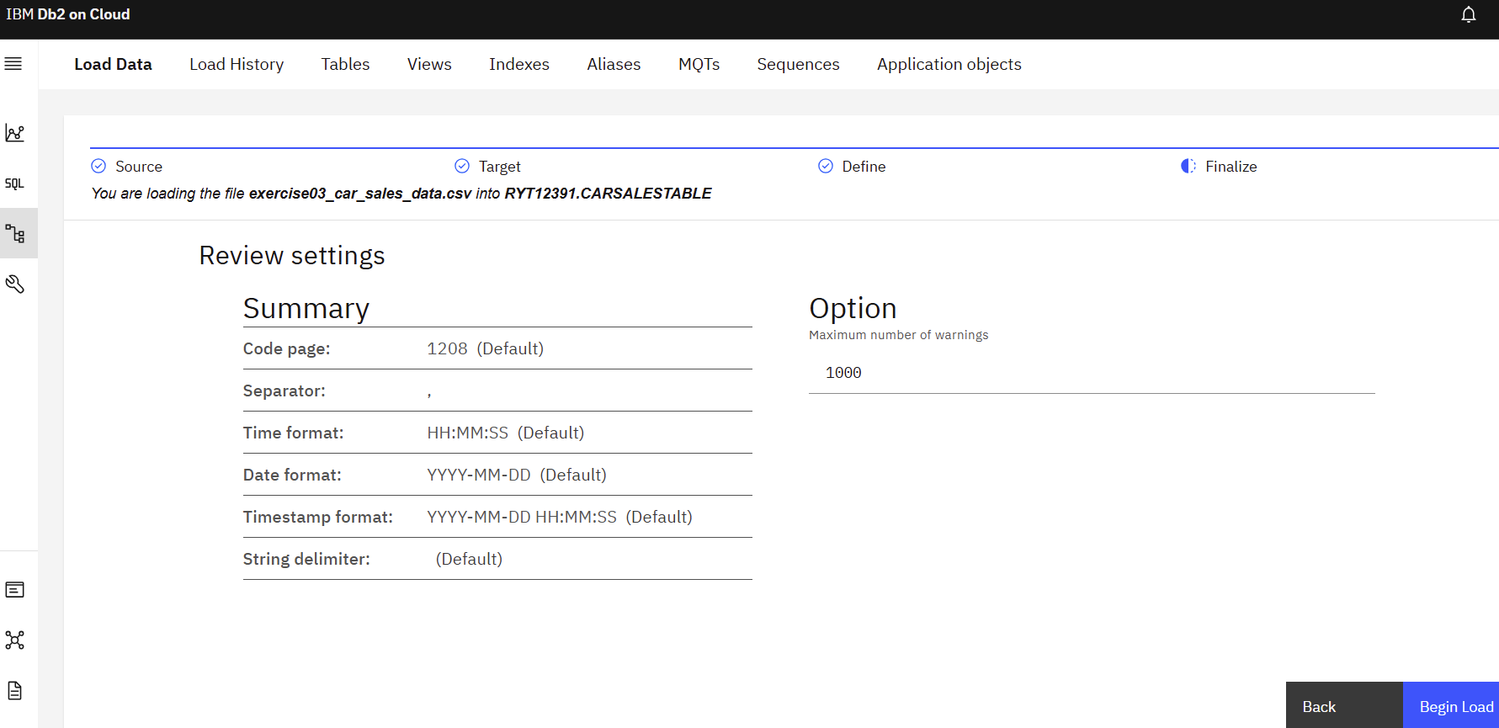

1. Data from your CSV file is now loaded into your Db2 instance.

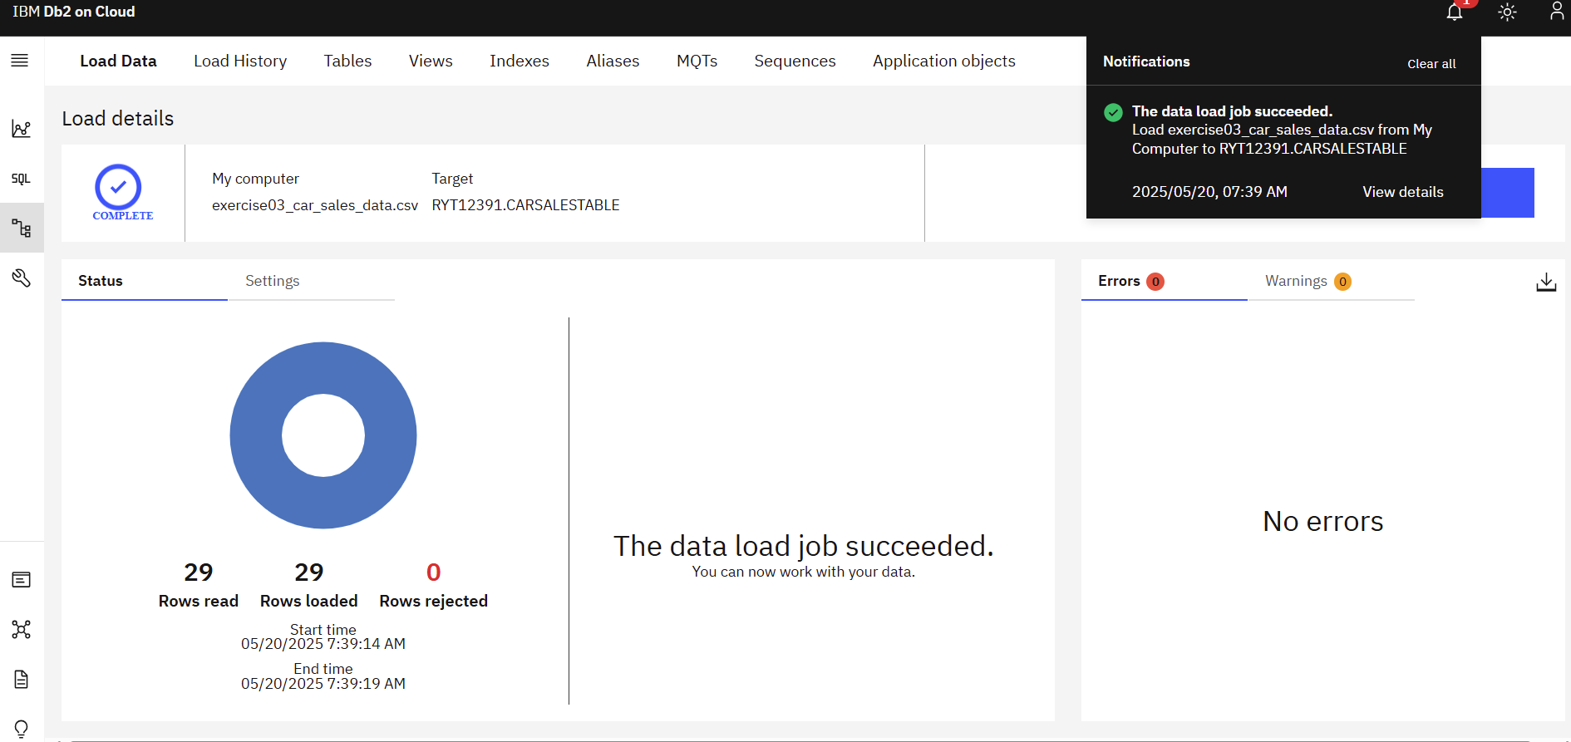

**Summary**

Depending on where the data must be sourced from, there are a number of methods and tools available for gathering data. These include query languages for extracting data from databases, APIs, Web Scraping, Data Streams, RSS Feeds, and Data Exchanges.

Once the data you need has been gathered and imported, your next step is to make it analytics-ready. This is where the process of Data Wrangling, or Data Munging, comes in. Data Wrangling involves a whole range of transformations and cleansing activities performed on the data. Transformation of raw data includes the tasks you undertake to:

* Structurally manipulate and combine data using Joins and Unions.
* Normalize data, that is, clean the database of unused and redundant data.
* Denormalize data, that is, combine data from multiple tables into a single table so that it can be queried faster.

Cleansing activities include:

* Profiling data to uncover anomalies and quality issues.
* Visualizing data using statistical methods in order to spot outliers.
* Fixing issues such as missing values, duplicate data, irrelevant data, inconsistent formats, syntax errors, and outliers.

A variety of software and tools are available for the data wrangling process. Some of the popularly used ones include Excel Power Query, Spreadsheets, OpenRefine, Google DataPrep, Watson Studio Refinery, Trifacta Wrangler, Python, and R, each with their own set of features, strengths, limitations, and applications.

### Practice Quiz

**Question 1. How is data gathered using Application Programming Interfaces, or APIs?**

APIs are invoked from applications to access databases, web services, data marketplaces and other such data endpoints for gathering data

APIs are used for aggregating constant streams of data flowing from instruments, IoT devices and applications, and GPS data from cars

APIs are used for capturing updated data from online forums and news sites where data is refreshed on an ongoing basis

APIs are used for downloading specific data from web pages based on defined parameters

**sQuestion 2. What is one of the common structural transformations used for combining data from one or more tables?**

Cleaning

Denormalization

Joins

Normalization

**Correct**

Joins are one of the common structural transformations used for combining data from multiple tables.

**Question 3. What tool allows you to discover, cleanse, and transform data with built-in operations?**

Trifacta Wrangler

Watson Studio Refinery

Google DataPrep

OpenRefine

**Correct**

Watson Studio Refinery has built-in features that allow you to discover, cleanse, and transform data.

### Graded Quiz

**Question 1. Web scraping is used to extract what type of data?**

Data from news sites and NoSQL databases

Text, videos, and data from relational databases

Text, videos, and images

Images, videos, and data from NoSQL databases

**Correct**

Web scraping is used for extracting text, videos, and images from the web.

**Question 2. ___________ focuses on cleaning the database of unused data and reducing redundancy and inconsistency.**

Data Visualization

Data Profiling

Normalization

Denormalization

**Incorrect**

Data profiling helps you to inspect the source data to understand the structure, content, and interrelationships in your data.

**Question 3. OpenRefine is an open-source tool that allows you to:**

Automatically detect schemas, data types, and anomalies

Enforces applicable data governance policies automatically

Use add-ins such as Microsoft Power Query to identify issues and clean data

Transform data into a variety of formats such as TSV, CSV, XLS, XML, and JSON

**Correct**

Using OpenRefine, you can transform data into a wide variety of formats such as TSV, CSV, XLS, XML, and JSON.

**Question 4. When you’re combining rows of data from multiple source tables into a single table, what kind of data transformation are you performing?**

Unions

Joins

Denormalization

Normalization

**Correct**

Unions are a common structural transformation used for combining rows of data from multiple source tables.

**Question 5. When you detect a value in your data set that is vastly different from other observations in the same data set, what would you report that as?**

Missing value

Irrelevant data

Syntax error

Outlier

**Correct**

Outliers are values in your data set that may be vastly different from other values in the same data field.

### **Querying Data, Performance Tuning, and Troubleshooting**

Una de las cosas que los lenguajes de consulta nos ayudan a hacer es acceder a los datos en la base de datos para que podamos entenderlos mejor.

Algunas técnicas básicas de consulta para analizar datos en una base de datos incluyen COUNT y agregar tu conjunto de datos, identificar valores extremos, segmentar datos, ordenar datos, filtrar patrones, y agrupar datos:

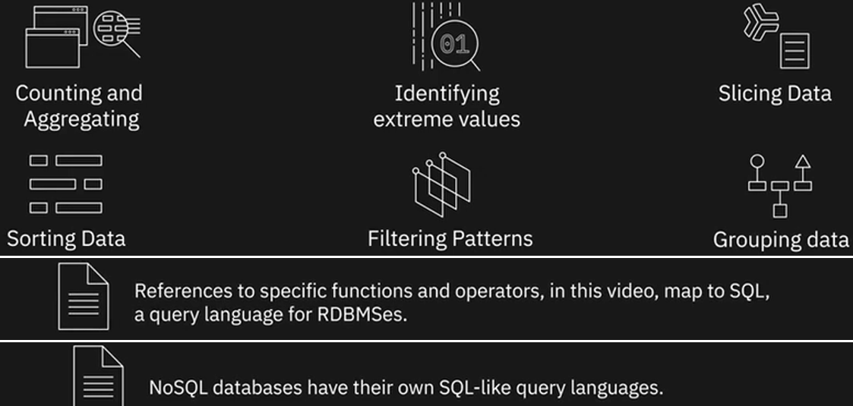

Las bases de datos NoSQL, por ejemplo, tienen sus propios Lenguaje de consulta similares a SQL, como Cassandra CQL y Cypher para Neo4j, además de APIs que se pueden usar para consultar datos.

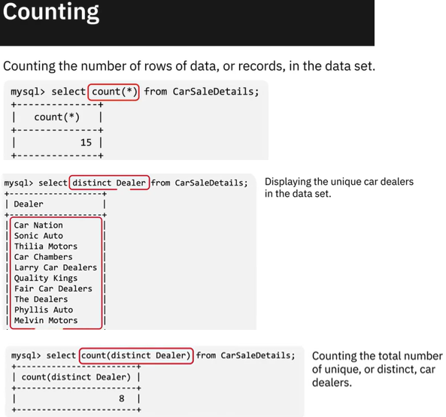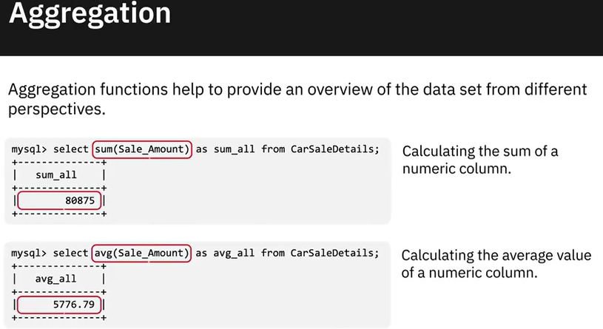

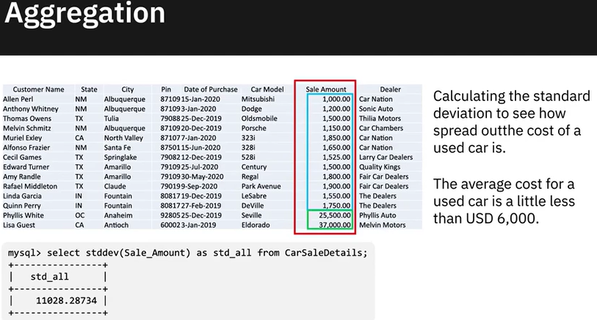

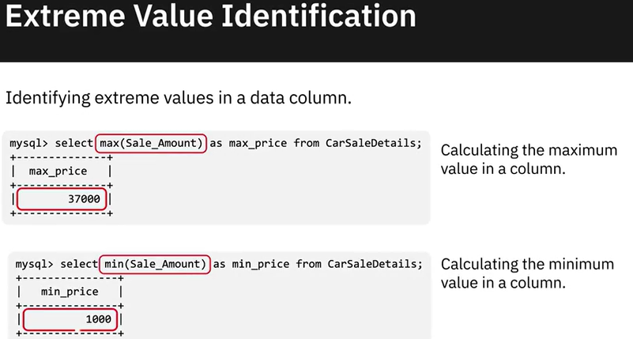

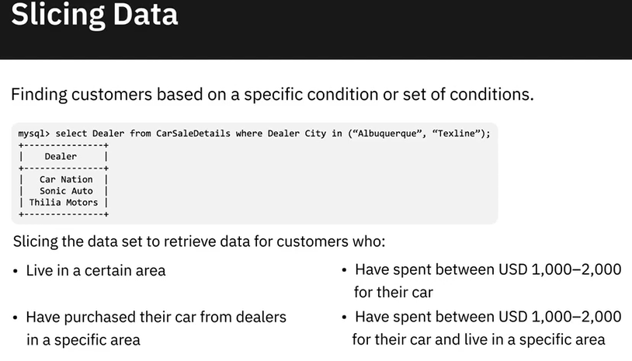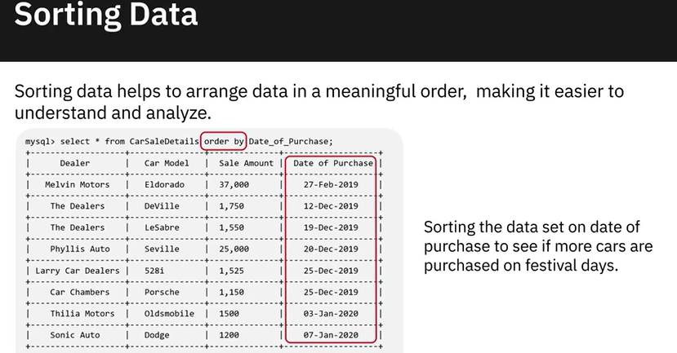

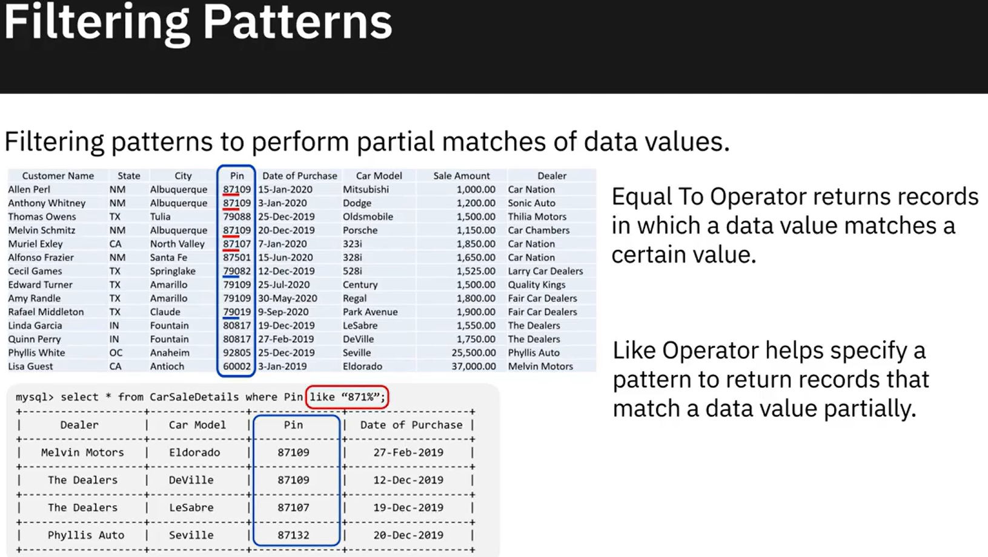

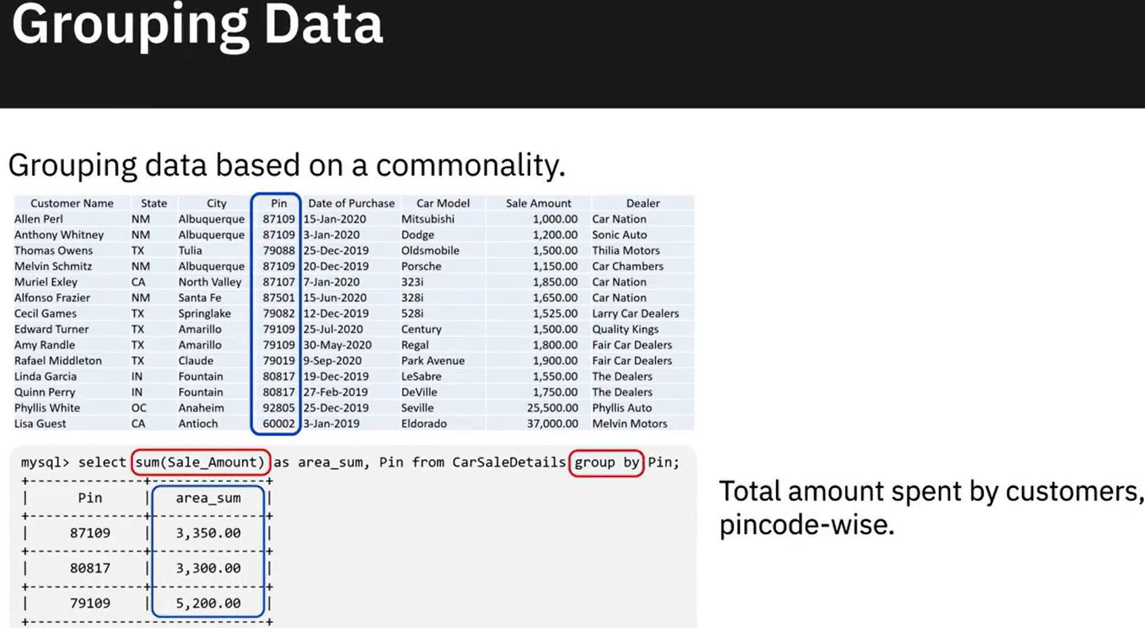

### **Performance Tuning and Troubleshooting**

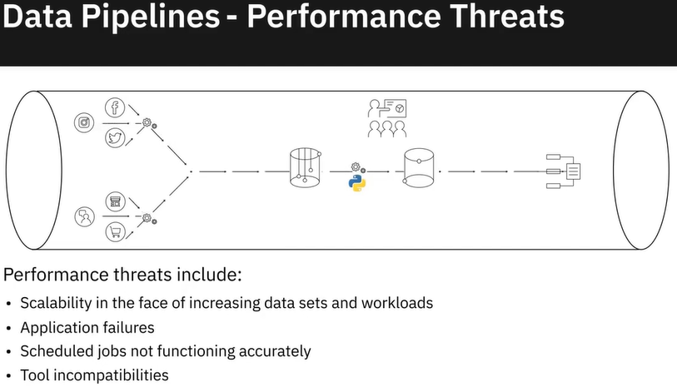

En el caso de las canalizaciones de datos, las métricas de rendimiento incluirían la latencia, es decir, el tiempo que tarda un servicio en cumplir una solicitud, fallos, que es la tasa a la que un servicio falla, utilización de recursos y patrones de utilización y el tráfico o número de solicitudes de usuario recibidas en un período determinado.

Entonces, ¿cuál es la mejor manera de solucionar problemas de rendimiento en una canalización de datos? Depende del problema, pero genéricamente hablando, estos son algunos de los pasos que probablemente tomarás:

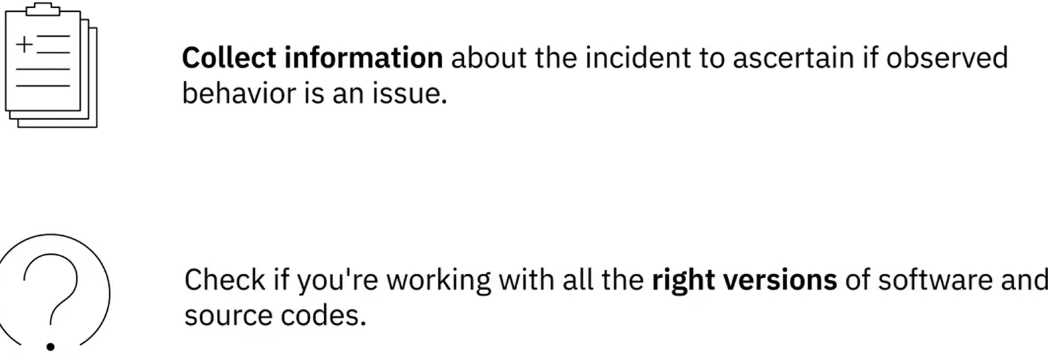 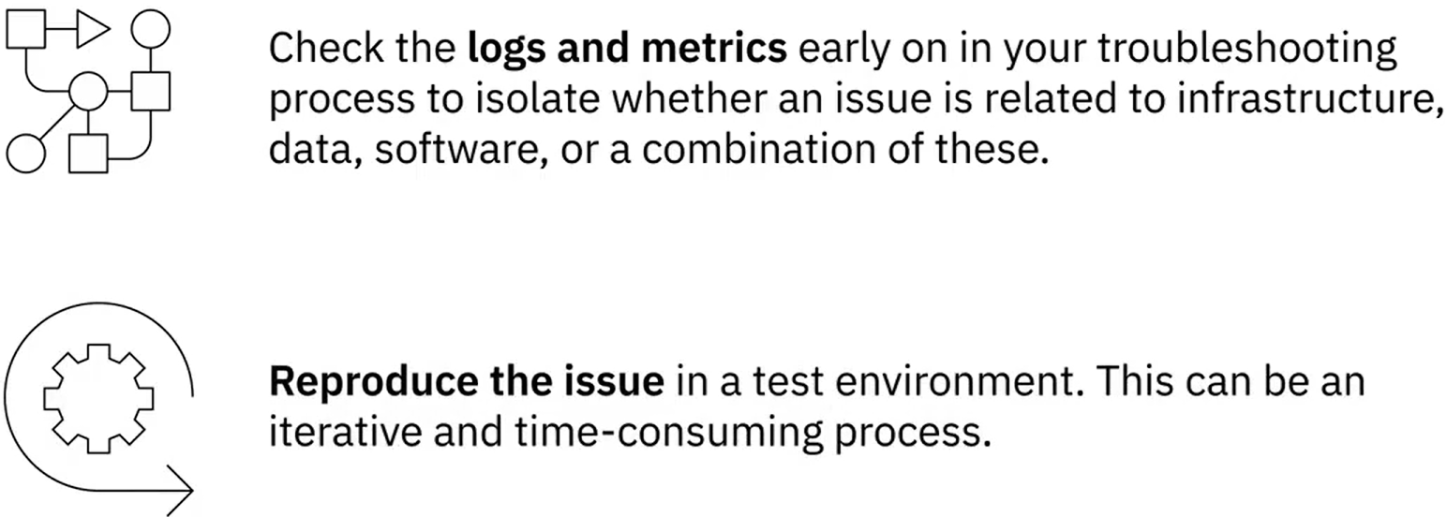

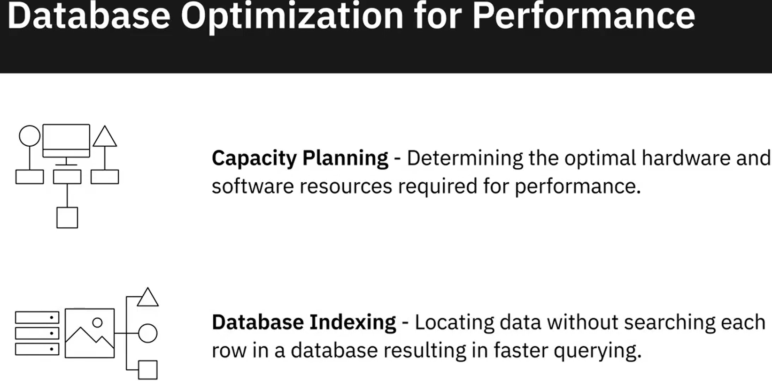 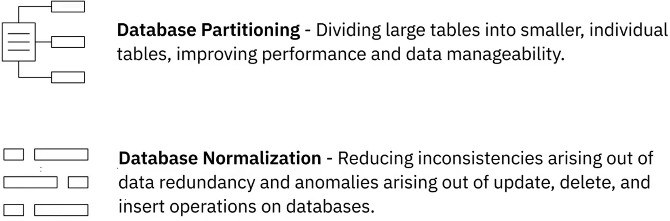

Monitoring systems

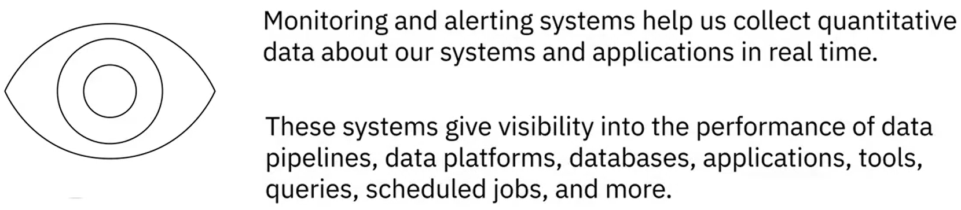

|  |  |
| --- | --- |
|  |  |
|  |  |
|  |  |

### Lab: Explore your dataset using SQL queries using Datasette

Here, we are making use of an internal preloaded **CarSalesdata** database that contains the **exercise03_car_sales_data table**.

**Exercise 1: Execute basic SQL queries on the data you loaded into your database.**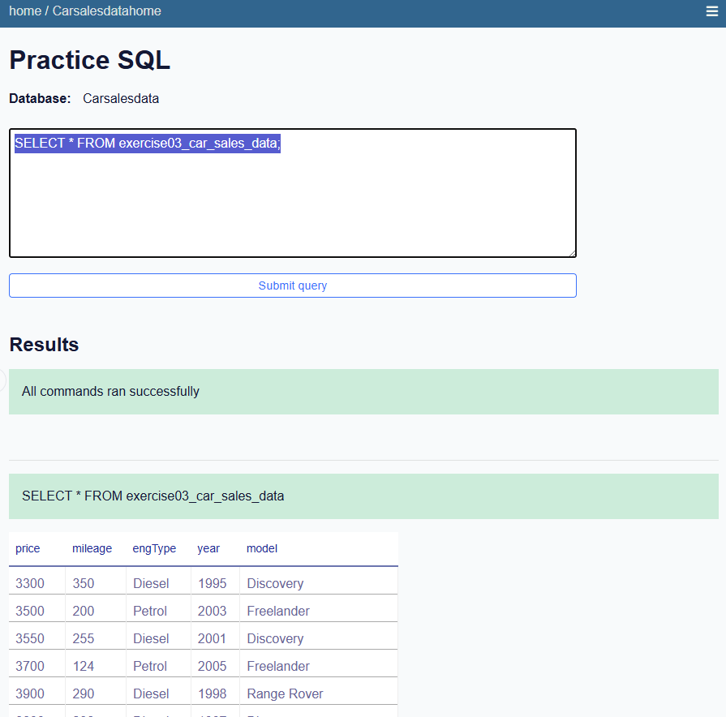

* 1. Execute the following query to check the maximum price.

select max(price) as max_price from exercise03_car_sales_data

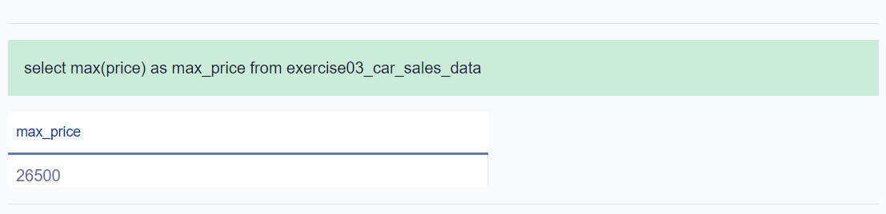

* 1. Execute the following query to display the distinct models.

select distinct(model) from exercise03_car_sales_data;

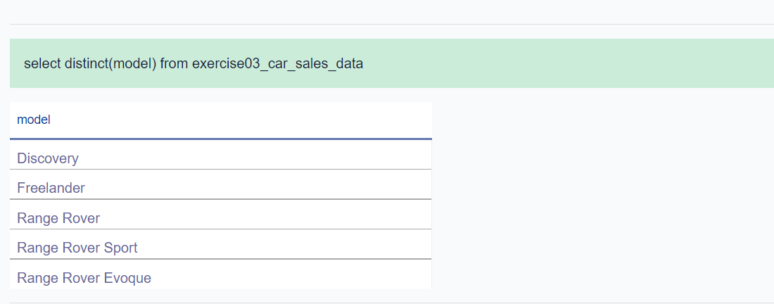

### Hands-on Lab: Explore Your Dataset Using SQL Queries in DB2

1. Click on [https://cloud.ibm.com/catalog/services/db2](https://cloud.ibm.com/catalog/services/db2?utm_source=skills_network&utm_content=in_lab_content_link&utm_id=Lab-IBM-DB0100EN-SkillsNetwork) to access your Db2 dashboard on Cloud.
2. If you’re not already logged in to your IBM Cloud Lite account, click on **Log in** at the bottom right of the screen to log in.
3. Click on the **Go to UI** button



1. Click on the 3-bar menu at the top left of the screen and select **RUN SQL** from the dropdown menu.

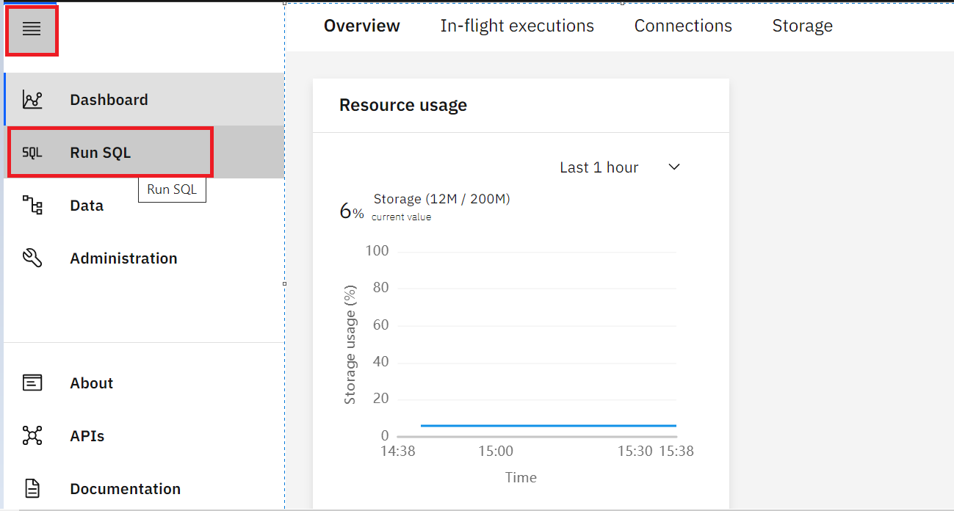

1. On the next screen click on **Create new**. The **SQL editor** will open
2. Run one by one:

select count(*) from CARSALESTABLE;

select max(price) as max_price from CARSALESTABLE;

select max(price) as max_price from CARSALESTABLE;

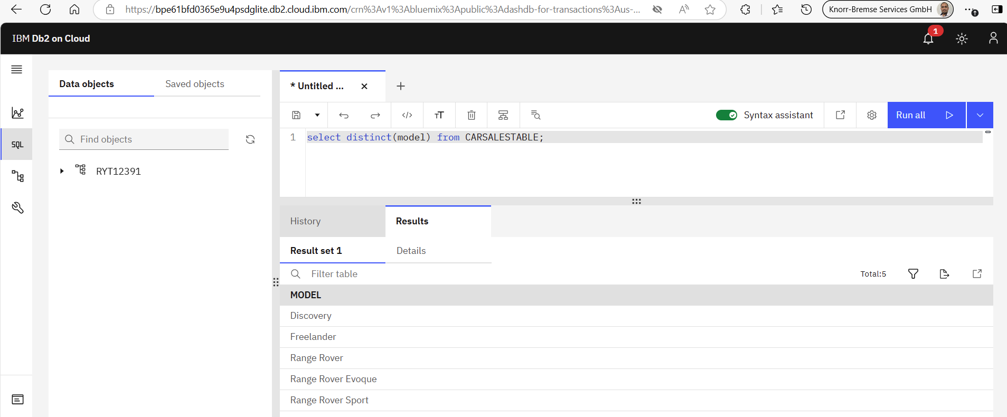

### Summary and Highlights

* In order for raw data to become analytics-ready, a number of transformation and cleansing tasks need to be performed on raw data. And that requires you to understand your dataset from multiple perspectives. One of the ways in which you can explore your dataset is to query it.
* Basic querying techniques can help you explore your data, such as, counting and aggregating a dataset, identifying extreme values, slicing data, sorting data, filtering patterns, and grouping data.
* In a data engineering lifecycle, the performance of data pipelines, platforms, databases, applications, tools, queries, and scheduled jobs, need to be constantly monitored for performance and availability.
* The performance of a data pipeline can get impacted if the workload increases significantly, or there are application failures, or a scheduled job does not work as expected, or some of the tools in the pipeline run into compatibility issues.
* Databases are susceptible to outages, capacity overutilization, application slowdown, and conflicting activities and queries being executed simultaneously.
* Monitoring and alerting systems collect quantitative data in real time to give visibility into the performance of data pipelines, platforms, databases, applications, tools, queries, scheduled jobs, and more.
* Time-based and condition-based maintenance schedules generate data that helps identify systems and procedures responsible for faults and low availability.

### Practice quiz

**Question 1. In the video, we used a query function to see how spread out the values in the “Sale Amount” field are. What function did we use?**

Standard Deviation

Count

Maximum Value

Average

**Correct**

The Standard Deviation function helps us see how far out our values are in a certain numeric column.

**Question 2. ______________ helps you assess if the size of a workload is slowing down the system.**

Monitoring the performance of queries

Monitoring the amount of data being processed through a data pipeline

Job-level Runtime Monitoring

Database Monitoring

**Correct**

Monitoring the quantum of data being processed in a data pipeline at a time helps you assess if the size of the workload is slowing down the system.

### Graded Quiz

**Question 1. What are some of the querying techniques you can apply to identify extreme values in a data column?**

Aggregation

Maximum and Minimum values in a data column

Performing partial matches of data values

Slicing a data set

**Correct**

Finding the maximum and minimum values in a data column can help you identify extreme values in that column.

**Question 2. You can perform partial matches of data values in a data column using:**

Count function

Filtering patterns

Average function

Slicing a data set

**Question 3. Tools for ______________ break up a job into a series of logical steps which are monitored for completion and time to completion.**

Job-level Runtime Monitoring

Monitoring Query Performance

Application Performance Monitoring

Monitoring the amount of data being processed in a data pipeline

**Question 4. Database partitioning helps optimize databases for performance. It does this by:**

Dividing large tables into smaller individual tables

Reducing inconsistencies and anomalies in data

Tracking request response time and error messages

Minimizing the number of times a disk needs to be accessed when a query is processed

**Correct**

Database partitioning is a process by which very large tables are divided into smaller, individual tables. It helps with data manageability and also impacts the speed of querying, cleansing, and analyzing operations on the database.

**Question 5. Database normalization is a design technique that helps reduce inconsistencies and anomalies from data.**

True

False

**Correct**

Database normalization helps reduce inconsistencies that arise out of data redundancy and also anomalies arising out of update, delete, and insert operations on databases.

### **Governance and Compliance**

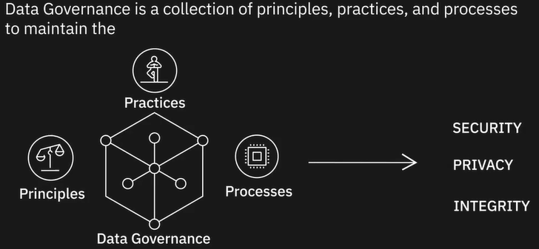

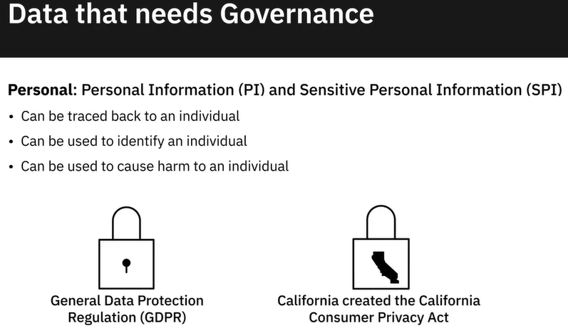 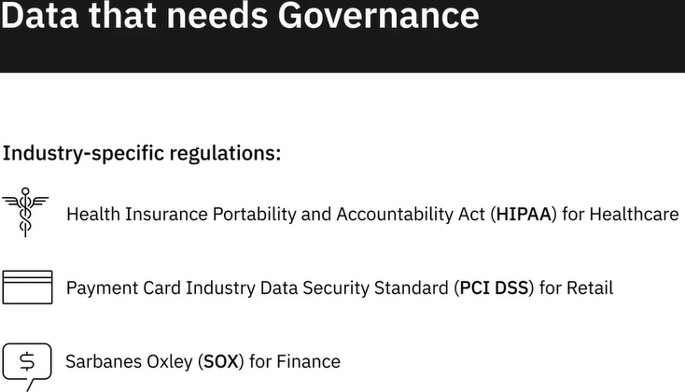

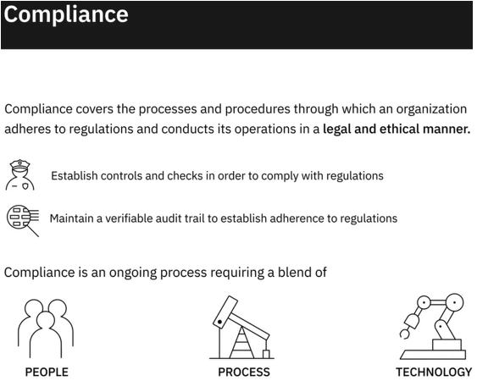

**Data Lifecycle:**

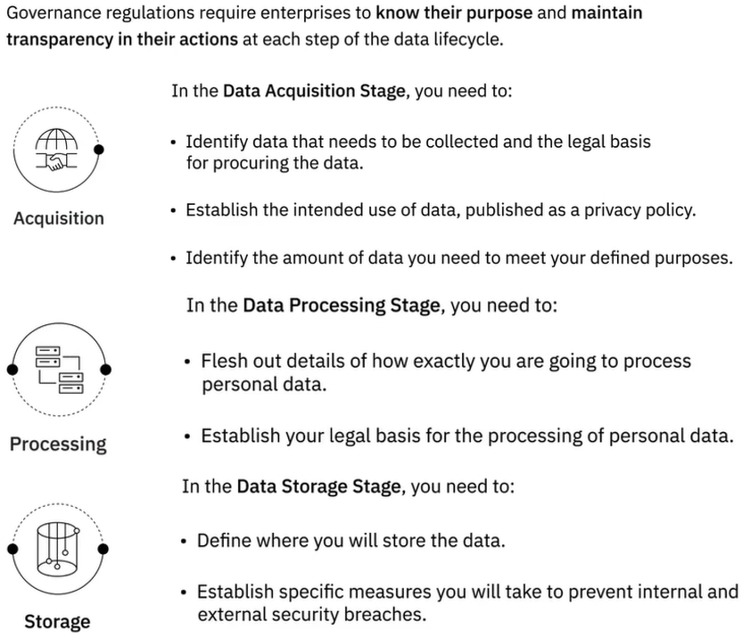

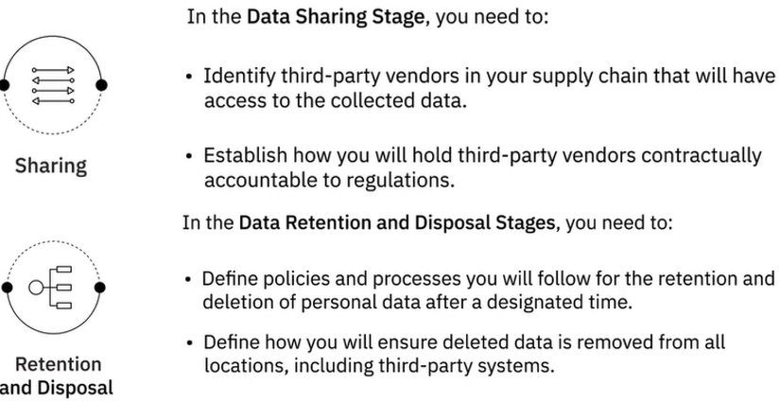

**Technology as an enabler:**



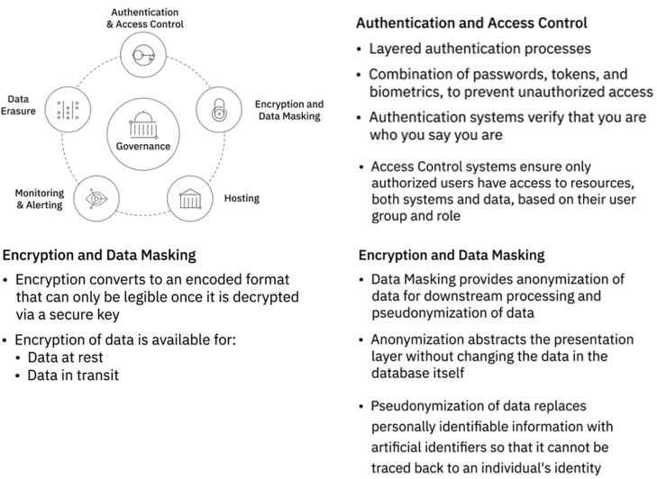

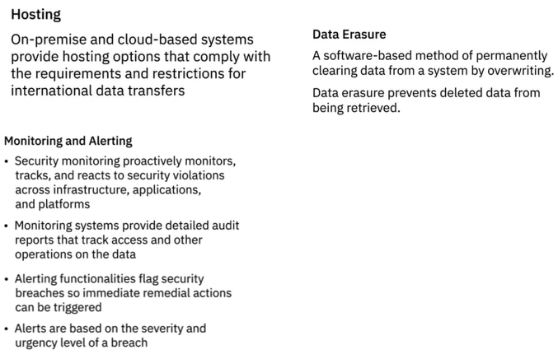

### **Summary**

Data Governance is a collection of principles, practices, and processes that help maintain the security, privacy, and integrity of data through its lifecycle.

Personal Information and Sensitive Personal Information, that is, data that can be traced back to an individual or can be used to identify or cause harm to an individual, needs to be protected through governance regulations.

General Data Protection Regulation, or GDPR, is one such regulation that protects the personal data and privacy of EU citizens for transactions that occur within EU member states. Regulations, such as HIPAA (Health Insurance Portability and Accountability Act) for Healthcare, PCI DSS (Payment Card Industry Data Security Standard) for retail, and SOX (Sarbanes Oxley) for financial data are some of the industry-specific regulations.

Compliance covers the processes and procedures through which an organization adheres to regulations and conducts its operations in a legal and ethical manner.

Compliance requires organizations to maintain an auditable trail of personal data through its lifecycle, which includes acquisition, processing, storage, sharing, retention, and disposal of data.

Tools and technologies play a critical role in the implementation of a governance framework, offering features such as:

* Authentication and Access Control.
* Encryption and Data Masking.
* Hosting options that comply with requirements and restrictions for international data transfers.
* Monitoring and Alerting functionalities.
* Data erasure tools that ensure deleted data cannot be retrieved.

### Practice Quiz

**Question 1. At what stage of the data lifecycle would you establish which third-party vendors in your supply chain will have access to the data you are collecting?**

Data Sharing

Data Storage

Data Processing

Data Acquisition

**Correct**

It is in the Data Sharing phase of the data lifecycle that you establish which third-party vendors will have access to your data, and how they will be held accountable to the same regulations you are liable for.

### Graded Quiz

**Question 1. In which phase of the data lifecycle do you establish the data you need, the amount of data you need, and how you intend to use the data you are collecting.**

Data Processing

Data Acquisition

Data Retention

Data Sharing

**Question 2. The process of _____________ abstracts the presentation layer without changing the data in the database physically.**

Encryption

Anonymization

Data Profiling

Pseudonymization

### Optional: Overview of the DataOps Methodology

Gartner defines DataOps as a collaborative data management practice focused on improving the communication, integration, and automation of data flows between data managers and consumers across an organization. DataOps aims to create predictable delivery and change management of data, data models, and related artifacts. DataOps uses technology to automate data delivery with the appropriate levels of security, quality, and metadata to improve the use and value of data in a dynamic environment.” (Source: <https://blogs.gartner.com/nick-heudecker/hyping-dataops/>) A small team working on a simpler or limited number of use cases can meet business requirements efficiently. As data pipelines and data infrastructures get more complex, and data teams and consumers grow in size, you need development processes and efficient collaboration between teams to govern the data and analytics lifecycle. From data ingestion and data processing to analytics and reporting, you need to reduce data defects, ensure shorter cycle times, and ensure 360-degree access to quality data for all stakeholders. DataOps helps you achieve this through metadata management, workflow and test automation, code repositories, collaboration tools, and orchestration to help manage complex tasks and workflows. Using the DataOps methodology ensures all activities occur in the right order the right security permissions. It helps set in a continual process that allows you to cut wastages, streamline steps, automate processes, increase throughput, and improve continually. Several DataOps Platforms are available in the market, some of the popular ones being IBM DataOps, Nexla, Switchboard, Streamsets, and Infoworks.

**DataOps Methodology:**

The purpose of the DataOps Methodology is to enable an organization to utilize a repeatable process to build and deploy analytics and data pipelines. Successful implementation of this methodology allows an organization to know, trust, and use data to drive value.

It ensures that the data used in problem-solving and decision making is relevant, reliable, and traceable and improves the probability of achieving desired business outcomes. And it does so by tackling the challenges associated with inefficiencies in accessing, preparing, integrating, and making data available.

In a nutshell, the DataOps Methodology consists of three main phases:

* The **Establish DataOps Phase** provides guidance on how to set up the organization for success in managing data.
* The **Iterate DataOps Phase** delivers the data for one defined sprint.
* The **Improve DataOps Phase** ensures learnings from each sprint is channeled back to continually improve the DataOps process.

The figure below presents a high-level overview of these phases and the key activities within each of these phases.

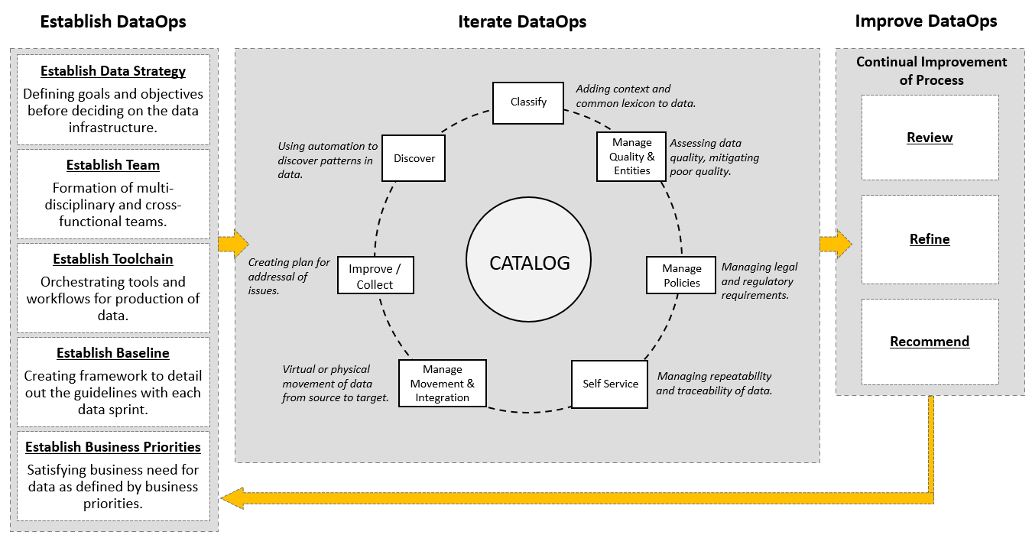

**Benefits of using the DataOps methodology:**

Adopting the DataOps methodology helps organizations to organize their data and make it more trusted and secure. Using the DataOps methodology, organizations can:

* Automate metadata management and catalog data assets, making them easy to access.
* Trace data lineage to establish its credibility and for compliance and audit purposes.
* Automate workflows and jobs in the data lifecycle to ensure data integrity, relevancy, and security.
* Streamline the workflow and processes to ensure data access and delivery needs can be met at optimal speed.
* Ensure a business-ready data pipeline that is always available for all data consumers and business stakeholders.
* Build a data-driven culture in the organization through automation, data quality, and governance.

As a data practitioner, using the methodology can help you reduce development time, cut wastages and duplication of effort, increase your productivity and throughput, and ensure that your actions produce the best possible quality of data.

With DataOps, data professionals, consumers, and stakeholders can collaborate more effectively towards the shared goal of creating valuable insights for business. While implementing the methodology will require systemic change, time, and resources, but in the end, it makes data and analytics more efficient and reliable.

Interestingly, it also opens up additional career opportunities for you as a data engineer. **DataOps Engineers** are technical professionals that focus on the development and deployment lifecycle rather than the product itself. And as you grow in experience, you can move into more specialist roles within DataOps, contributing to defining the data strategy, developing and deploying business processes, establishing performance metrics, and measuring performance.

### **Career Opportunities and Learning Paths**

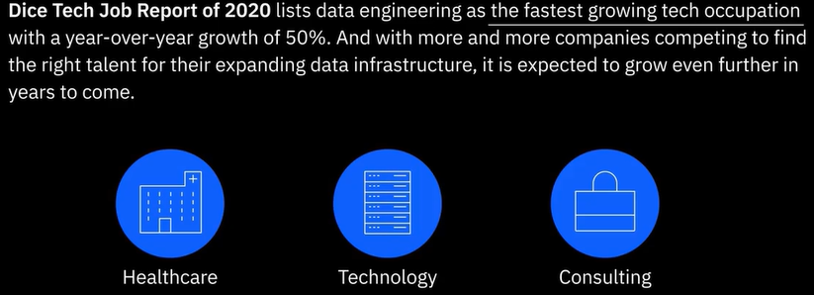

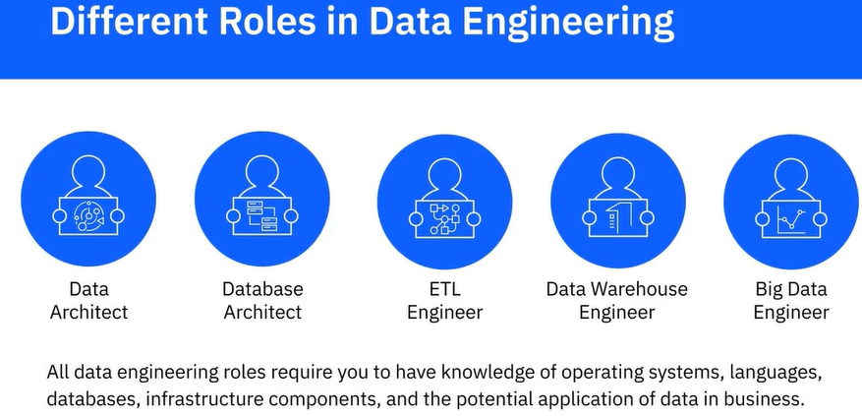

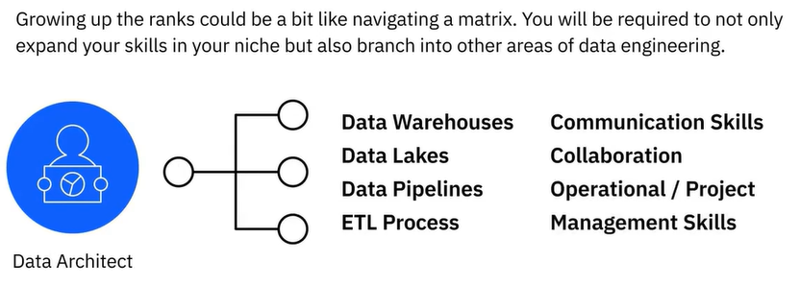

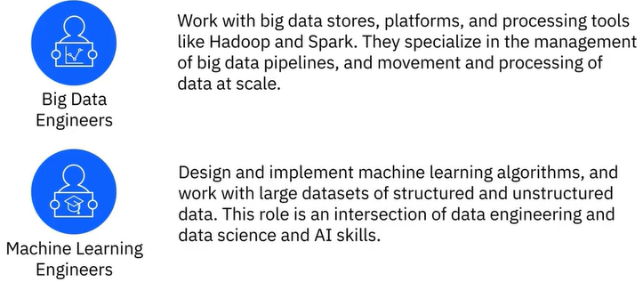

### Reading: Data Warehousing Specialist

According to salary.com, the median salary for a Data Warehouse Specialist in the US is $110,168.

As a specialization within the broader field of Data Engineering, Data Warehousing Specialists may be responsible for many kinds of tasks. These tasks may include any of the following:

* Developing processes, procedures, and software applications for enterprise data management
* Analyzing and improving data warehousing processes for efficiency, accuracy, usablilty, or security
* Designing, modelling, or implementing corporate data warehousing activities
* Developing or maintaining standards, such as organization, structure, or nomenclature, for the design of data warehouse elements, such as data architectures, models, tools, and databases
* Providing or coordinating troubleshooting support for data warehouses
* Writing or modifying programs to meet customer requirements
* Creating documentation such as metadata and diagrams of entity relationships, business processes, and process flow
* Designing, implementing, or operating comprehensive data warehouse systems to balance optimization of data access with batch loading and resource utilization factors, according to customer requirements
* Performing system analysis, data analysis or programming, using a variety of computer languages and procedures
* Reviewing designs, code, test plans, or documentation to ensure quality
* Creating plans, test files, and scripts for data warehouse testing, ranging from unit to integration testing
* Implementing business rules via stored procedures, middleware, or other technologies
* Supporting users of the data warehouse

**Soft skills required for the Data Warehousing Specialist role**

* Critical thinking - Using logic and reasoning to identify the strengths and weaknesses of alternative solutions, conclusions, or approaches to problems
* Complex problem solving - Identifying complex problems and reviewing related information to develop and evaluate options and implement solutions
* Decision making - Assessing the costs and benefits of a variety of optional solutions, and choosing the most appropriate solution
* Systems evaluation - Identifying and evaluating system performance measures, and actions needed to improve or correct poor performance
* Active learning - Understanding the implications of new information or technologies for both current and future problem-solving and decision-making
* Communicating effectively

**Technical Skills required for the Data Warehousing Specialist role**

**Specialized knowledge**

* Programming - writing computer programs for various purposes
* Systems analysis - determining how a business system works, and understanding how changes in conditions may affect outcomes
* Data architecture - understanding the models, the policies, rules or standards that govern which data is collected, how data is stored, arranged, and integrated, and how to put data to use in data systems
* Data management and analysis - securely collecting, storing, and analyzing data
* Data pipelines - building and maintaining data pipelines
* Business intelligence - data warehousing; extract, transform, and load (ETL); and data mapping
* Database normalization - data integrity and normalization
* Data storage structures - especially relational databases
* Data migration - ETL of data from one system to another
* Metadata management and metadata standards
* Data integration platforms
* Overview of the Data Engineering Ecosystem
* Cloud data - building scalable cloud data infrastructure
* Database administration, including Big Data administration
* Data acquisition and transformation - Digitizing data for display, analysis, and storage
* Data lakes, data marts, data reservoirs
* IoT - Integrating data from various connected devices and systems in IoT using data pipelines
* Building event streaming pipelines

**Law & Government**

* Acts & Regulations - knowledge of laws, regulations, requirements and ethical issues related to the access and use of information, for example intellectual capital, personally identifiable information, and customer data

**Software and IT skills**

* Cloud computing and cloud platforms: Amazon Web Services (AWS), Microsoft Azure, SpringCloud, GCS (Google Cloud Storage)
* Data warehouse tools: Snowflake, Data Bricks, BigQuery, Redshift, Db2
* Data pipeline tools: Apache Kafka, Apache Airflow, Luigi
* Big data tools: Apache Hadoop, Apache Spark, Apache Hive
* Operating systems: UNIX, Linux
* Programming languages: SQL, Bash, Python, R, Java, C++
* Databases - Cassandra, Microsoft SQL Server, MySQL, PostgreSQL, Amazon DynamoDB, Apache Solr, IBM Db2, MongoDB, neo4j, Oracle PL/SQL, PostgreSQL
* Metadata management software - CA Erwin Data Modeler; Oracle Warehouse Builder; SAS Data Integration Server; Talend Data Fabric; Alation Data Catalog, SAP Information Steward, Azure Data Catalog, IBM Watson Knowledge Catalog, Oracle Enterprise Metadata Management (OEMM), Adaptive Metadata Manager, Unifi Data Catalog, data.world, and Informatica Enterprise Data Catalog
* Agile software development methodologies
* Version control - Git
* Modelling and API development
* Business intelligence and data analysis software - IBM Cognos Impromptu, MicroStrategy, Microsoft Power BI, Google Analytics, InsightSquared, Oracle Business Intelligence Enterprise Edition, Qlik Tech QlikView, ‎Sisense, ‎Tableau, ‎Dundas BI, ‎SAS Analytics, Domo, SAP Lumira

**Pathways to becoming a Data Warehouse Specialist**

There are many possible paths to becoming a Data Warehousing Specialist. Most practitioners have a minimum of a Bachelor’s Degree in a mathematical or computational field such as Computer Science, Computer Engineering or the Mathematical Sciences. However, many practitioners instead have a Technology or Technical Diploma in a Computational or Information Technology discipline. Combining this educational background with some hands-on experience with application development and use of software for managing databases and metadata is a good way to prepare for the role.

**Career progression**

The career progression of a Data Warehouse Specialist might take a direct path, such as starting at the Junior or Associate Data Warehouse Specialist role, and evolving over time through the Data Warehouse Specialist, Senior Data Warehouse Specialist, Lead Data Warehouse Specialist, and Principal Data Warehouse Specialist roles. Having said that, the path of progression is by no means unique.

Since the Data Warehouse Specialist role is simply a Data Engineering role with an emphasis on Data Warehousing, you will most likely find yourself shifting between specializations within the Data Engineering world, depending on your interests and abilities as well as the needs of the teams you find yourself working with.

On smaller teams you may need to participate day-to-day in many or all stages of the data engineering lifecycle. Working with larger teams, you will naturally find some combination of a smaller niche and career progression as the best fit. No matter your path, in order to progress throughout your career as an engineer, you will always need to be learning about and making use of emerging tools and technologies. This continuous learning will also inform you as you discover your path.

**Summary**

In this reading, you learned that:

* The Data Warehousing Specialist is a particluar kind of Data Engineer, more tightly focused on the data warehousing aspects of the broader discipline
* Data Warehousing Specialists design, model, and implement corporate data warehousing activities, program and configure warehouses of databases, and provide support to data warehouse users
* Data Warehousing Specialists require specialized knowledge of data architecture - understanding the models, the policies, rules or standards that govern which data is collected, how data is stored, arranged, and integrated, and how to put data to use in data systems
* Soft skills required for the data warehousing specialist role include complex problem solving and active learning
* No matter your path, in order to progress throughout your career as an engineer, you will always need to be learning about and making use of emerging tools and technologies

### Reading: Data Manager

Data-related technical roles focus on infrastructure, architecture, and machine learning. They typically require programming skills, knowledge of databases, and adept handling of large datasets. These roles include data engineer, machine learning engineer, database administrator (DBA), and data engineer.

To get started in these roles, you should consider an entry-level role in data engineering. This will familiarize you with the data ecosystem, where you work with data pipelines and maintain infrastructure under the direction of a more senior-level data engineer.

Machine learning engineers develop machine learning algorithms and models, assessing the most appropriate models for your data. A database administrator’s responsibilities include managing and maintaining a database to ensure performance and security.

**AI impact on technical roles**

Regarding how AI may affect technical data roles, you can expect AI will automate routine tasks and AI tools will assist in optimizing code. AI will allow you to focus on higher-level tasks such as designing and integrating AI components into infrastructures to ensure components work as expected.

**Analytical roles**

Another category of data-related roles includes analyzing data and providing insights based on your analysis. In these roles, you will explore collected data to identify insights from your data.

Data analysts and data scientists play roles in analysis. Analysts usually report to a data scientist and create visualizations, dashboards, and reports under the scientist’s direction. As a data scientist, you will bear the responsibility of leading the team and its direction by applying statistical techniques and crafting the stories they find in the data. Data scientists bear the responsibility of effectively championing their recommendations of their team’s findings to others in the organization.

**AI impact on analytical roles**

You can expect AI will certainly automate many aspects, but the role will need to craft and tell coherent, compelling stories with that data and how to utilize these insights best.

**Governance and privacy roles**

Regarding data governance and privacy, these related roles ensure that data collection, storage, and comply with legal, ethical, and organizational standards. Roles include data governance associate, data steward, compliance specialist, governance manager, data ethics steward, and data privacy officer. For an entry-level role, you should target a data governance associate who supports governance by developing documentation and ensuring data quality.

Data governance entails establishing and complying with the regulations and standards that direct how the business uses and manages its data, including legal issues. It ensures data integrity and security by developing and enforcing policies. Roles in data governance include the governance manager, data governance associate, and compliance specialist.

Data stewards ensure data quality, integrity, and proper management. They ensure their data is secure and handled in accordance with company policies related to data. Data stewards ensure AI models do not introduce bias or encourage misuse and promote responsible data use. Data ethics stewards ensure that the business handles its data ethically for transparency and accountability beyond compliance. Data stewardship tends toward more technical issues, whereas an ethics steward ensures that data practices align with societal values and ethical principles.

**AI impact on governance and privacy roles**

As AI adoption and integration mature, the data governance field will likely grow rapidly as industries endeavor to understand the quickly changing laws, policies, and the data landscape. AI itself can likely help monitor established policies and flag issues, freeing humans to focus on strategy alignment with business objectives, ethics, and regulations.

**Leadership roles and AI impact on leadership roles**

Data leadership roles include data architect, chief data officer, and data ethics officer. All of these roles help establish the vision and missions with respect to their particular area of expertise. These thought leaders set data policy for the business and ensure alignment with these directives throughout the organization. They will be the ones making decisions about how, where, and why AI should be used in their organizations. Ultimately, these leadership roles will determine the impact AI will have on their businesses.

**Data-related roles relationships**

Regarding the organizational structure of these roles within an organization, the exact positioning of them within the org chart may vary, but typically you will see something similar to the following diagram:

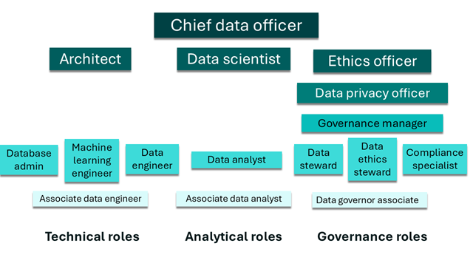

### Data Engineering Learning path

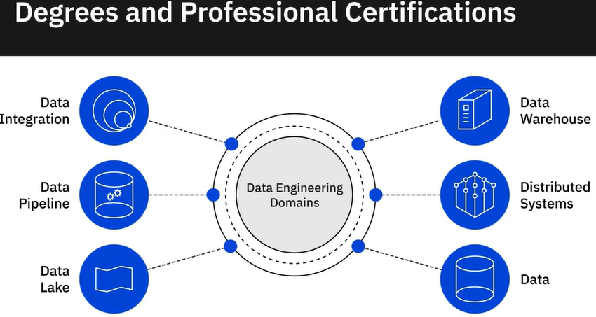

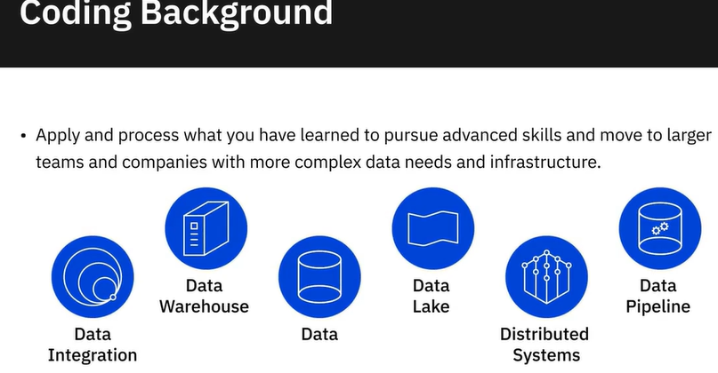

Una de las preguntas principales que hago cuando estoy entrevistando para ese rasgo en particular es decir, oye, alguien viene a ti y dice que la base de datos está lenta, ¿qué haces?

Y no busco que digan que optimizan la memoria, no busco que digan que miran este métrico, busco que hagan preguntas y piensen en diferentes direcciones de donde podría venir la lentitud, cosas así.

Alguien que sea curioso y que pueda comunicarse muy bien.

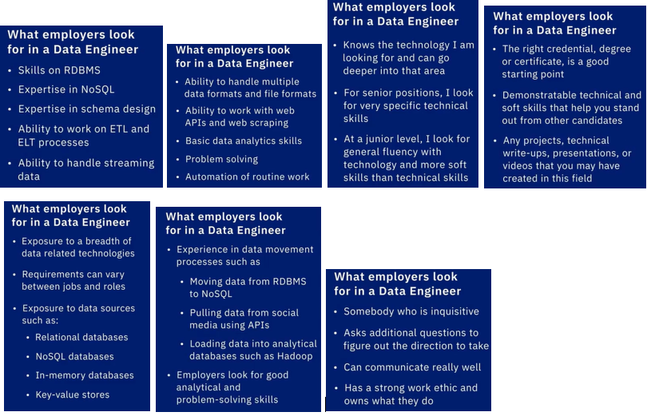

preguntarles qué han hecho para aprender el campo.

¿Qué han hecho qué cursos han tomado qué blogs leen qué direcciones están tomando para aprender más?

### Paths to Data Engineering

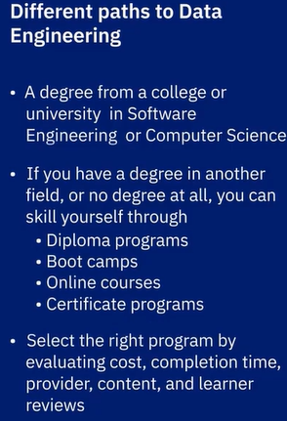 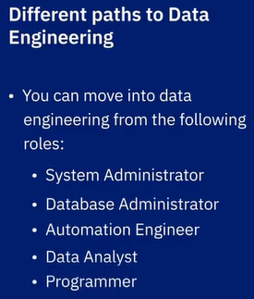 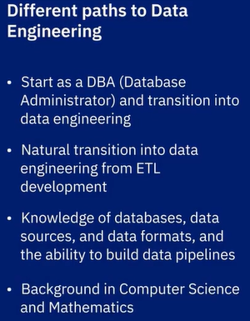

### **Viewpoints: Advice to Aspiring Data Engineers**

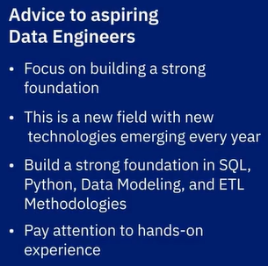 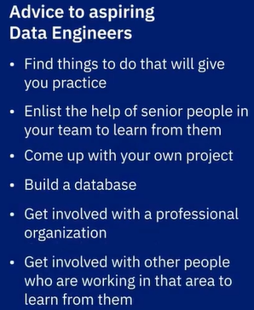 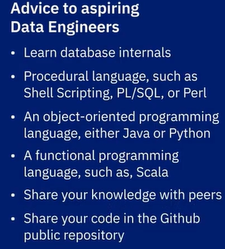

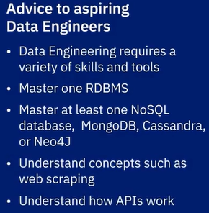 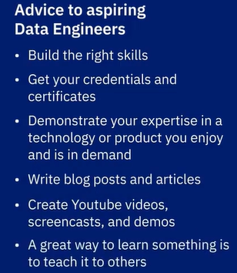

### Summary and Highlights

In this lesson, you have learned:

Data Engineering is reported to be one of the top ten jobs experiencing tremendous growth in the U.S. today. It is also reported to be one of the fastest growing tech occupations with year-over-year growth of around 50%.

Currently, the demand for skilled data engineers far outweighs the supply, which means companies are willing to pay a premium to hire skilled data engineers.

Data engineering roles in organizations tend to break the specialization up into Data Architecture, Database Design and Architecture, Data Platforms, Data Pipelines and ETL, Data Warehouses, and Big Data.

Regardless of the niche you choose to specialize in, knowledge of operating systems, languages, databases, and infrastructure components, is essential.

To work your way up from a Junior Data Engineer to a Lead or Principal Data Engineer, you need to continually advance your technical, functional, and soft skills from a foundational level to an expert level. You need to not only expand your skills in your niche area, but also into other areas of data engineering at the same time.

Big Data Engineers and Machine Learning Engineers are some of the emerging roles in this field and they require specialized skills in addition to basic data engineering.

There are several paths you can consider in order to gain entry into the data engineering field.

* An academic degree in Computer Science or engineering qualifies you for an entry-level job.
* If you are not a graduate, or a graduate in a non-relate stream, you can earn professional certifications from online multi-course specializations offered by learning platforms such as Coursera, edX, and Udacity.
* If you have a coding background, or you are an IT Support Specialist, a Software Tester, a Programmer, or a data professional such as a Statistician, Data Analyst, or BI Analyst, you can upskill with the help of online courses to become a Data Engineer.

### Practice Quiz

**Question 1. On the Data Engineering career path, you could be starting your career as an Associate or Junior Data Engineer and working your way up to a Principal Data Engineer role. What are some of the factors that influence your growth on this path?**

The experience you gain within your niche, or chosen area of expertise, and branching into other areas of data engineering.

At least five to six years of experience at each level

Specialization in any one domain area, such as Healthcare, Banking, Technology

A Master’s degree in either Mathematics or Statistics

**Correct**

The amount of experience you gain within your chosen area of specialization and how much you expand your understanding of the other areas in data engineering will influence your growth in this field.

**Question 2. If you are not a graduate, or you are a graduate in a non-related stream, gaining an entry into the field of data engineering will not be possible for you.**

True

False

**Correct**

If you are not a graduate, or, you are a graduate in a non-related stream, you can skill yourself with the help of online professional certifications and other learning resources to gain an entry into data engineering.

### Graded Quiz

**Question 1. Data Engineering is a highly technical field. While communication, collaboration, and project management skills are somewhat useful, you don’t need these skills in order to grow in your role as a data engineer.**

True

False

**Correct**

In order to grow in your role and responsibilities, it is important for you to develop both functional and soft skills, alongside your technical skills.

**Question 2. As a Lead Data Engineer what are some of the things you may be responsible for in addition to your hands-on skills?**

Identify correlations, find patterns, and apply statistical methods to analyze and mine data

Converting business requirements into technical specifications

Provide business intelligence solutions by extracting insights from data

Visualize data to interpret and present the findings of data analysis

**Correct**

As you grow into a lead position, you will serve as a bridge between what business wants and the technical solution created by the data engineering team.

**Question 3. What are some of the factors that influence your growth on your journey from an Associate Data Engineer to a Principal Data Engineer role?**

A Master’s degree in either Mathematics or Statistics

Domain specialization, such as in Healthcare, Banking, and Technology

If you spend enough time at one level, you are bound to grow into the next level role in a couple of years.

The amount of experience you gain within your chosen area of specialization and your understanding of other areas within data engineering

**Correct**

Growing up the ranks will require you to not only expand your skills in your niche, but also in different areas within data engineering.

**Question 4. If you are an IT Support Specialist or a Software Tester gaining an entry into the field of data engineering will not be possible for you.**

True

False

**Correct**

If you are an IT Support Specialist, a Software Tester, or involved in any other technical role in your current job, you can upskill to gain an entry into data engineering.

**Question 5. If you have basic familiarity with coding, you can develop some baseline technical skills that can get you started on your journey as a Data Engineer. What are some of these baseline skills?**

Knowledge of operating systems, databases, and programming and query languages

Designing data pipelines

Familiarity with Big Data processing tools

Architecting data warehouses

**Correct**

Along with basic coding skills, knowledge of different operating systems, databases, and languages can get you started in the field of data engineering.

## Final Quiz

**Question 1:**

**In the modern data ecosystem, what is one of the key challenges when organizing data within a data repository?**

* A) Replicability
* B) Scalability
* C) Markeability
* D) Security

**Correct answer:** **~~B) Scalability~~**

**Explanation:** As data volumes grow, ensuring that data can be handled efficiently at scale is one of the primary challenges in modern data ecosystems.

**Question 2:**

**In the data ecosystem, what are data analysts responsible for?**

* A) Converting raw data from disparate sources into usable data
* B) Providing business solutions based on insights and predictions
* C) Creating predictive models based on the data
* D) Using the data to generate insights and identify patterns

**Correct answer:** **D) Using the data to generate insights and identify patterns**

**Question 3:**

**Which of the following data sources contain structured data?**

* A) Emails
* B) Sensors
* C) Spreadsheets
* D) Tweets

**Correct answer:** **C) Spreadsheets**

**Question 4:**

**SQL is ideal for which of the following tasks?**

* A) Accessing information from relational databases
* B) Creating mobile and desktop web applications quickly
* C) Automating repetitive tasks that are time-consuming to execute one line at a time
* D) Deploying statistical software and performing data analytics

**Correct answer:** **A) Accessing information from relational databases**

**Question 5:**

**Which of the following is an advantage of using relational databases?**

* A) Optimization for low-cost hardware
* B) Data redundancy across tables
* C) Unlimited length of data fields
* D) Easy backup and disaster recovery

**Correct answer:** **D) Easy backup and disaster recovery**

**Explanation:** Relational databases are designed with built-in features for backup and disaster recovery, ensuring data consistency and recoverability.

**Question 6:**

**Which of the following is a typical usage scenario for data integration?**

* A) Master data management
* B) Front-end development
* C) Online transaction processing
* D) Disaster recovery

**Correct answer:** **A) Master data management**

**Explanation:** Data integration is commonly used in Master Data Management (MDM) to ensure consistent, accurate records across multiple systems.

**Question 7:**

**In a data platform architecture, the data analysis and user interface layer performs which of the following tasks?**

* A) Makes data available for processing
* B) Supports querying tools and programming languages
* C) Delivers data to data customers
* D) Maintains information about the data

**Correct answer:** **C) Delivers data to data customers**

**Explanation:** This layer is responsible for presenting processed data to end-users through dashboards, reports, or interfaces.

**Question 8:**

**When using SQL, which of the following operators could you use to search for a specific pattern in a column of data?**

* A) Union
* B) Between
* C) Like
* D) All

**Correct answer:** **C) Like**

**Explanation:** The LIKE operator is used to search for specific patterns in a column of data using wildcards (% and _).

**Question 9:**

**What role does an authentication system play in ensuring compliance with data governance regulations?**

* A) Ensures data access only for users who are authorized
* B) Verify that users are who they say they are
* C) Converts user session data to an encoded format

**Correct answer:** **B)** Verify that users are who they say they are

**Question 10:**

**For any data engineering role, you will be expected to have knowledge of which of the following?**

* A) Application development
* B) Public speaking
* C) Business Management
* D) Operating systems

**Correct answer:** **D) Operating systems**

**Explanation:** A solid understanding of operating systems is important in data engineering, especially for managing distributed systems and working with data infrastructure.

**In the modern data ecosystem, what is one of the key challenges when stakeholders pull data from the enterprise data repository?**

Ensuring that the method of data access meets stakeholder needs,

**In the data ecosystem, what are data engineers responsible for?**

* A) Converting raw data from disparate sources into usable data
* B) Providing business solutions based on insights and predictions
* C) Creating predictive models based on the data
* D) Using the data to generate insights and identify patterns

**Which of the following data sources contain semi-structured data?**

Emails

**What is the function of a data integration platform?**

Combine disparate sources of data, physically or logically, to provide a unified view of the data for analytics purposes.

**When using SQL, for what purpose should you use the STDDEV function?**

Measuring how spread out the values are in a data set

**At which stages of the data lifecycle must you maintain an auditable trail of personal data?**

Acquisition, processing, storage, sharing, retention, and disposal

**Which of the following is a mainstay for your career in data engineering?**

Technical abilities

**In the data ecosystem, what are data scientists responsible for?**

Creating predictive models based on the data

**R is ideal for which of the following tasks?**

Developing statistical software and performing data analytics,

Accessing information from relational databases,

Automating repetitive tasks that are time-consuming to execute one line at a time,

Creating mobile and desktop web applications quickly

**Document-based databases are ideal for storing which type of data?**

~~User preferences~~

Medical Records

Social Newtwork information

Weather data

**In a data platform architecture, the data collection, or ingestion, layer performs which of the following tasks?**

~~Transforms data~~

Supports querying tools

Maintains metadata

Delivers processed data

**Which of the following is a mainstay for your career in data engineering?**

Broad understanding of the scope and use of data in business

There are two types of data repositories – Transactional and Analytical.

**OLTP** está enfocado en el **procesamiento de transacciones** en tiempo real, mientras que **OLAP** está orientado a realizar **análisis de grandes volúmenes de datos** históricos para obtener **informes** y tomar **decisiones estratégicas**.

| **Aspecto** | **OLTP (Transaccional)** | **OLAP (Analítico)** |
| --- | --- | --- |
| **Objetivo principal** | Gestión de transacciones diarias en tiempo real | Análisis de grandes volúmenes de datos históricos |
| **Frecuencia de actualización** | Alta (frecuente) | Baja (generalmente mensual o anual) |
| **Tipo de operaciones** | Insertar, actualizar, borrar | Consultas complejas, agregación de datos |
| **Modelo de datos** | Normalizado (para evitar redundancias) | Denormalizado (para consultas rápidas) |
| **Velocidad de consulta** | Rápida, pero con énfasis en las transacciones | Rápida en consultas analíticas y de agregación |
| **Ejemplos** | Sistema bancario, ventas, inventarios | Data Warehouses, análisis de rendimiento |

There are two types of data repositories – Transactional and Analytical. Transactional systems, also known as Online Transaction Processing (or OLTP) systems, are designed for real-time execution of a large number of database transactions that are taking place simultaneously, typically online. **Give two examples of the kind of transactional data for which an OLTP system may be used**.

First example is for E-commerce purchases, a customer who buys products from online stores, for example amazon.

Second example for Banking transactions, for example deposit or withdrawals

According to the course material, the architecture of a data platform consists of five layers, each layer responsible for a specific set of tasks. **List at least 2 layers in a data platform**.

The layers are: Data ingestion, Data storage and integration, Data processing, Analysis & user interface, and Data pipeline

**List two factors that you would consider in order to make a decision about the type of data store** that meets your organization’s needs for a particular implementation.

One could be the data structure required, if it will be required to have a Relational database or NoSQL database, or a data lake.

And the second factor is the data volume that will be used to consider scalability